

**CAPSTONE PROJECT REPORT**

**Report 6 – Software User Guides**

– Hanoi, April 2025 –

**Table of Contents**

I. Record of Changes 4

II. Release Package & User Guides 5

1. Deliverable Package 5

1.1 Source codes & documents 5

1.2 Known Issues, Limitations & Restrictions 5

2. Installation Guides 5

2.1 System Requirements 5

2.2 Installation Instruction 6

3. User Manual 17

3.1 Overview 17

3.2 Workflow on web 18

3.2.1 Login 18

3.2.2 Register 20

3.2.3 Register for a student account 21

3.2.4 Log Out 25

3.2.5 Forget password 27

3.3 Workflow Manage Profile 28

3.3.1 Change password 28

3.3.2 Manage Profile 30

3.3.3 History order 32

3.3.4 Notification 34

3.4 Workflow Booking 34

3.4.1 Booking Daily 35

3.4.2 Booking Regular 38

3.4.3 Cancel Booking 42

3.4.4 Change Booking 44

3.5 Workflow Report 47

3.5.1 Statistics Dashboard 47

3.5.2 Analysis Dashboard 50

3.5.3 Order Dashboard 52

3.5.4 Transaction Dashboard 55

3.6 Workflow Manage User 57

3.6.1 View User 57

3.6.2 Add User 59

3.6.3 Edit User 61

3.6.4 Change Status User 63

3.7 Workflow Manage Court 64

3.7.1 View Court 64

3.7.2 Add Court 65

3.7.3 Edit Court 67

3.7.4 Upload Logo Image 69

3.7.5 Upload Background Image 71

3.7.6 View Sub-Court 74

3.7.7 Add Sub-Court 75

3.7.8 Add TimeSlot 78

3.7.9 Change Status Sub-Court 80

3.7.10 Edit Sub-Court 81

3.7.11 Edit Timeslot 84

3.8 Workflow Manage Service 86

3.8.1 View Service 86

3.8.2 Add Service 87

3.8.3 Edit Service 89

3.8.4 Change Status User 92

3.9 Workflow Manage Maintenance Court 93

3.9.1 View Maintenance 93

3.9.2 Create Maintenance 95

3.9.3 Edit Maintenance 98

3.10. Workflow Manage Role 101

3.10.1 View Role 101

3.10.2 Create Role 101

3.10.3 Delete Role 103

3.3 Workflow on Mobile 105

# I. Record of Changes

| **Date** | **A* M, D** | **In charge** | **Change Description** |
| --- | --- | --- | --- |
|  |  |  |  |
|  |  |  |  |
|  |  |  |  |
|  |  |  |  |
|  |  |  |  |
|  |  |  |  |
|  |  |  |  |
|  |  |  |  |
|  |  |  |  |
|  |  |  |  |
|  |  |  |  |
|  |  |  |  |
|  |  |  |  |

*A - Added M - Modified D - Deleted

# II. Release Package & User Guides

## 1. Deliverable Package

### 1.1 Source codes & documents

| **No.** | **Deliverable Item** | **Description** |
| --- | --- | --- |
| 1 | Front-end | [Code FE](https://github.com/devsep2025/Website_Pickleball) |
| 2 | Back-end | [Code BE](https://github.com/ruannguyen05/Pickleball-Court-Management-System) |
| 3 | Mobile | [Code Mobile](https://github.com/LBHai/Pickleball-Court-Management-System.git), [app](https://drive.google.com/drive/folders/1ewQ1Arnzk6OXIFhwojIef_JFxJrWUMaK) |
| 4 | Database Script(s) |  |
| 6 | Report 1 | [SEP490_G9_Report1_Project_Introduction.docx](https://drive.google.com/file/d/19lZymvOtJ43GoqJq_06VLg_FoP-oWKws/view) |
| 7 | Report 2 | [SEP490_G9_Report2_Project Management Plan.docx](https://drive.google.com/file/d/1QP-N4YIsviRcQk7LQay0m4K6Wwe1cixn/view) |
| 8 | Report 3 | [SEP490_G9_Report3_Software_Requirement_Specification.docx](https://drive.google.com/file/d/1q9CZ4-1a-zr1bGCj2Tgsmm4sOACvzSWr/view) |
| 9 | Report 4 | [SEP490_G9_Report4_Software_Design_Specification.docx](https://docs.google.com/document/d/1HDCHeNf3hxFSA-s42XSMc5-vSC5xEvpy/edit?usp=sharing&ouid=112731070246089566637&rtpof=true&sd=true) |
| 10 | Report 5 | [SEP490_G9_Report5.0_Test_Documentation.docx](https://drive.google.com/file/d/1F4zVyQv3NX0qcxlxzRE7lg_ZAZCNxEvL/view) |
| 11 | Unit Test | [SEP490_G9_Report5_1_Unit Test.xlsx](https://drive.google.com/file/d/1Lto8hlJapovZTOvK7aGpCSWNOndQMXmG/view) |
| 12 | Integration Test | [SEP490_G9_Report5_2_Integration_Test.xlsx](https://drive.google.com/file/d/16yGhR4F2qUyuXQ213czh9L4T9jNDNolh/view), [SEP490_G9_Report5_2_Integration_Test_Mobile.xlsx](https://drive.google.com/file/d/1W123dXFK0UFIIQ-tE1CwLKM63AiAmOY8/view) |
| 13 | System Test | [SEP490_G9_Report5_3_System Test.xlsx](https://drive.google.com/file/d/1UJlBmc5FNuGlyCCIwb497vsLTbZu_fic/view) |
| 14 | Report 6 | [SEP490_G9_Report6_Software_User_Guides.docx](https://drive.google.com/file/d/158cqZn8NZrc_Lq_pOCMpnzY3a4t6hn2f/view) |
| 15 | Final Report | [SEP490_G9_Report7_Final_Project_Report.docx](https://docs.google.com/document/d/1gXKL4H78J988O_wstE-W66ip6kTGcs5J/edit?rtpof=true&tab=t.0) |
| 16 | Presentation |  |

### 1.2 Known Issues, Limitations & Restrictions

* **User Requirement**: The user creating the new project based on our project must be a developer.
* **Language and Framework**: Our project only supports Javascript developers using Sails Js (BE) and NextJs (FE). Users can customize the FE only, we encourage users to utilize Sails.js due to its numerous benefits.

## 2. Installation Guides

### 2.1 System Requirements

* Require Internet connection.
* Require browsers on PC and Laptop: Google Chrome, Mozilla FireFox, Microsoft Edge, and other browsers.
* Require application on Mobile: Android

#### 2.1.1. Client

* NodeJs (Version 18.17.0)
* Framework NextJs
* Visual Studio Code

#### 2.1.2. Server

* NodeJs (Version 18.17.0)
* Framework SailsJs (Version 1.xx)
* Database: MySQL
* Visual Studio Code

### 2.2 Installation Instruction

#### 2.2.1.Front-end installation

**Github:**

**Step 1:** Clone that git repository

**Step 2:** Open that folder with Visual Studio Code and Open Terminal Window

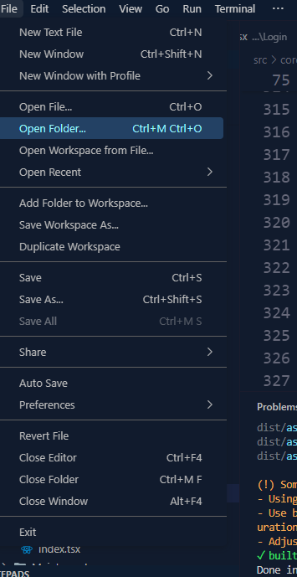

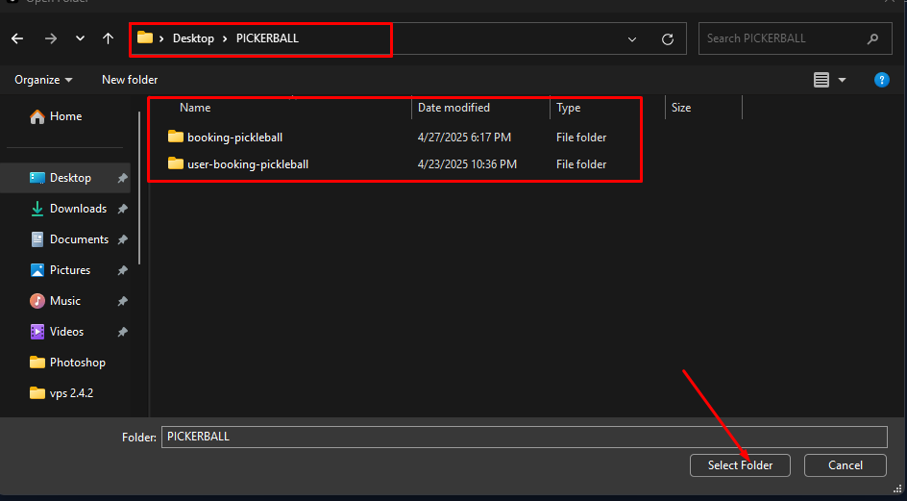

**Step 3**: Setup **environment for project**

Open terminal setup environment for 2 app admin and user project

- Admin

Navigate to the admin-booking-pickleball folder:

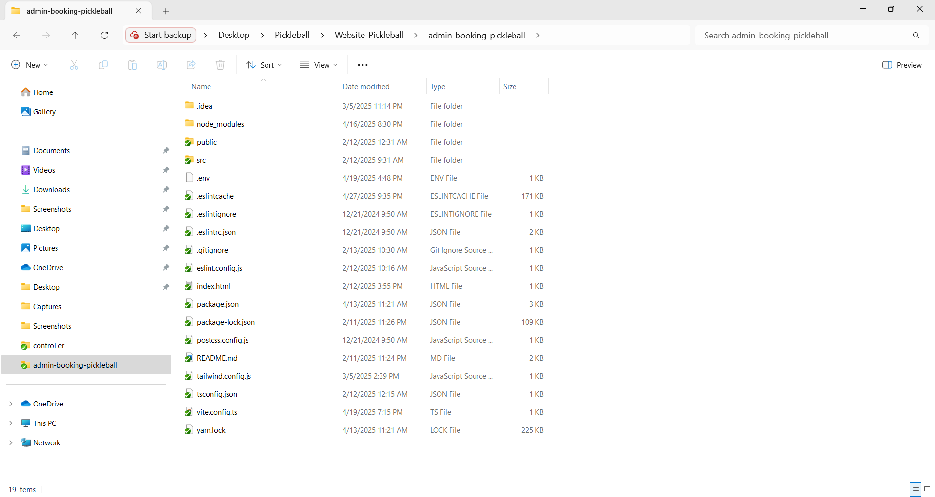

Install project dependencies

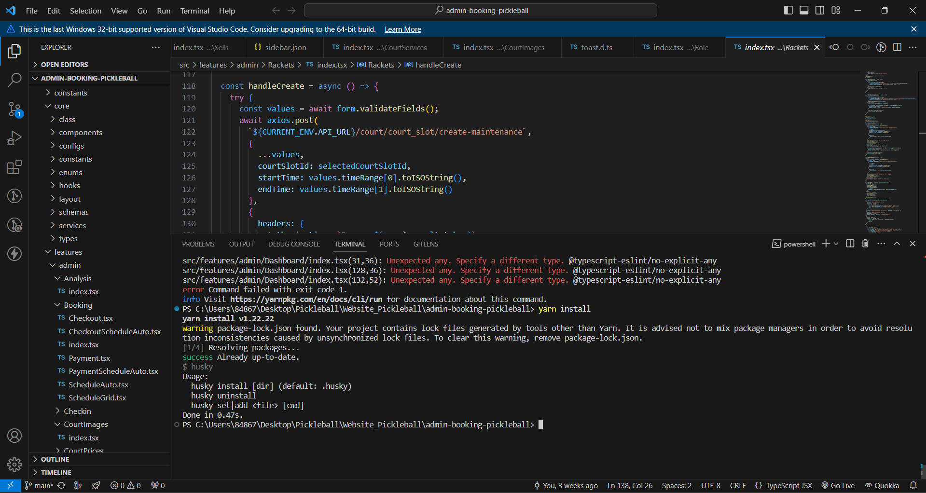

**Create the .env file:** You can use a text editor or the touch command to create an empty .env file.

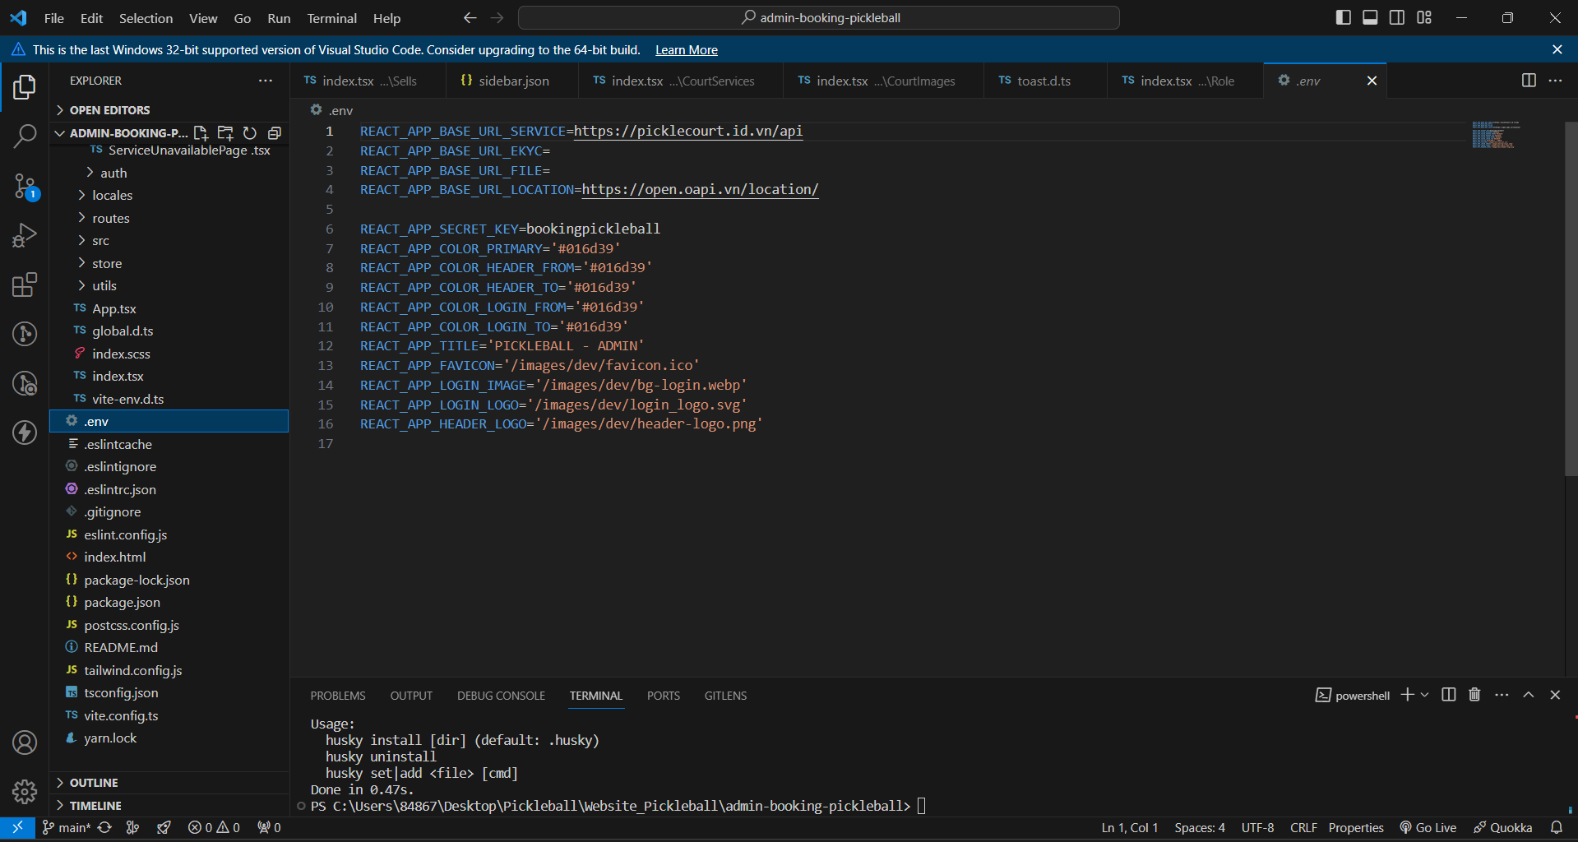

**Open the .env file to add environment variables:** Use a text editor (like VS Code, Sublime Text, Nano, or Vim) to open the .env file and add your environment-specific configurations.

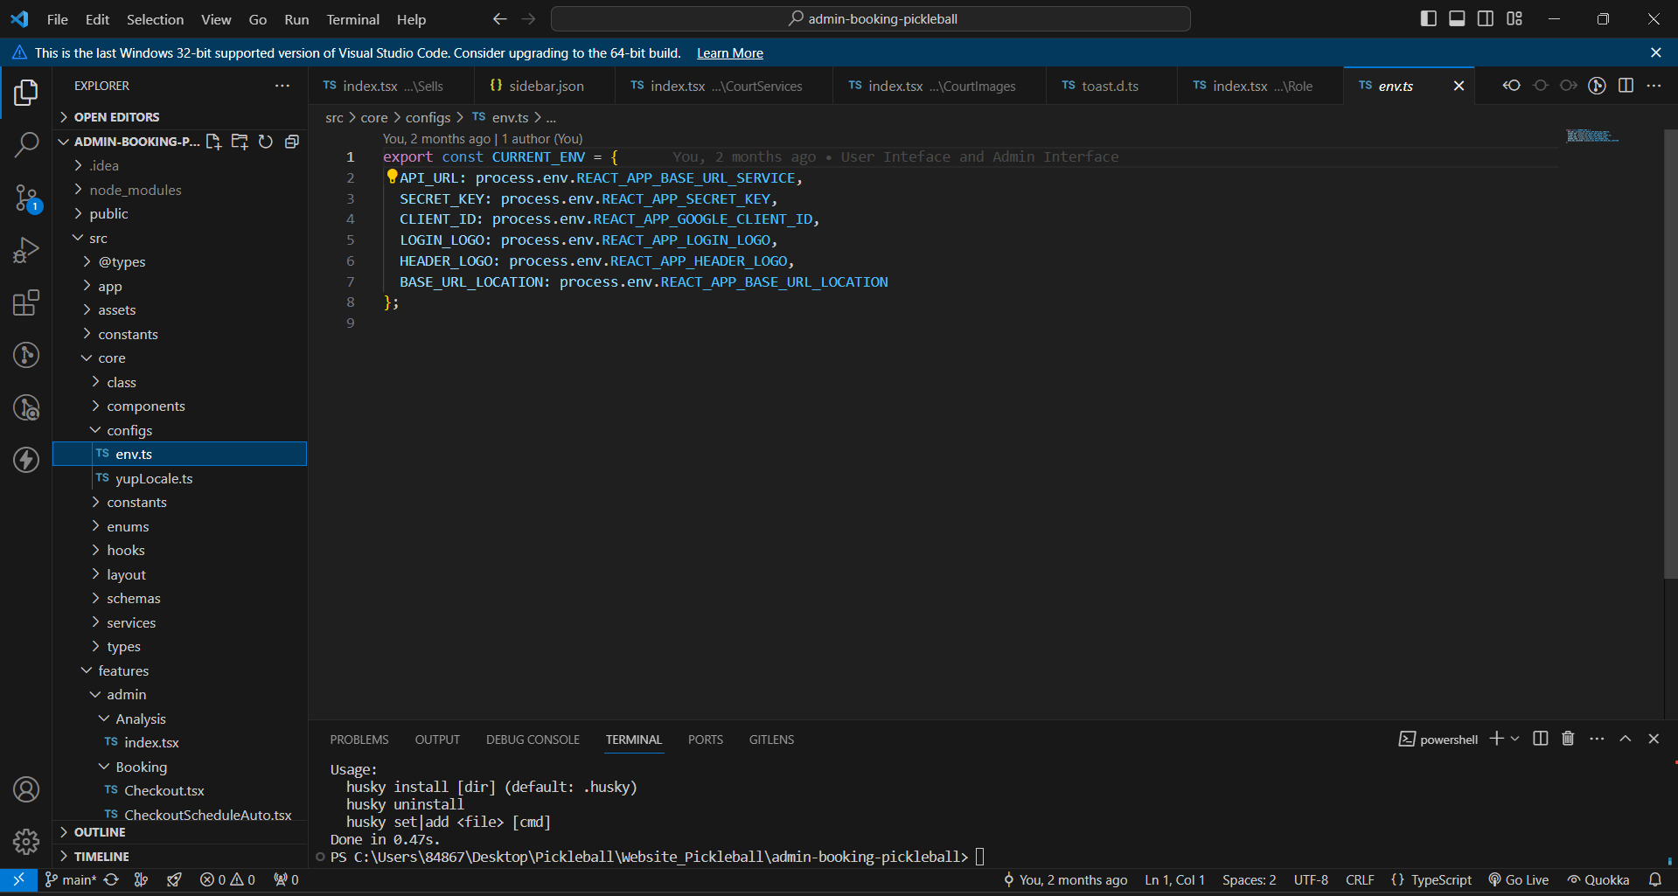

- User

Navigate to the user-booking-pickleball folder:

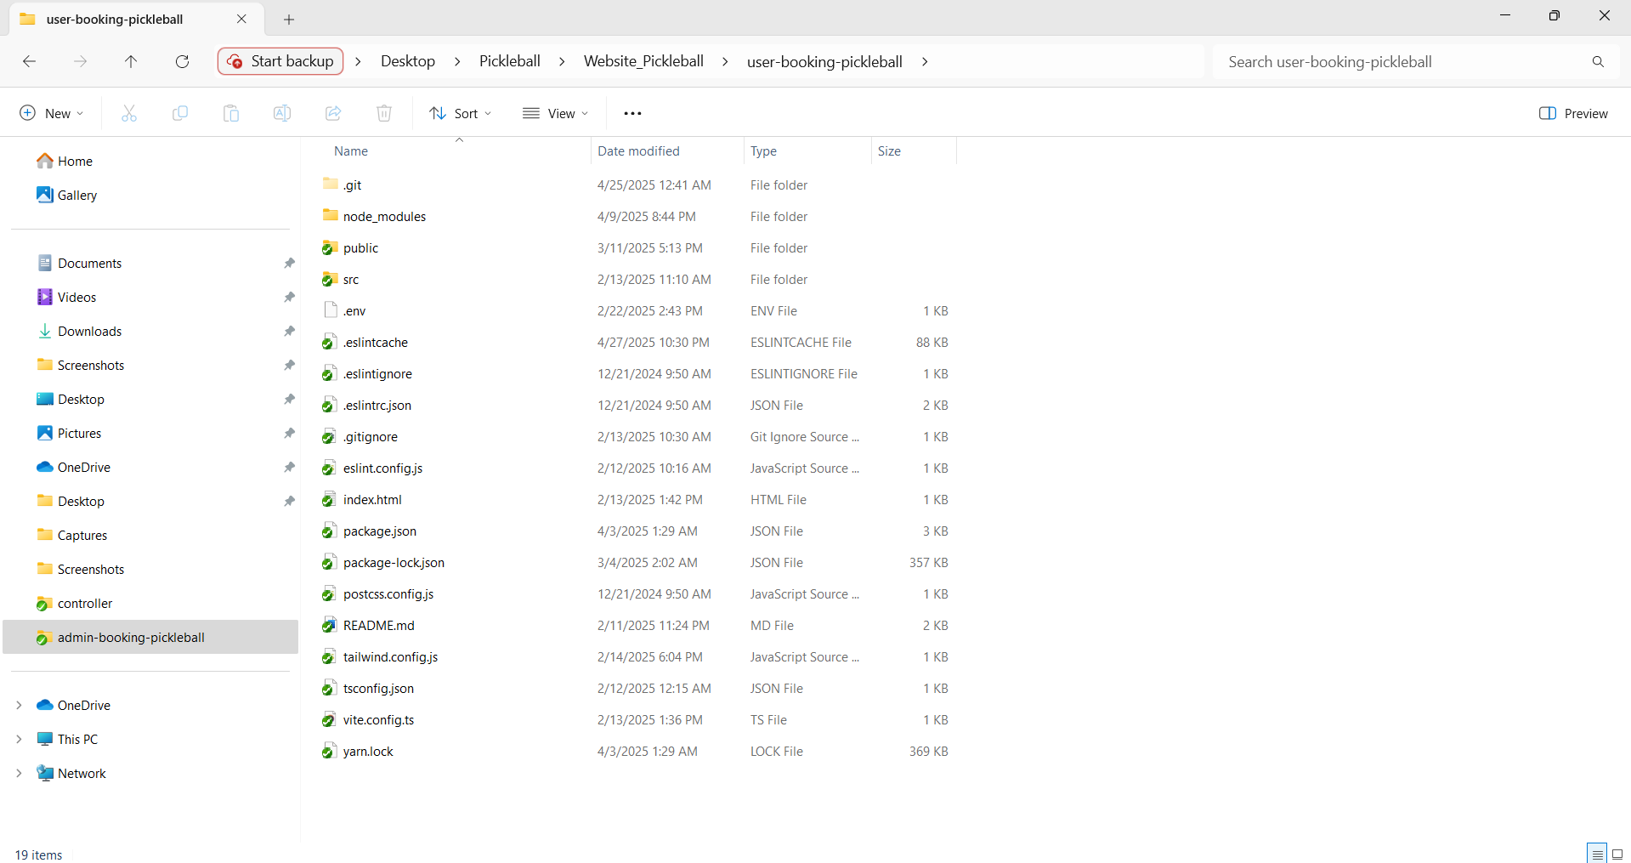

Install project dependencies

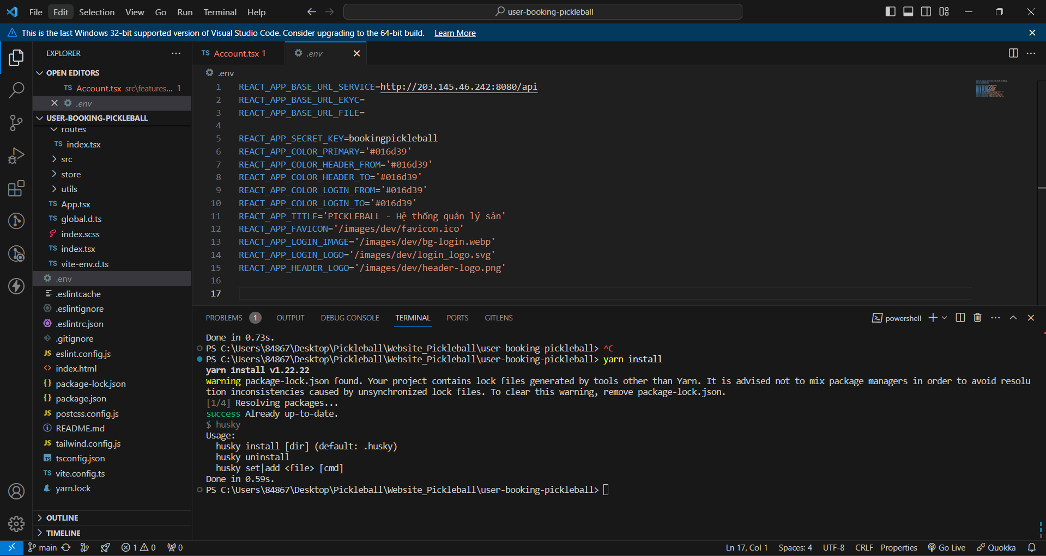

**Create the .env file:** You can use a text editor or the touch command to create an empty .env file.

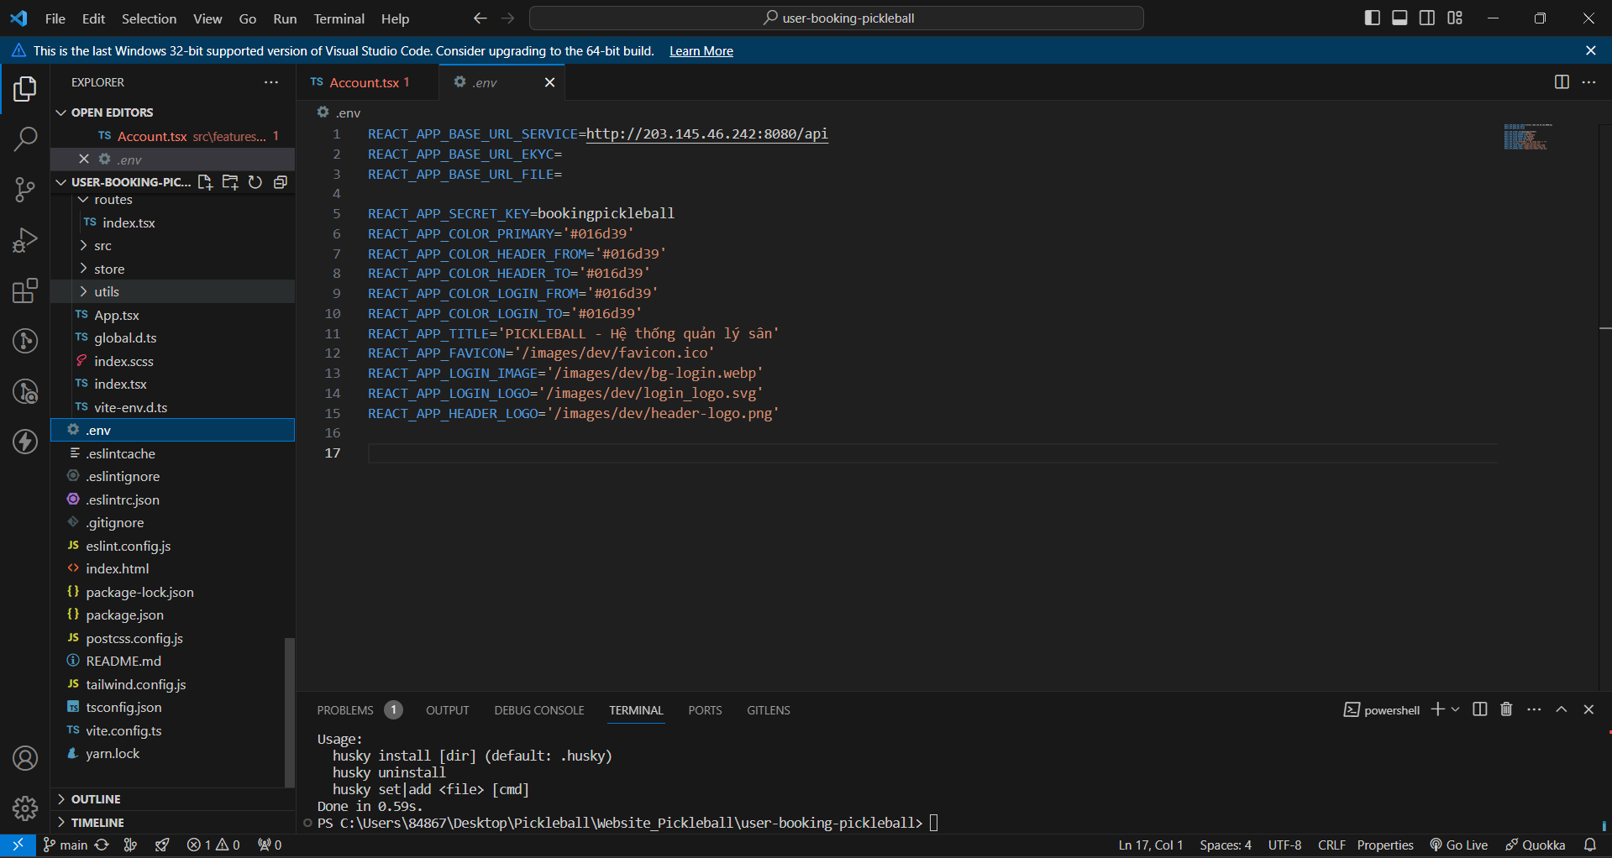

**Open the .env file to add environment variables:** Use a text editor (like VS Code, Sublime Text, Nano, or Vim) to open the .env file and add your environment-specific configurations.

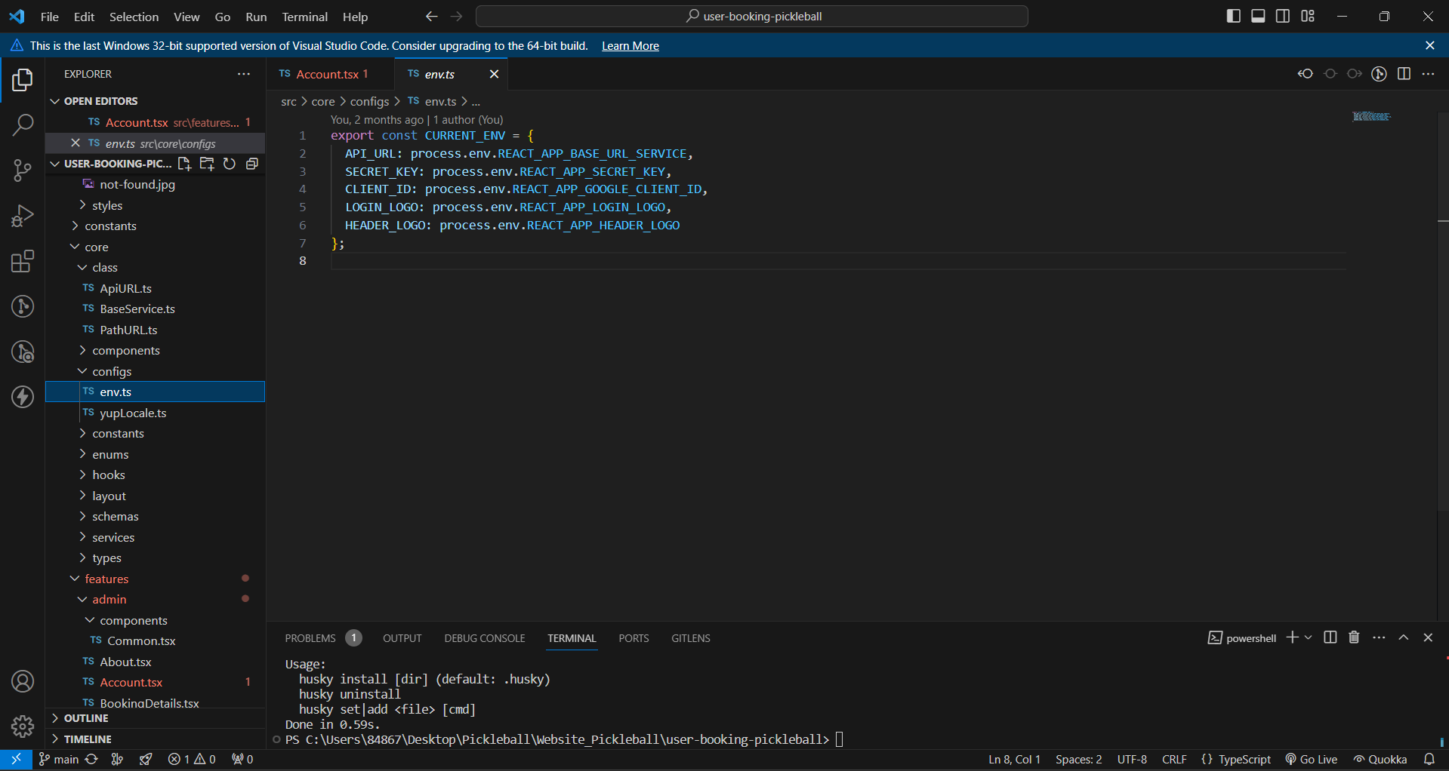

**Step 4:** Run project

**Start the development server:** The command for this will vary based on your project's setup. Here are some common examples:



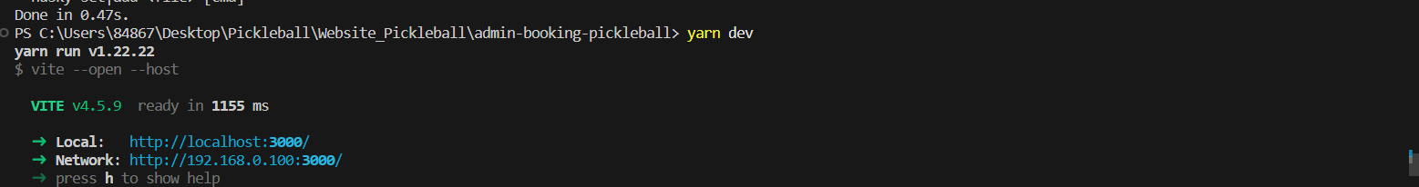

**2.2.2.Back-end installation  
Install IDE :** IntelliJ IDEA Ultimate or IntelliJ IDEA Community:

https://www.jetbrains.com/idea/download///?section=windows

**Download jdk 17 :**[**https://www.oracle.com/java/technologies/javase/jdk17-archive-downloads.html**](https://www.oracle.com/java/technologies/javase/jdk17-archive-downloads.html) **Clone code :** <https://github.com/ruannguyen05/Pickleball-Court-Management-System> **Step 1 : clone code clone code from the link above  
  
Step 2 : Open project in IntelliJ IDE**

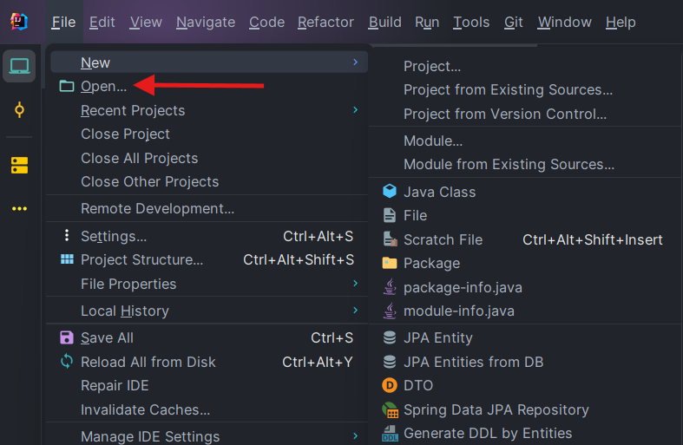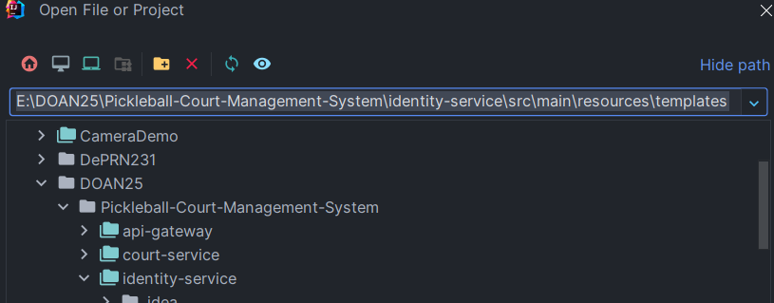

**Step 3 : Setup JDK 17   
  
   
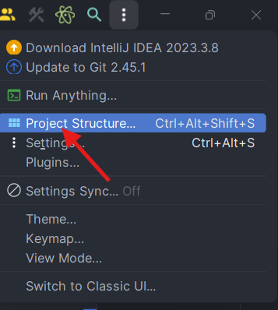  
  
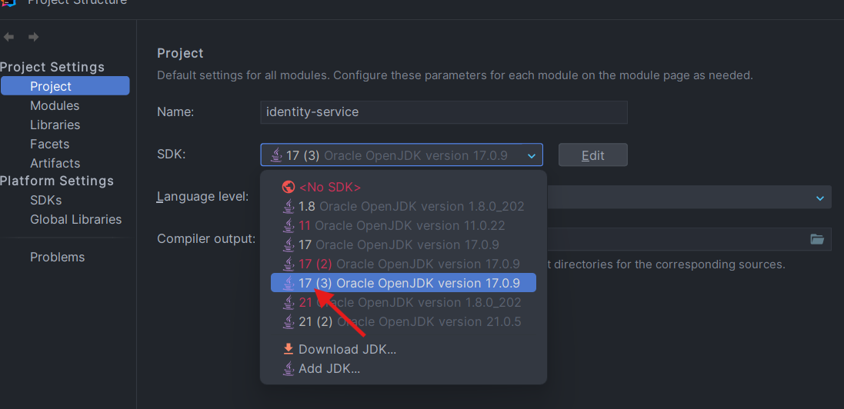  
  
  
Step 4 Config environment in application.yaml  
  
  
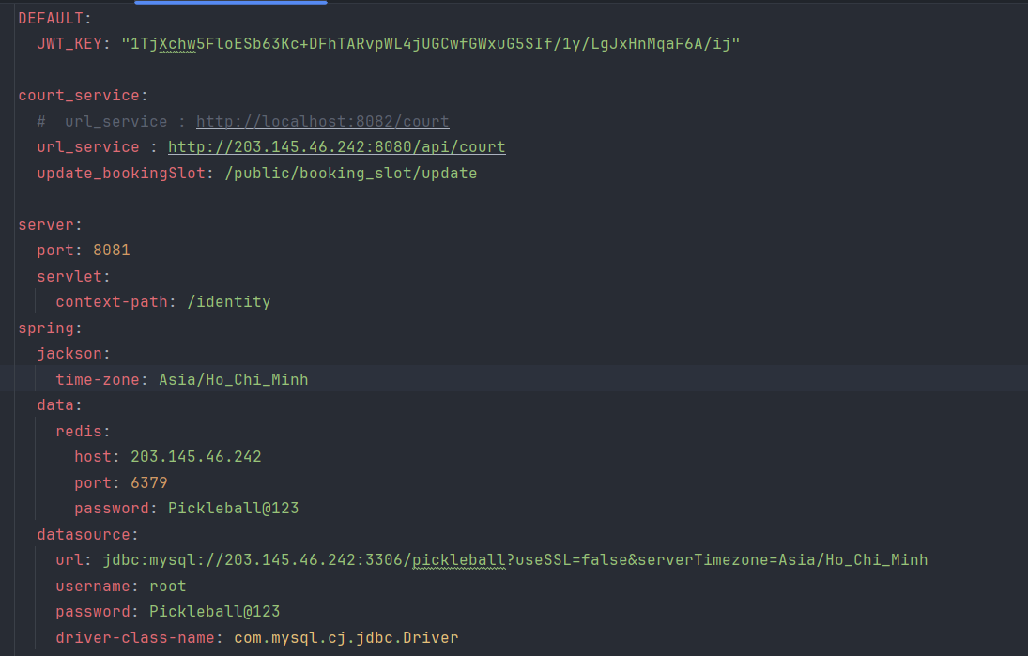  
  
Step 5 : Run project  
  
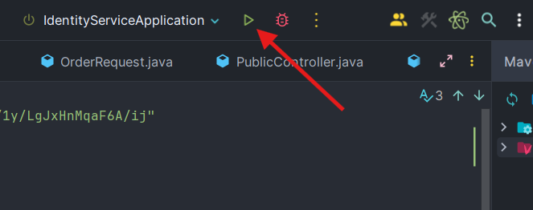  
  
If you want run all project in local , you must change :**

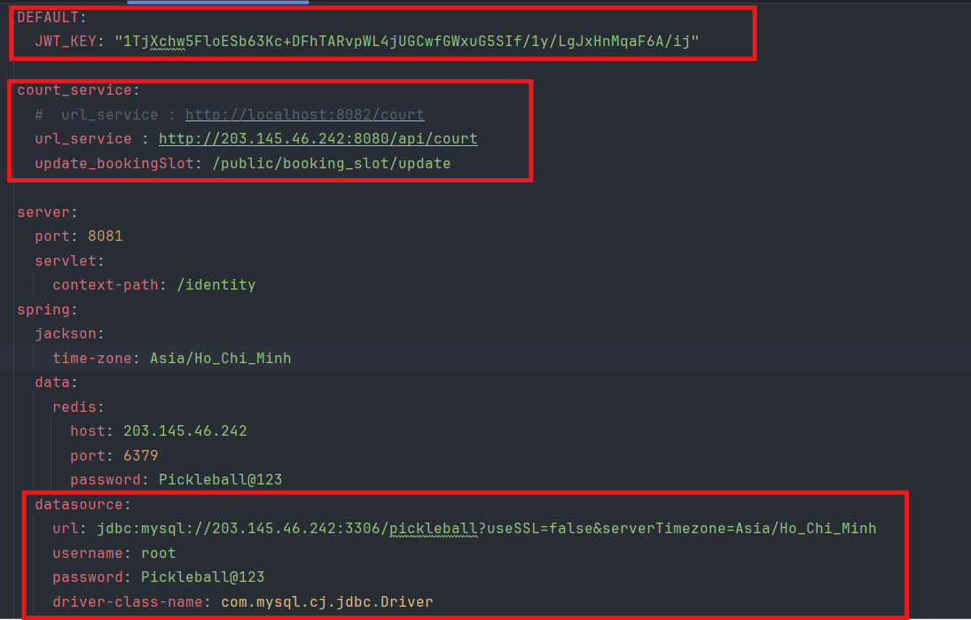

#### 2.2.2.Database Installation

**Step 1:** See how to install it [here](https://www.youtube.com/watch?v=u96rVINbAUI).

**Step 2:** After install successful , config to connect database

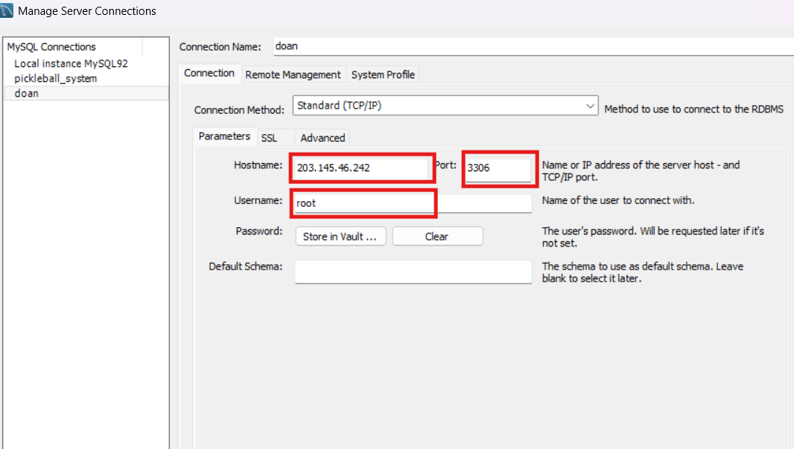

#### 2.3.1. Mobile Step 1: Install app in [Google Drive](https://drive.google.com/drive/folders/1ewQ1Arnzk6OXIFhwojIef_JFxJrWUMaK)

**Step 2:** Once the download is complete, just click on the downloaded application and install it.

## 3. User Manual

### 3.1 Overview

The Pickleball Court Management System is a sophisticated web-based application designed to streamline the management and reservation of pickleball courts, catering to players, facility owners, managers, and staff. Developed to address the inefficiencies of traditional court management and booking processes, this system leverages modern technology to provide a seamless, efficient, and user-friendly experience. Its primary purpose is to facilitate real-time court reservations, equipment rentals, user management, payment processing, and court maintenance, enhancing accessibility and engagement for both casual players and dedicated pickleball enthusiasts.

**Key Features**

* **Automatic Scheduling Management**: Customers can book and pay online without staff confirmation. The system automatically refunds cancellations, depending on the business's policy.
* **Flexible Schedule Changes and Cancellations**: Customers can easily change or cancel bookings via the mobile app, with an automatic refund process.
* **Advanced Data Analysis**: Analyze peak hours, booking trends, and revenue to support business owners in making more effective decisions.
* **Financial Management**: Easily track transactions, payments, and court maintenance. Business owners can customize court and hourly rates for holidays or regular days.
* **Permission and Security Management**: The flexible permission system helps business owners manage staff access rights.

**Caution**

Managing schedules, payments, and permissions is crucial and closely interrelated. Use these features carefully to avoid errors, as your settings will directly impact customer experience and internal management.

*Advice: Read the user manual carefully and follow the agreed-upon procedures. Your product should undergo thorough testing before official deployment.*

### 3.2 Workflow on web

### 3.2.1 Login

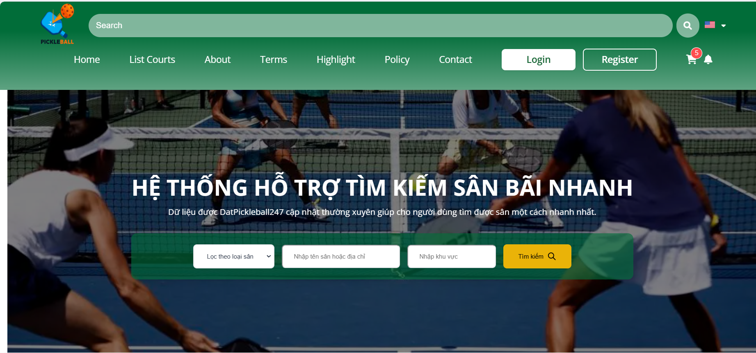

**Step 1**: Click on the “Login” button

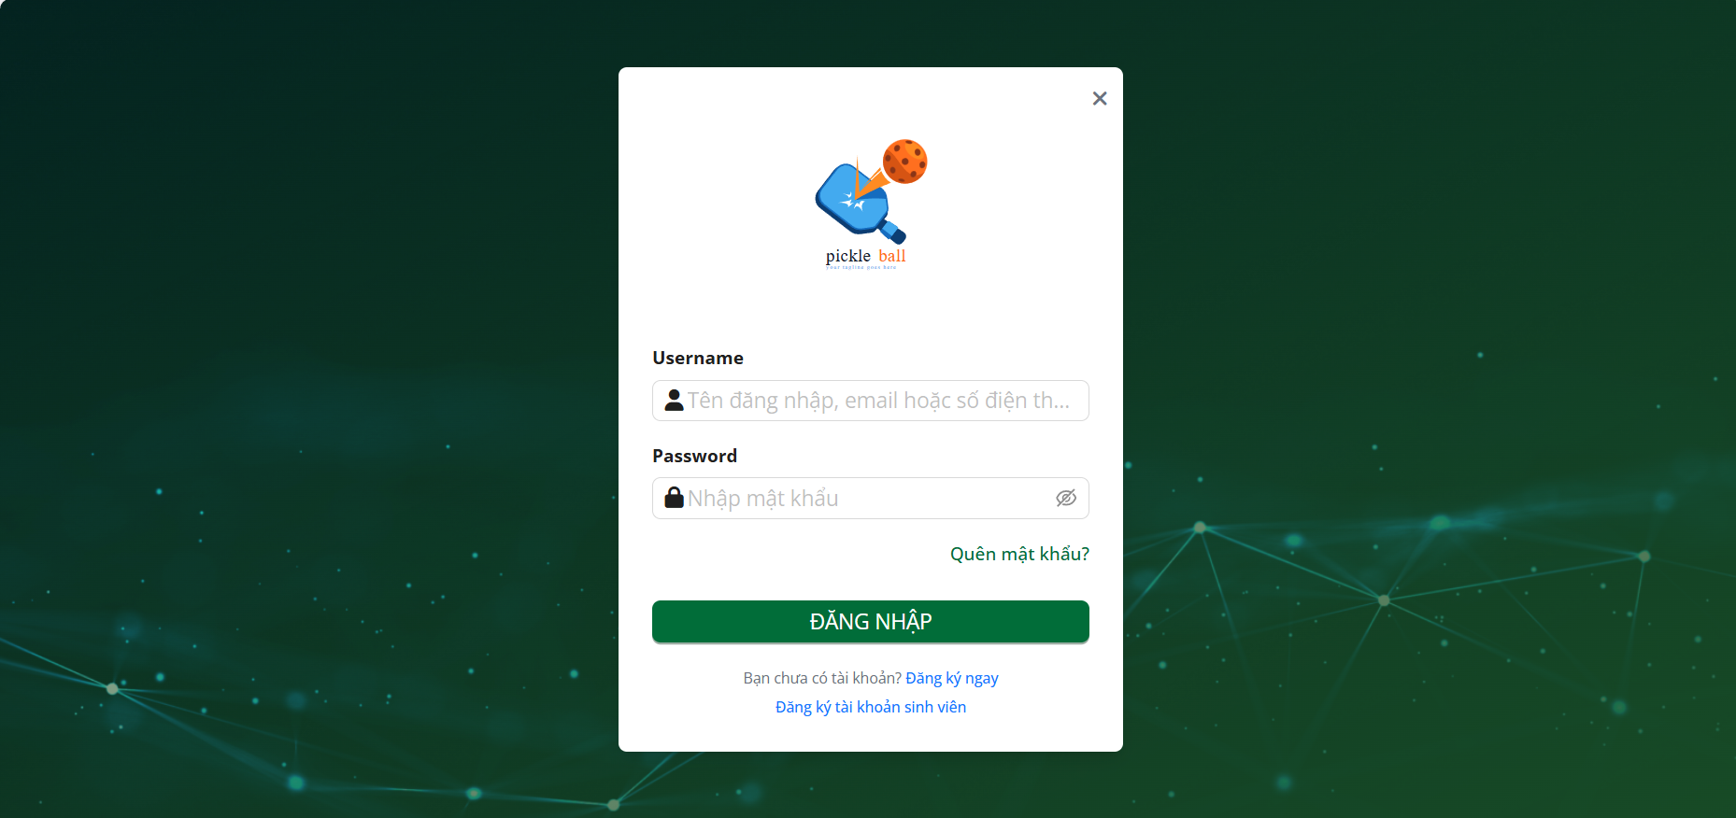

**Step 2**: Enter “Username” and “Password”

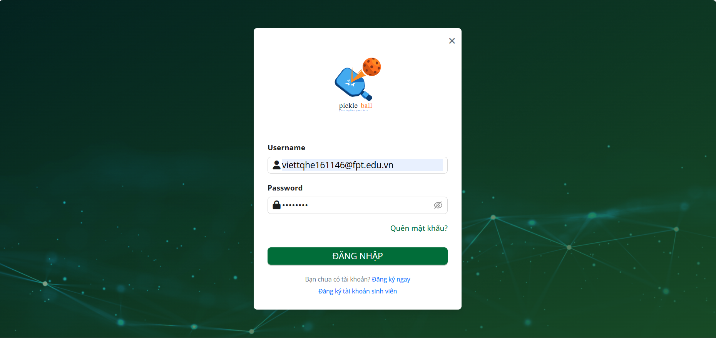

**Step 3**: Click on the “Đăng nhập”

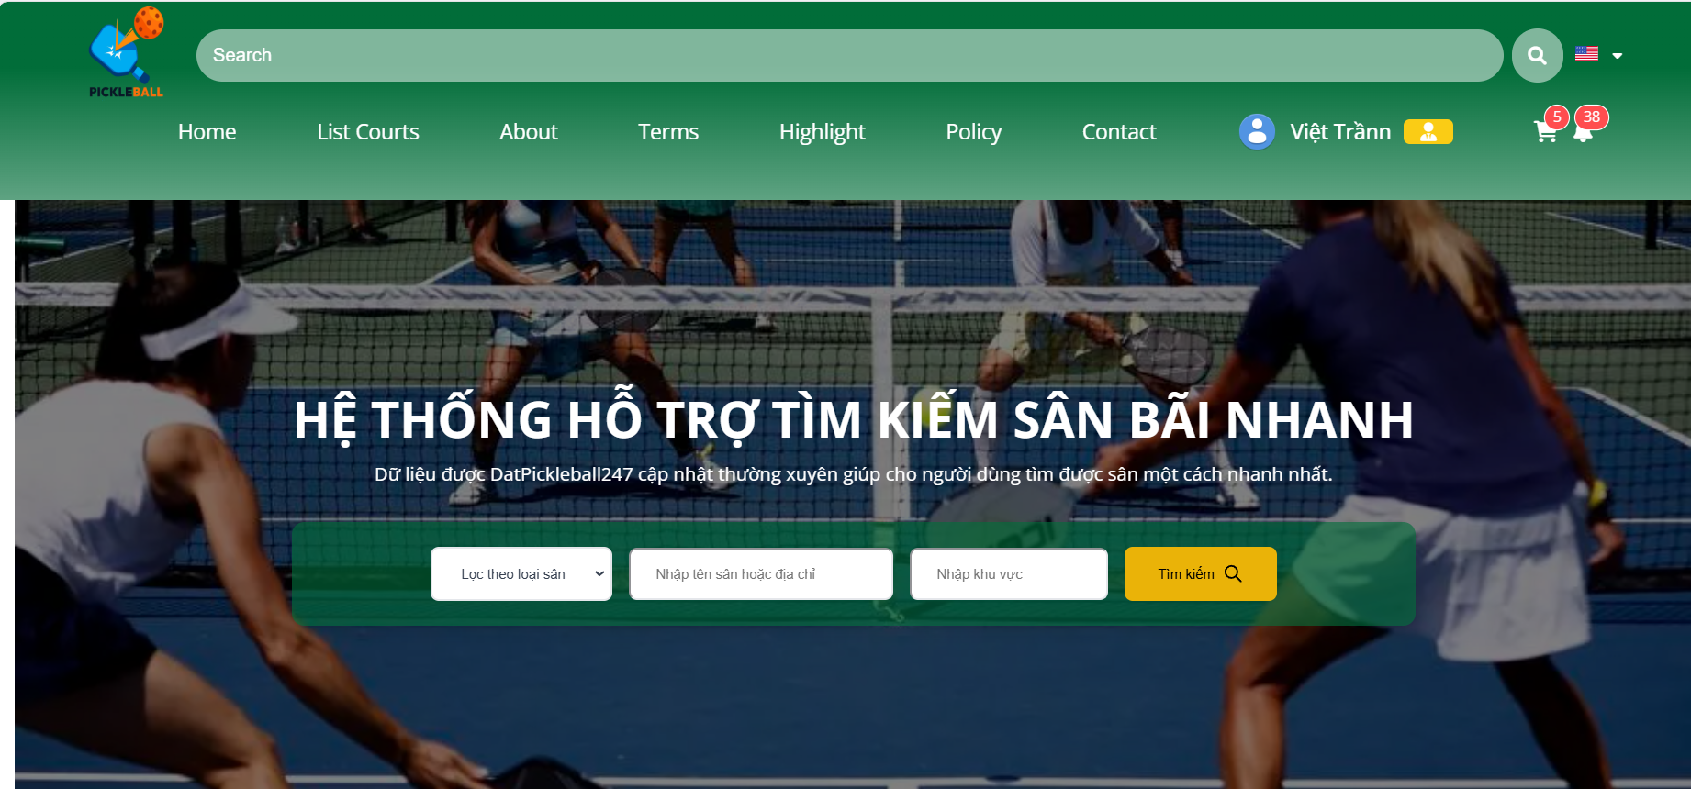

### 

### 3.2.2 Register



**Step 1**: Click on the “Register”

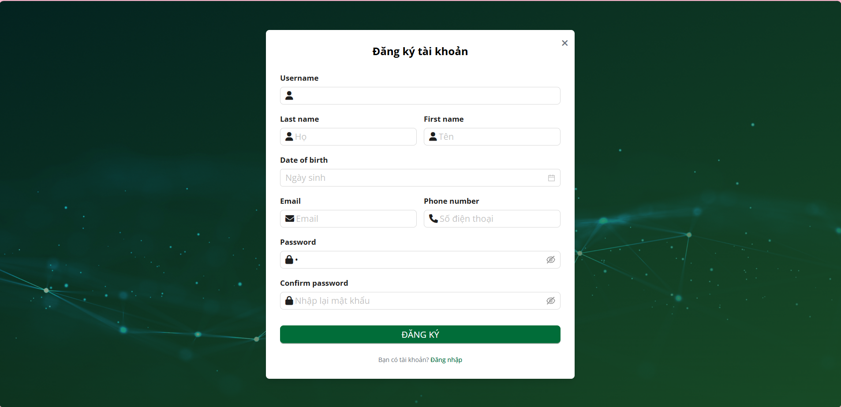

**Step 2:** Input all field valid to create account

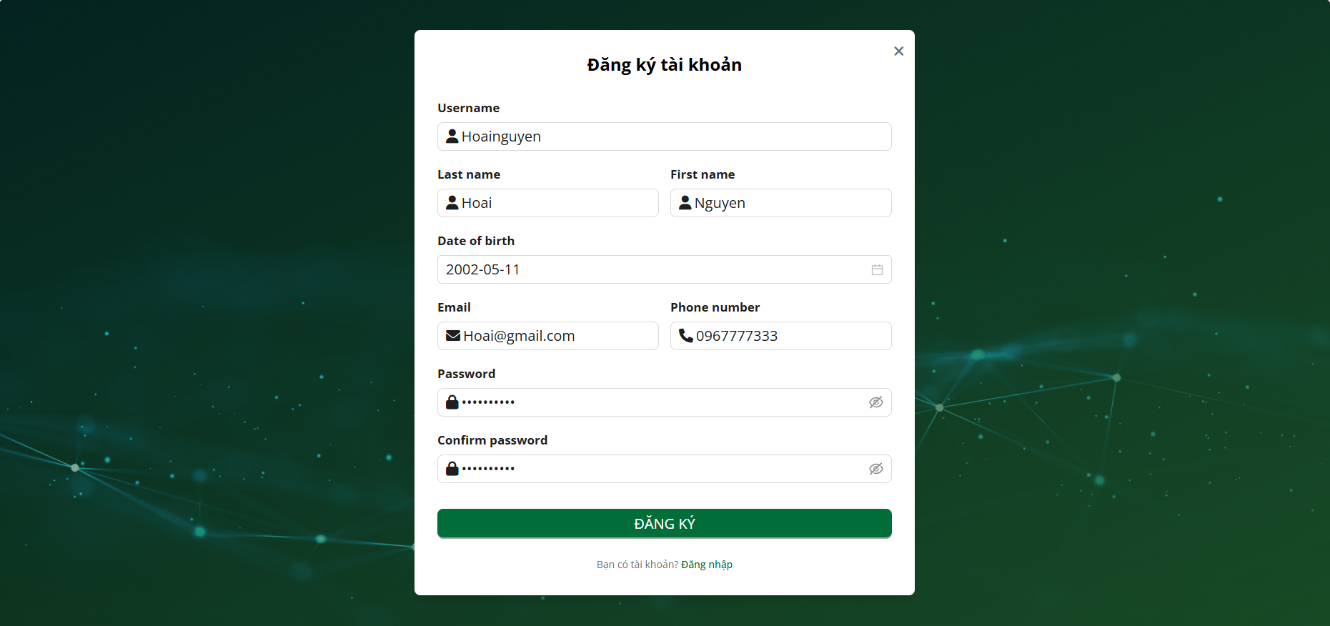

**Step 3:**Click on the “Đăng kí”

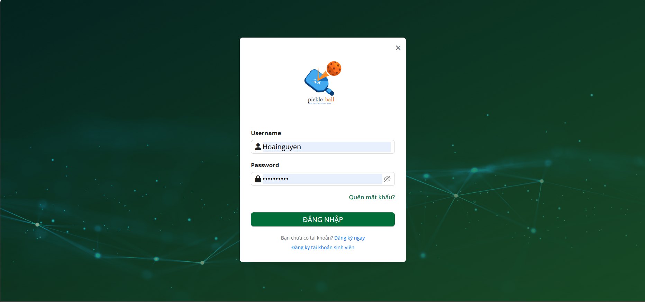

### 3.2.3 Register for a student account

### 



**3.2.2 Register**



**Step 1**: Click on the “Login”

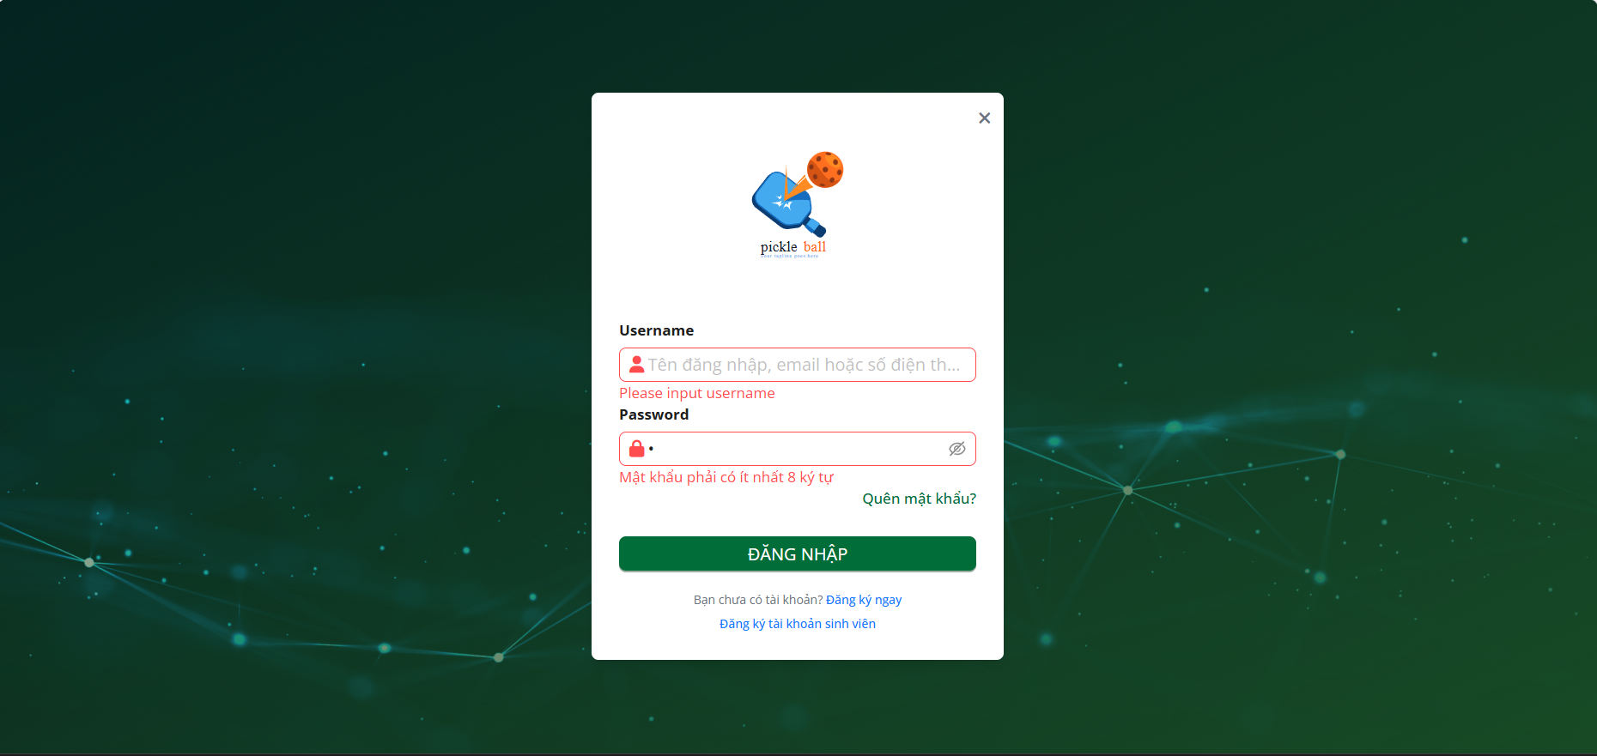

**Step 2:** Click on the “Đăng kí với tài khoản sinh viên”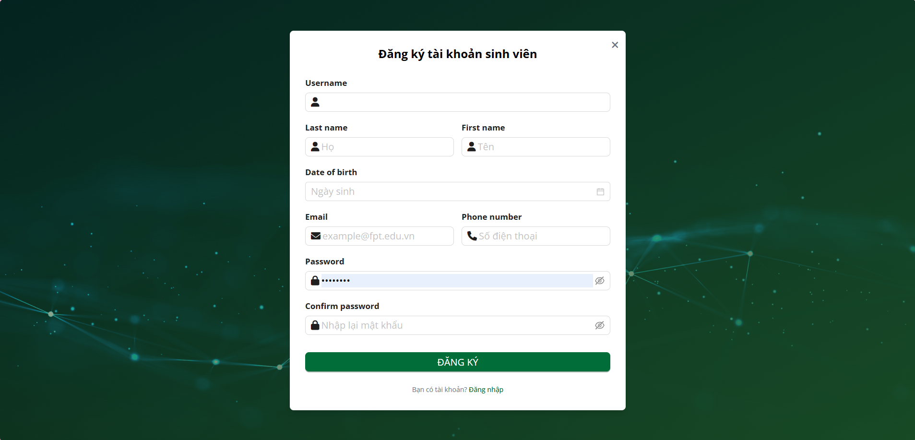

**Step 3:** Input all field valid to create account

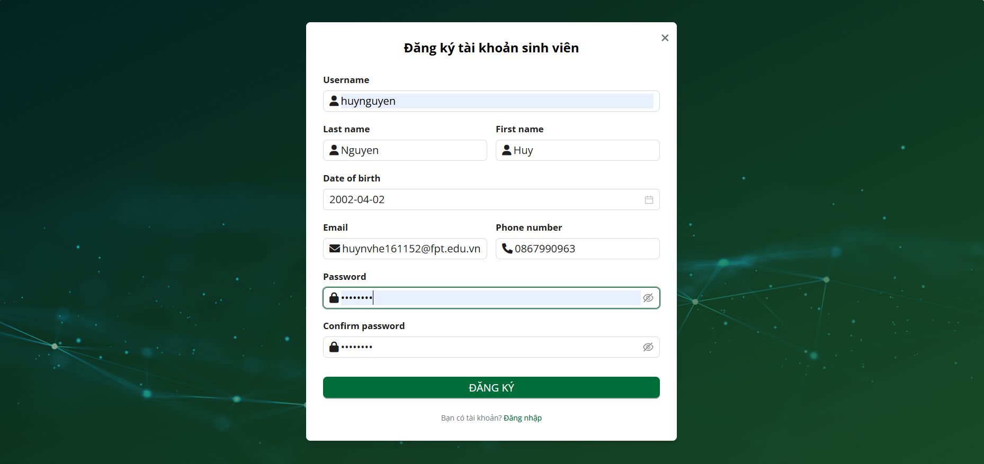

**Step 3:**Click on the “Đăng kí”

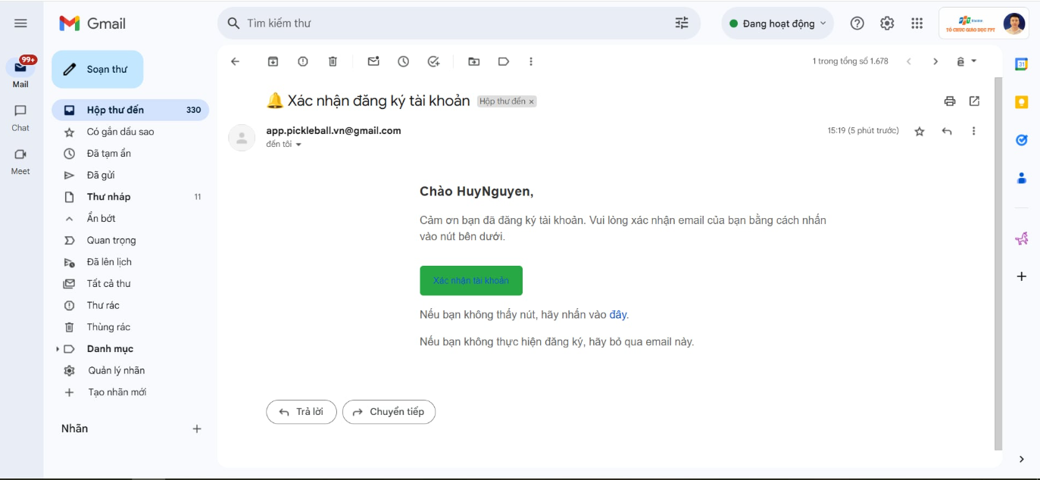

**Step 4:**Go to your email and click on the account confirmation button



### 3.2.4 Log Out

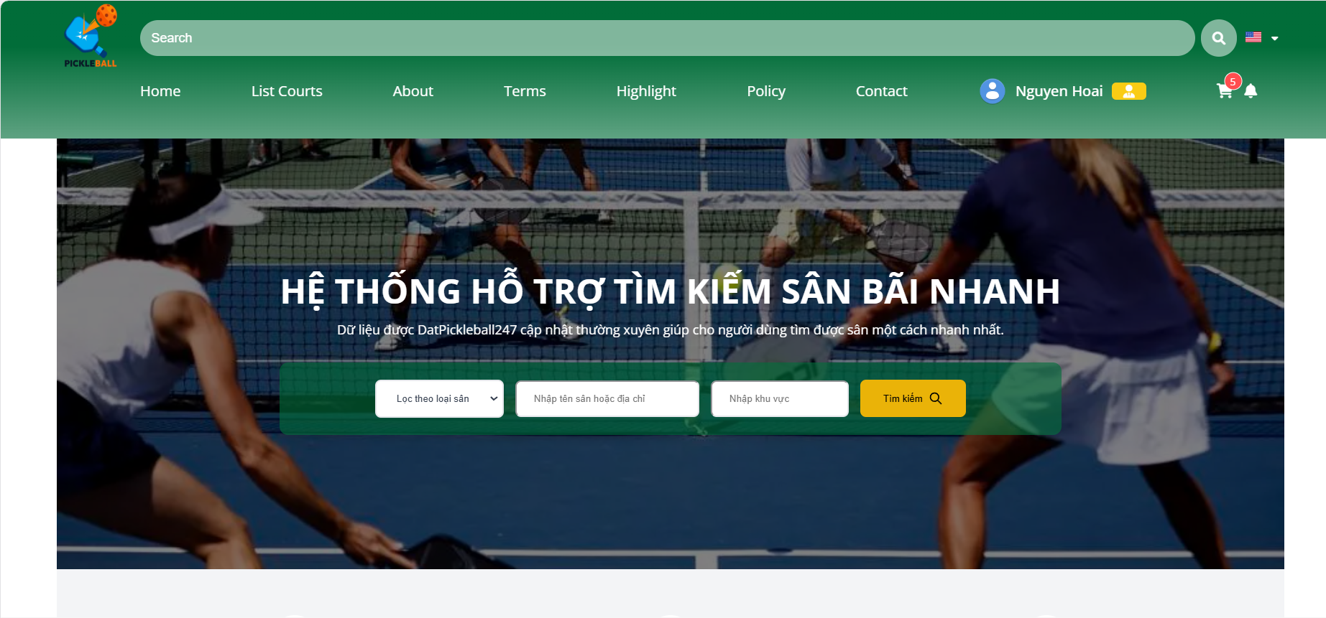

**Step 1:** Click on the “Profile” button

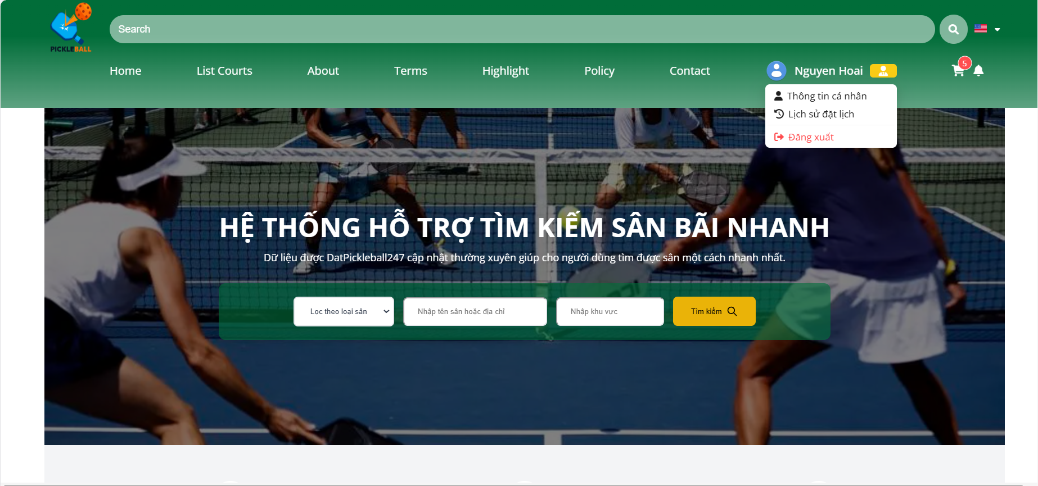

**Step 2:** Click on the “Đăng xuất” button

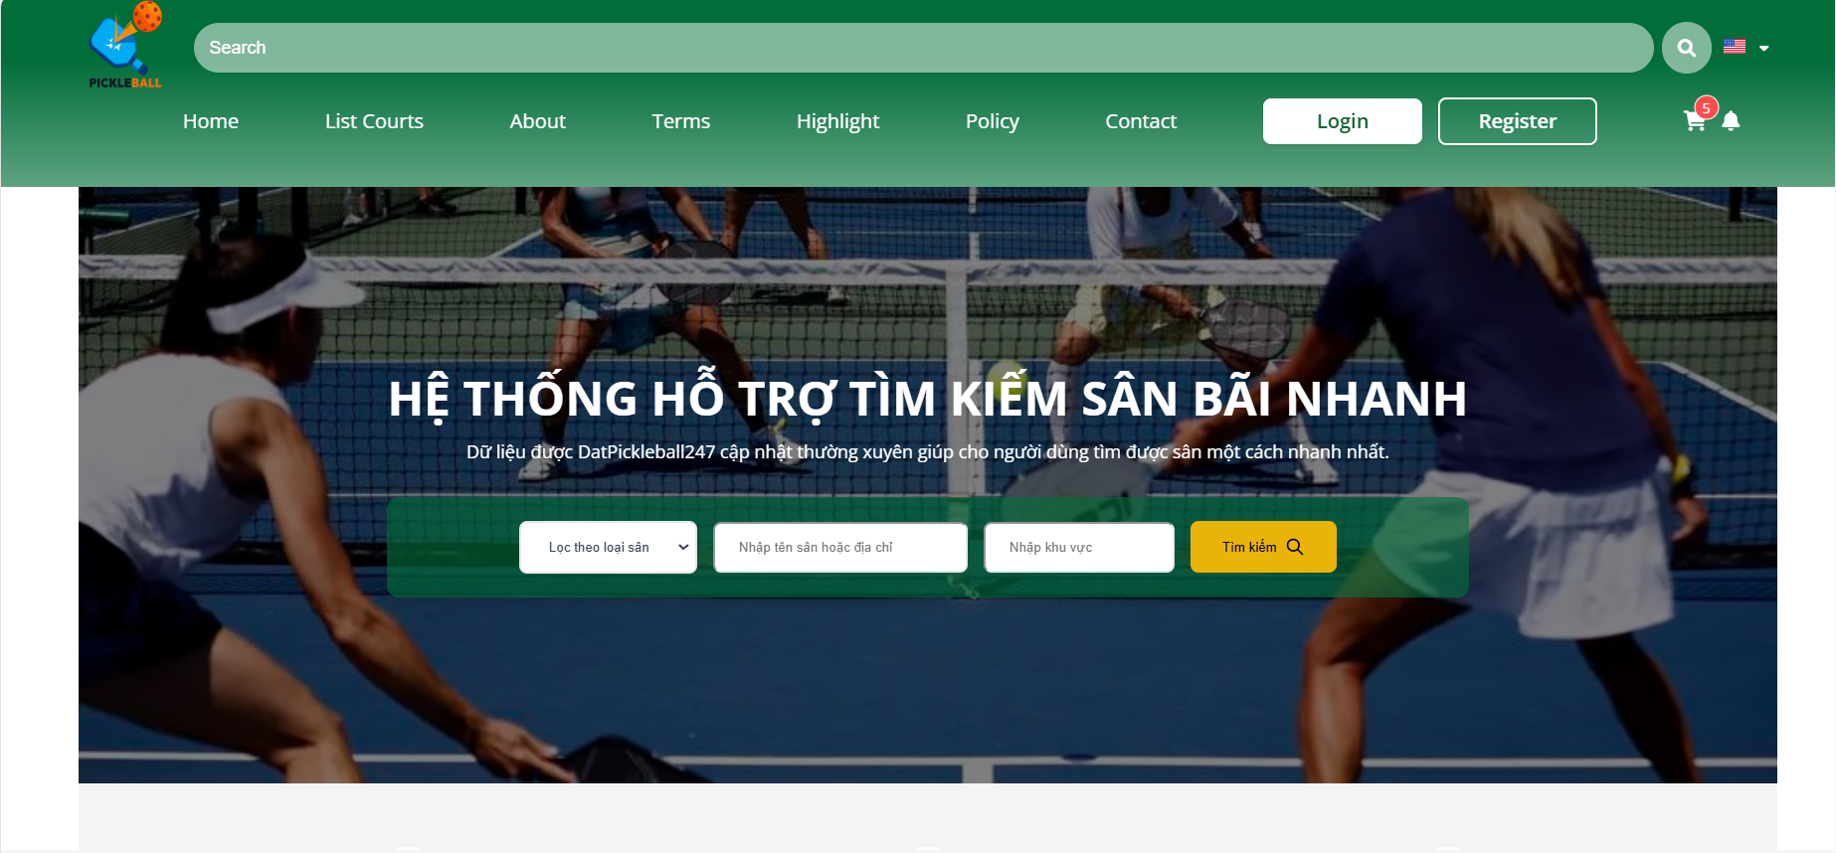

### 3.2.5 Forget password

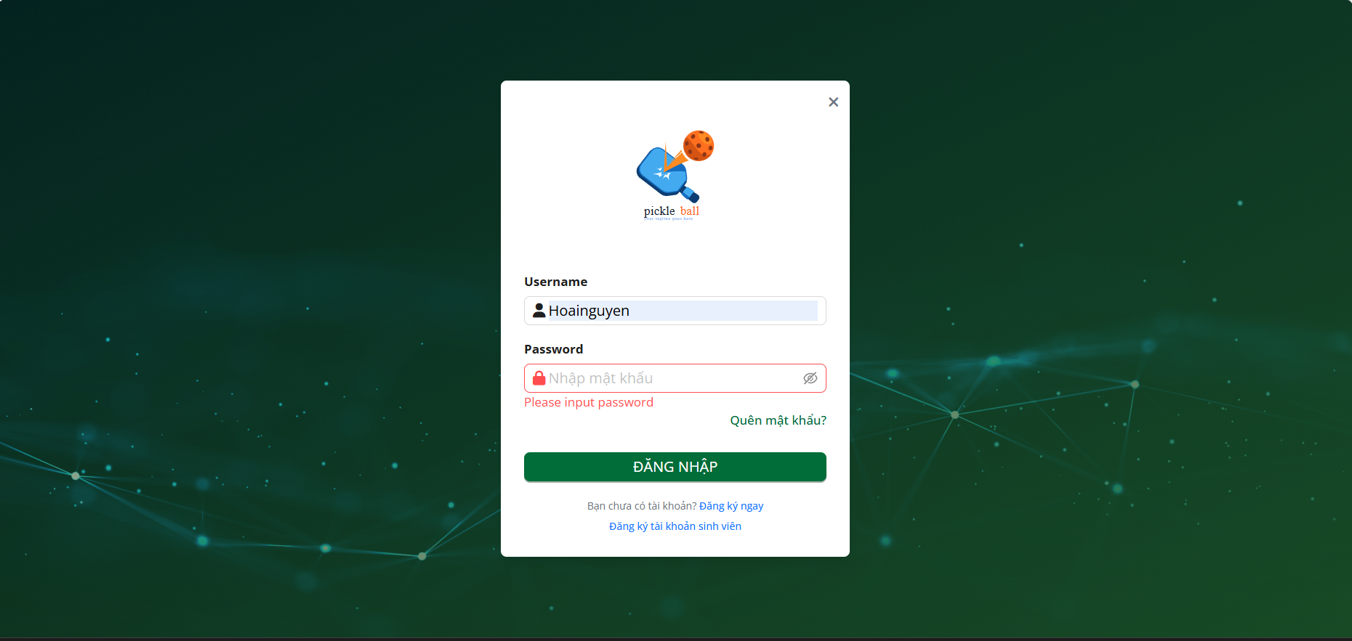

#### 

**Step 1:** Click on the “Quên mật khẩu ” button

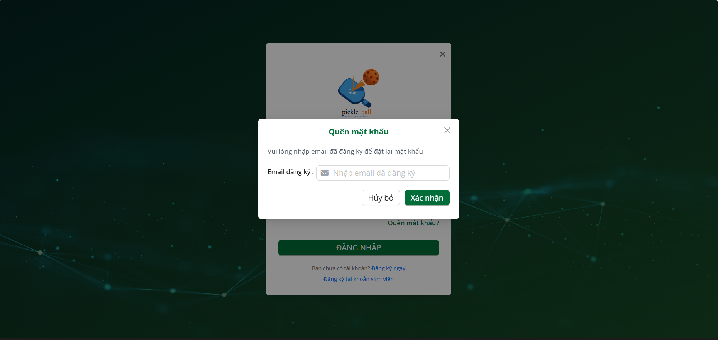

**Step 2:** Input email valid

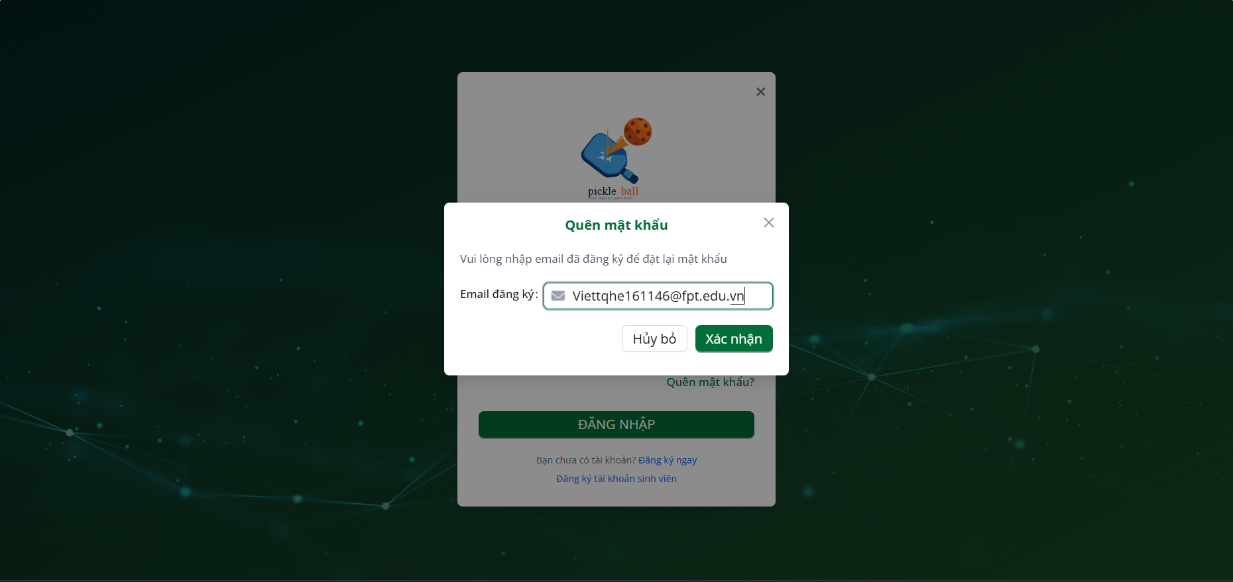

**Step 3:** Click on the “Xác nhận” button

### 3.3 Workflow Manage Profile

### 

### 

### 3.3.1 Change password

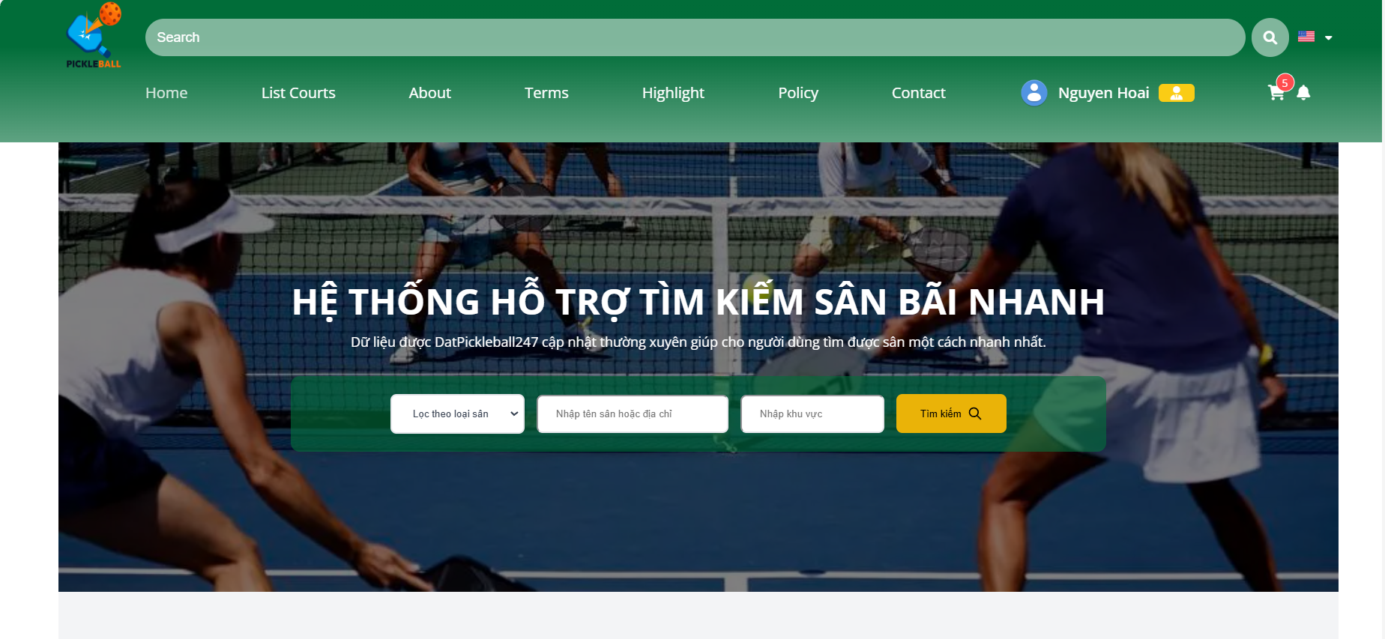

**Step 1:** Click on the “Profile” button

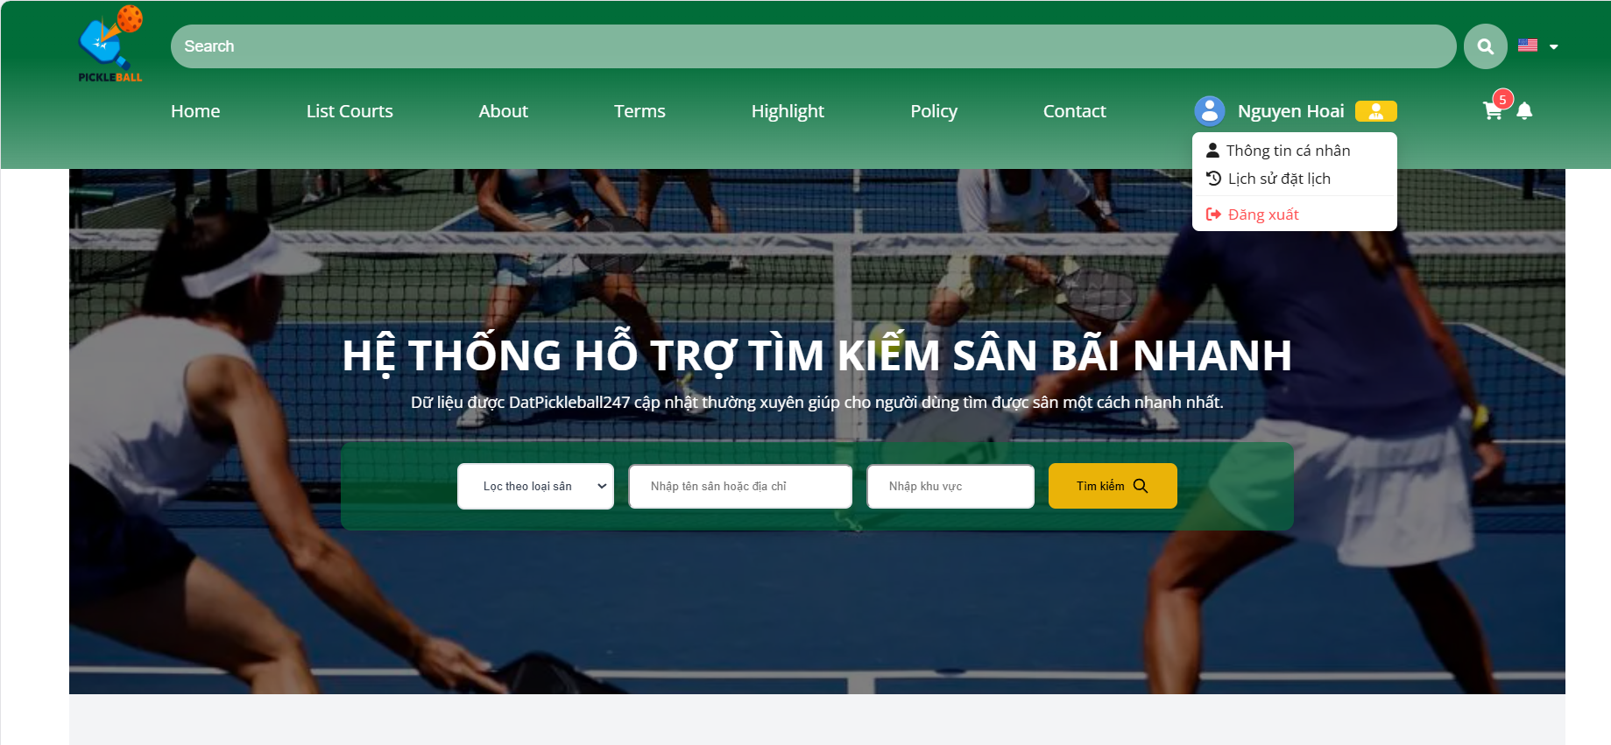

**Step 2:** Click on the “Thông tin cá nhân” button

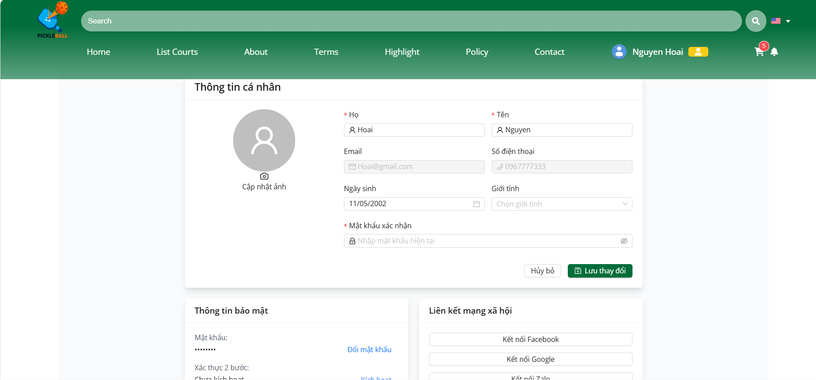

**Step 3:** Click on the “Đổi Mật Khẩu” button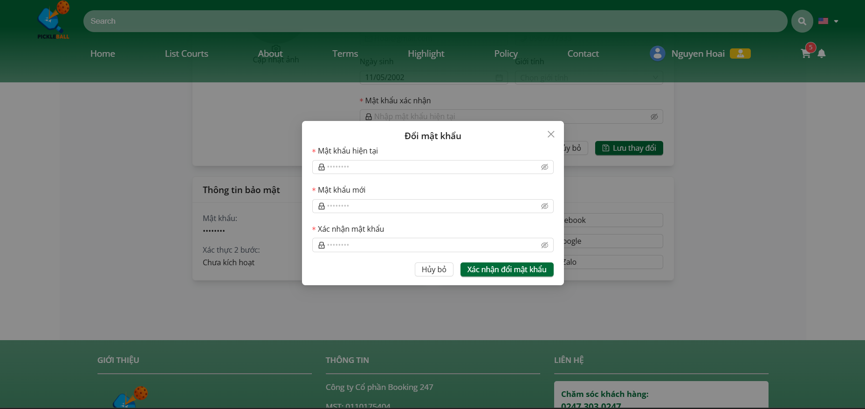

**Step 4:** Input Old Password, new password, confirm password

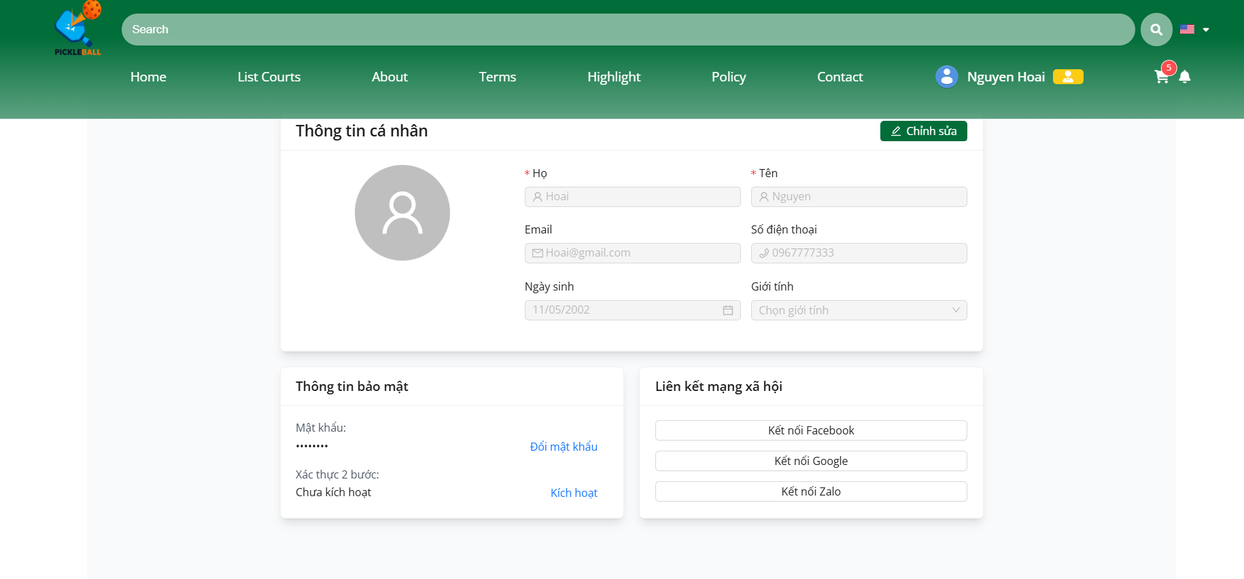

**Step 5 :** Click on the “Xác nhận đổi mật khẩu ” button

### 3.3.2 Manage Profile



**Step 1:** Click on the “Profile” button

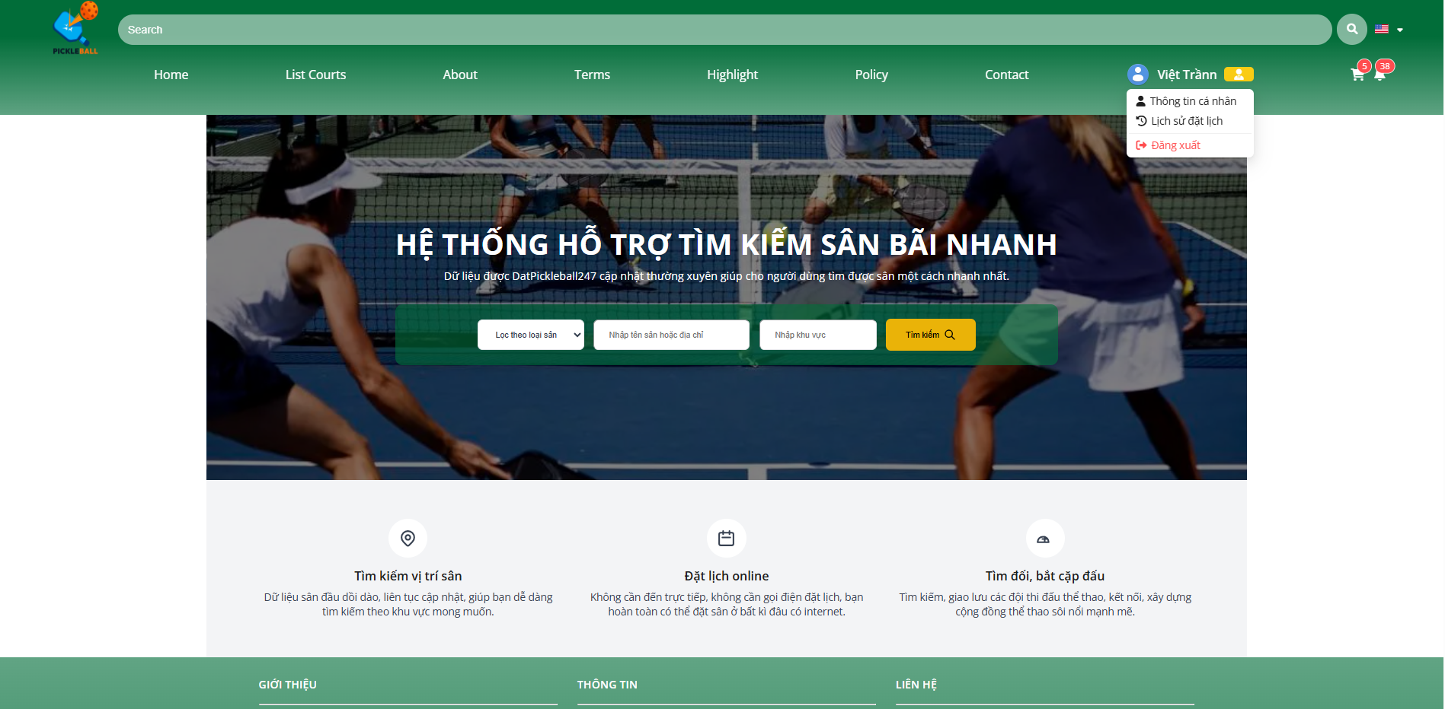

**Step 2:** Click on the “Thông tin cá nhân” button

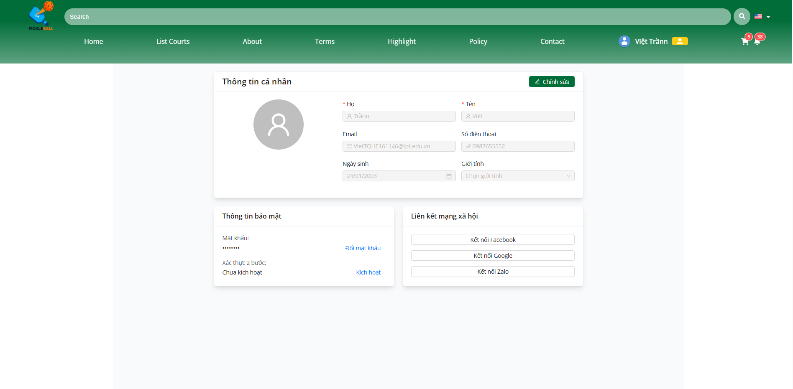

**Step 3:** Click on the “Chỉnh sửa” button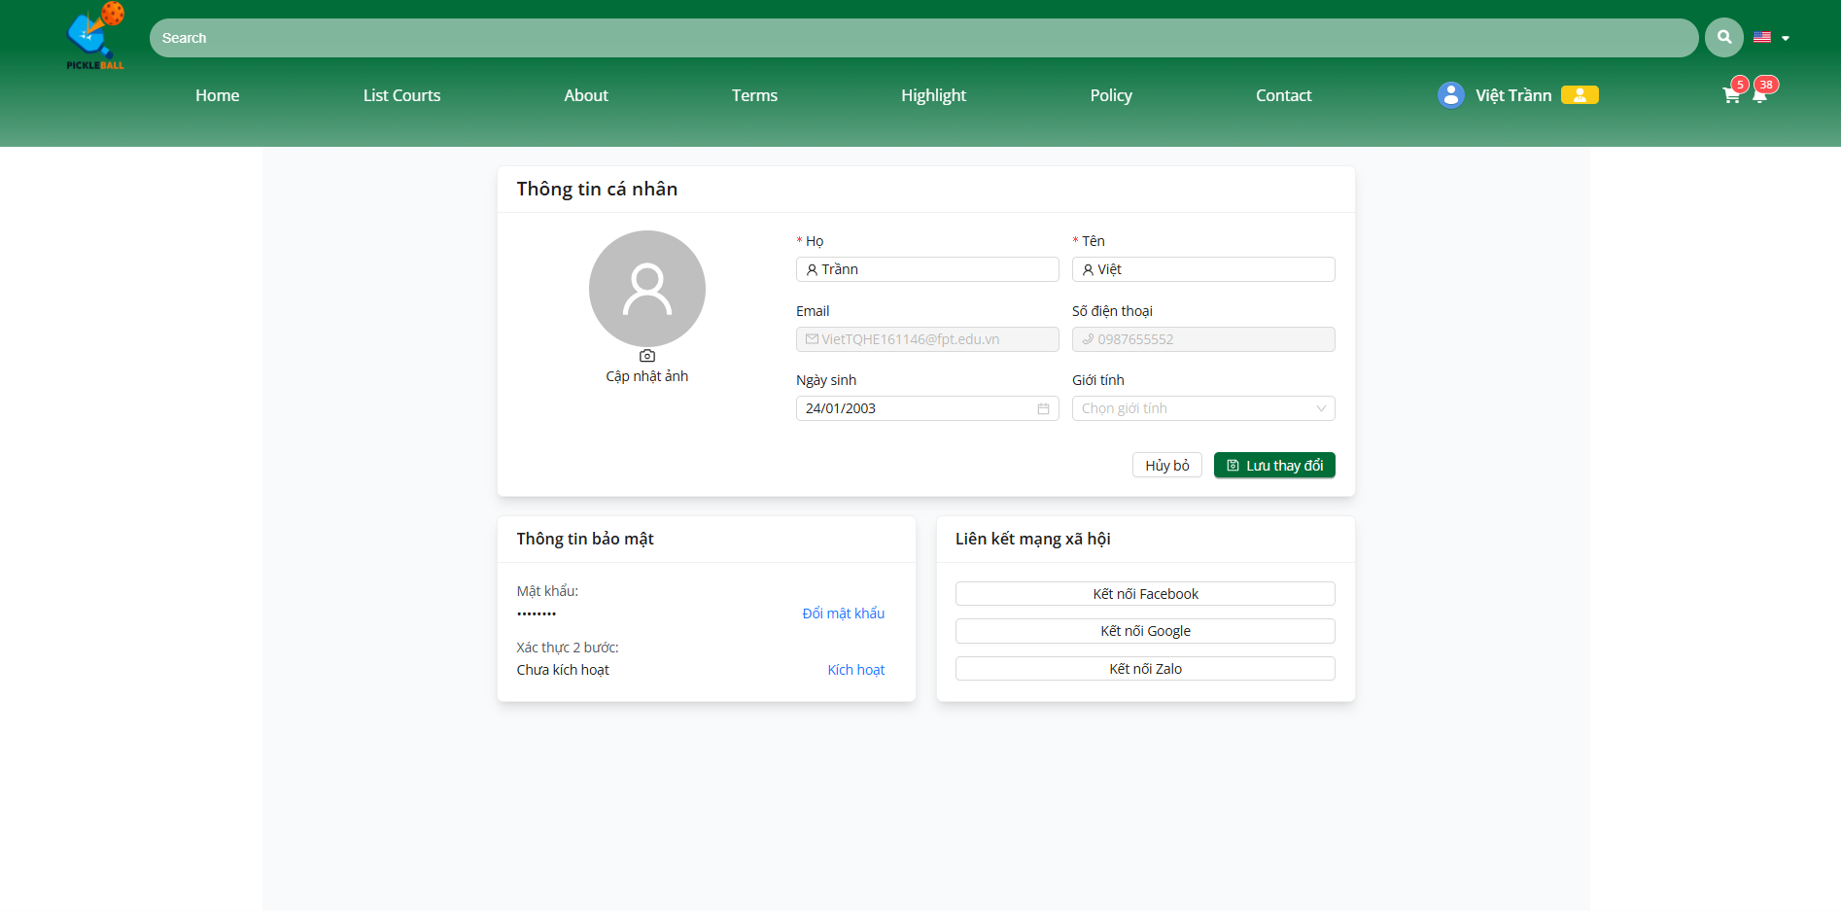

**Step 4:** Input new information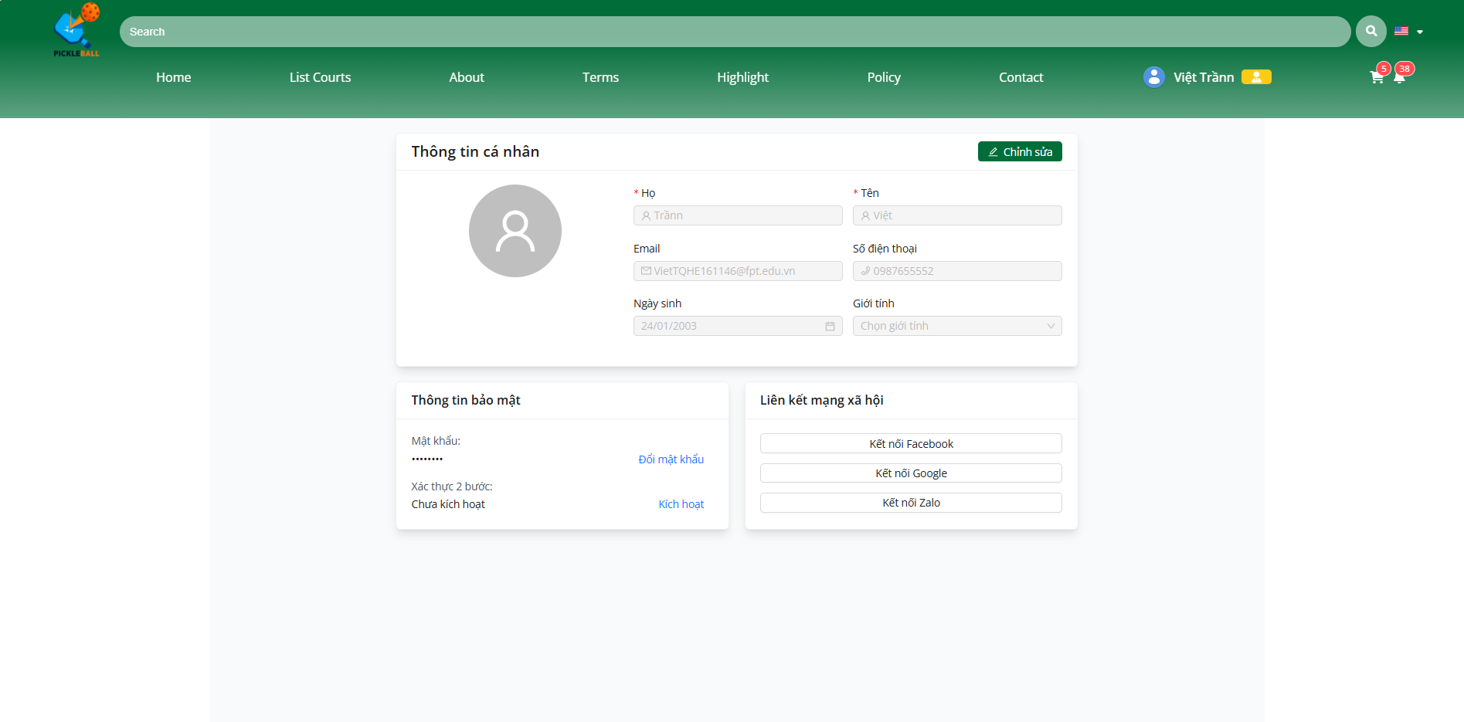

**Step 5 :** Click on the “Lưu thay đổi ” button

### 3.3.3 History order



**Step 1:** Click on the “Profile” button

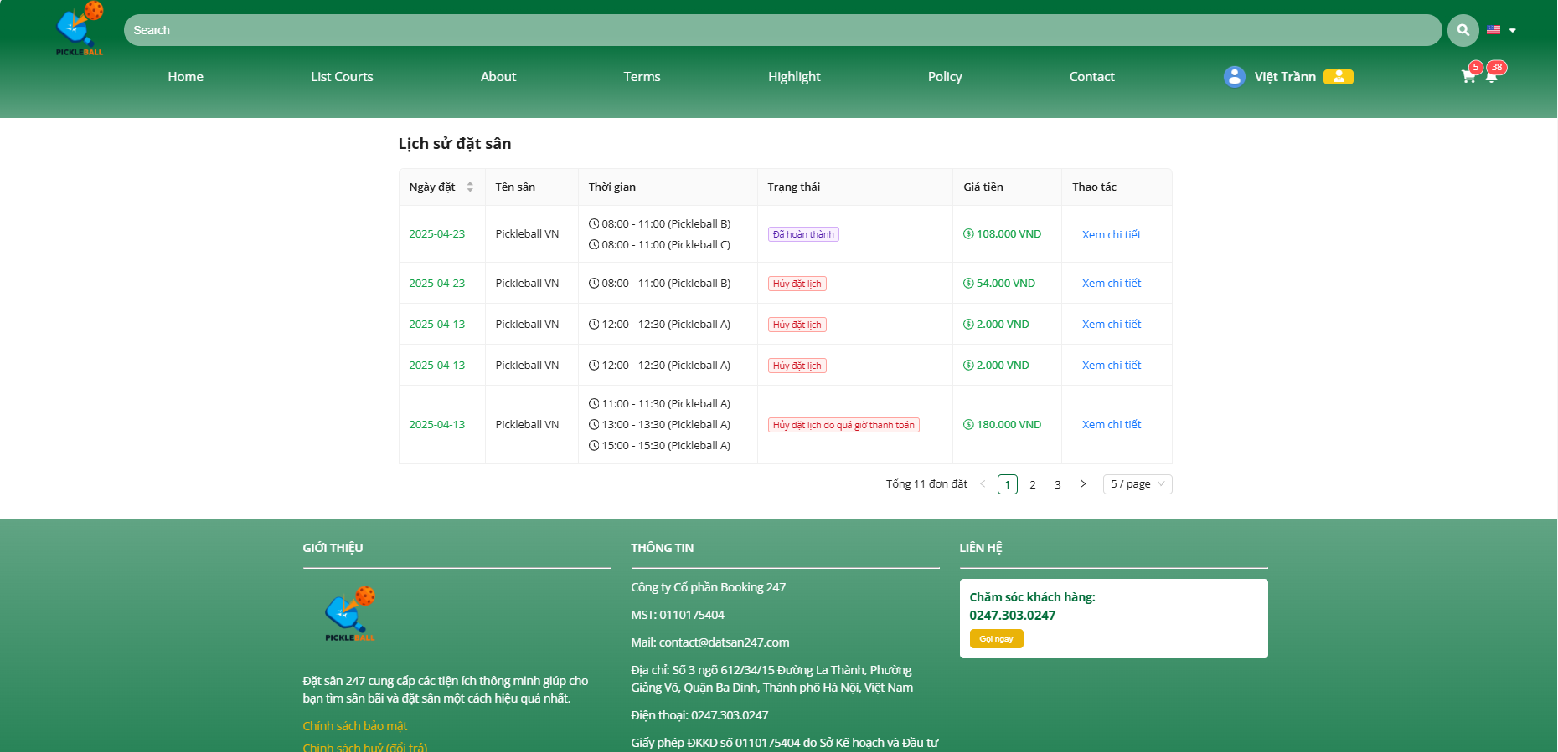

**Step 2:** Click on the “Lịch sử đặt hàng” button

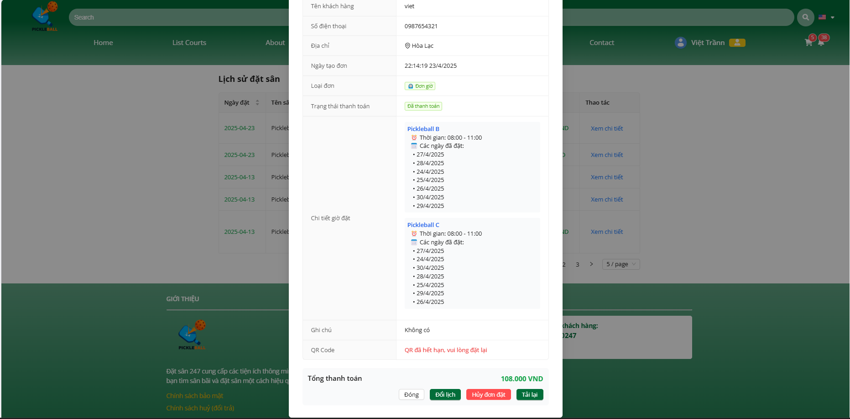

**Step 3:** Click on the “Xem chi tiết” button

### 3.3.4 Notification

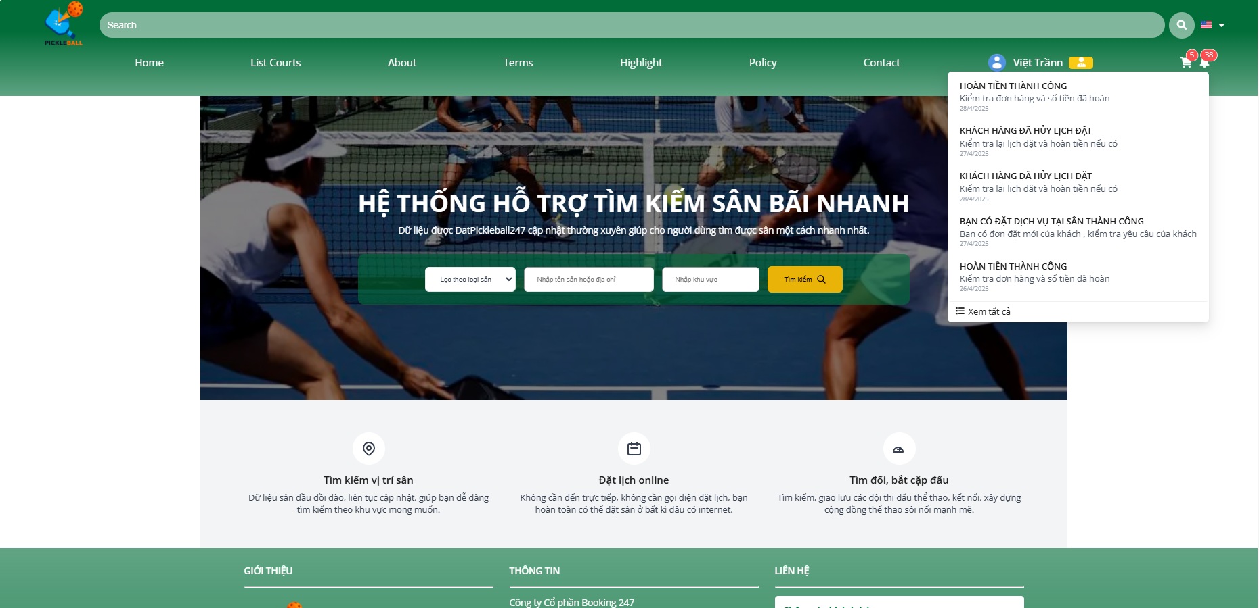

**Step 1:** Click on the “Notification” button

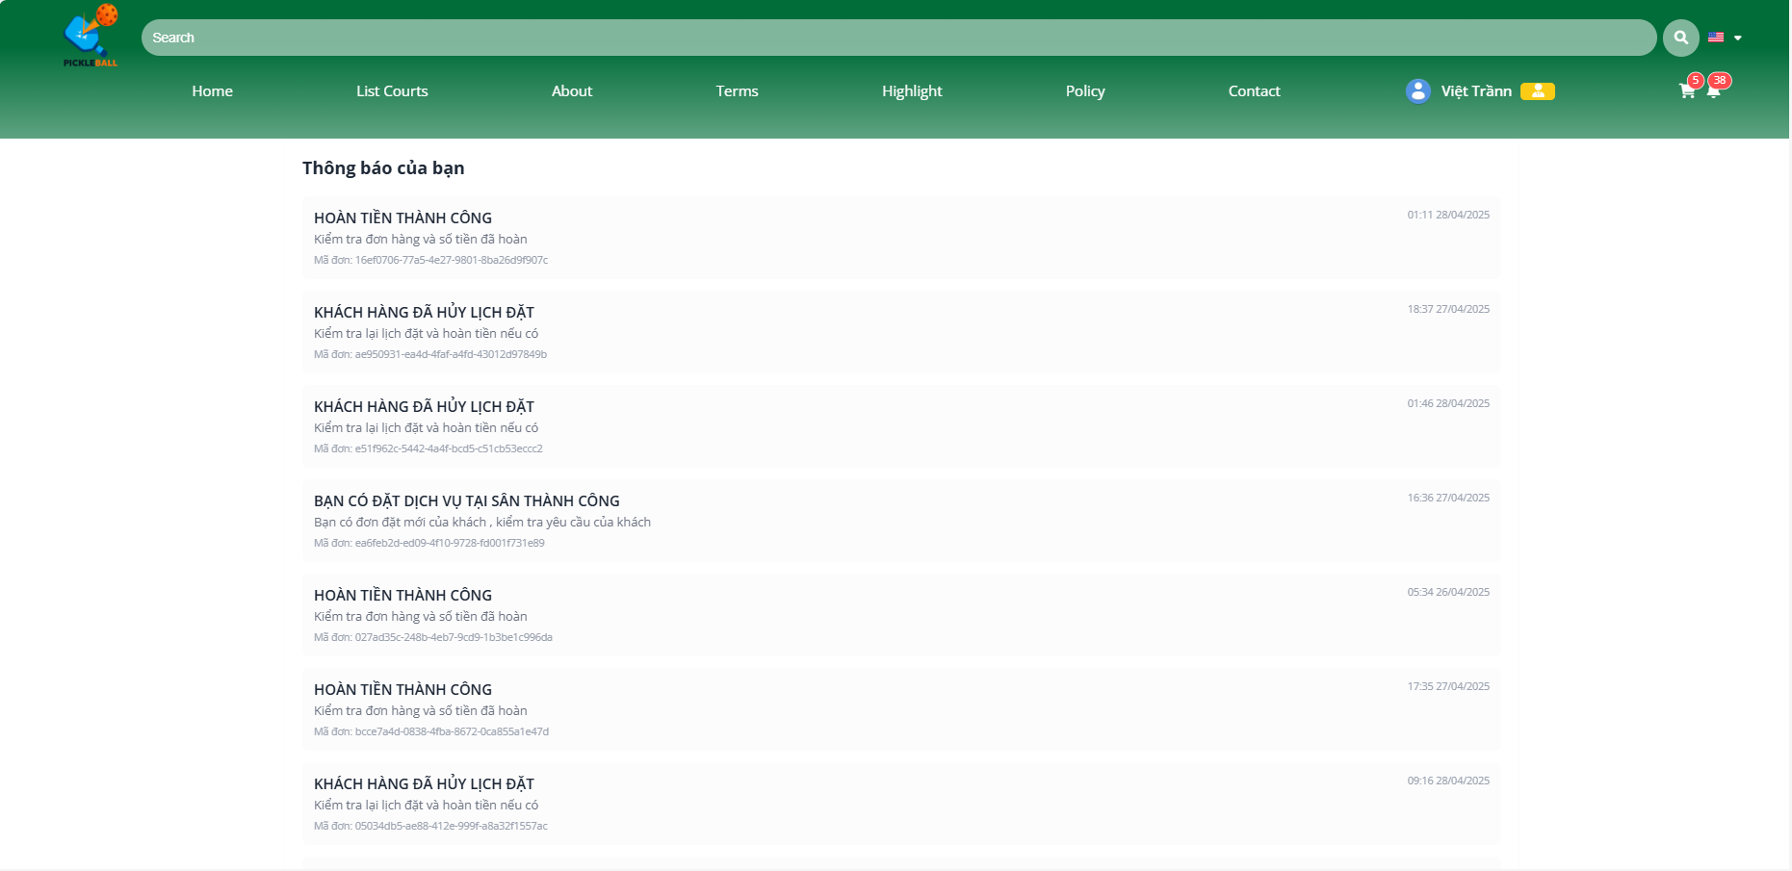

**Step 2:** Click on the “Xem tất cả” button

### 3.4 Workflow Booking

### 

### 

### 3.4.1 Booking Daily

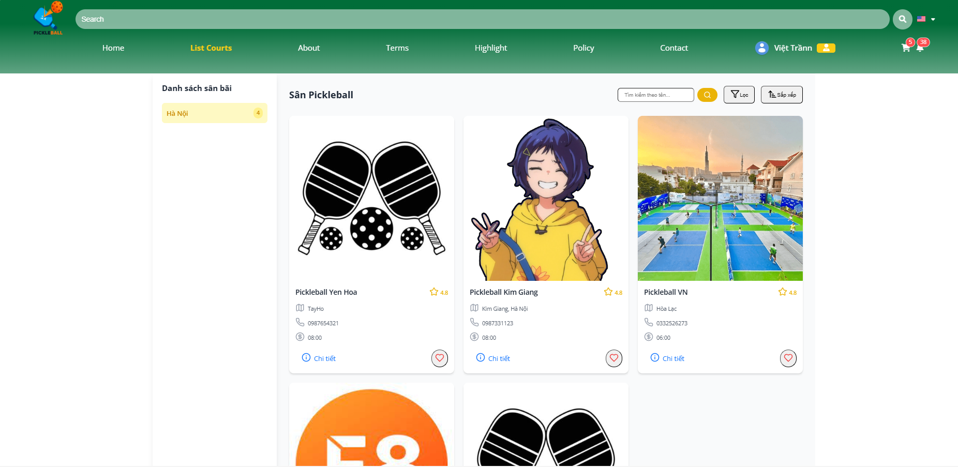

**Step 1:** Click on the “List Courts” button

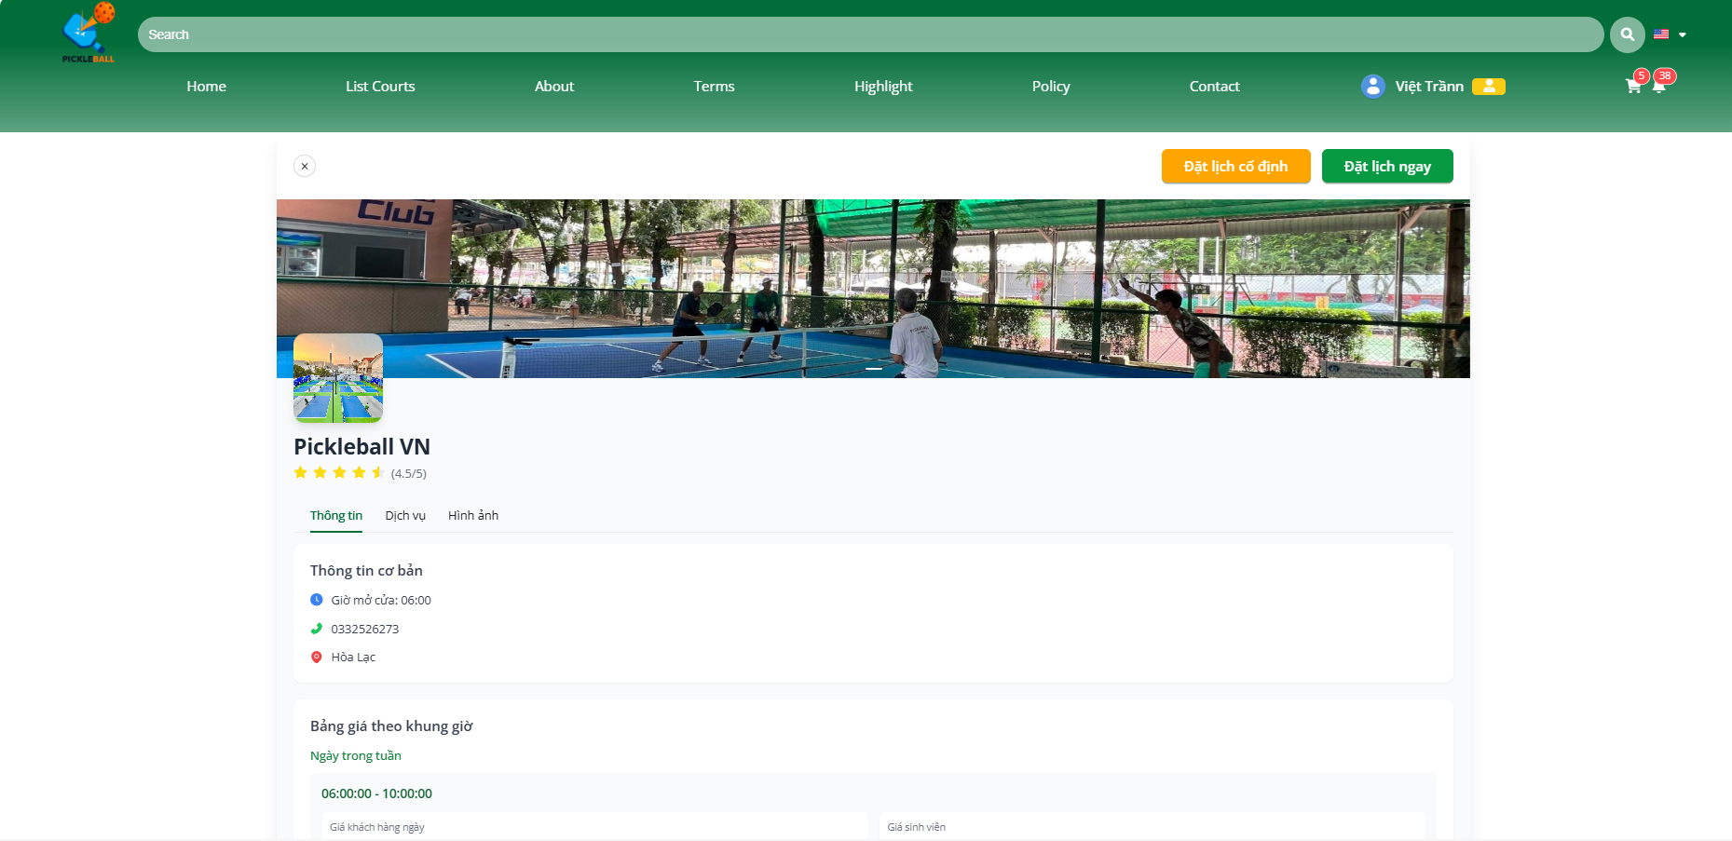

**Step 2:** Click on the “Chi tiết” button

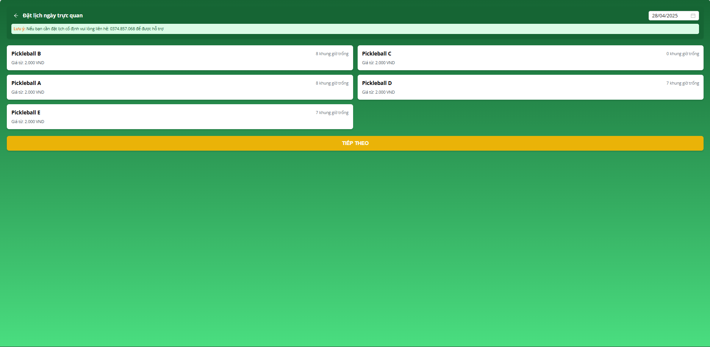

**Step 3:** Click on the “Đặt lịch ngày” button

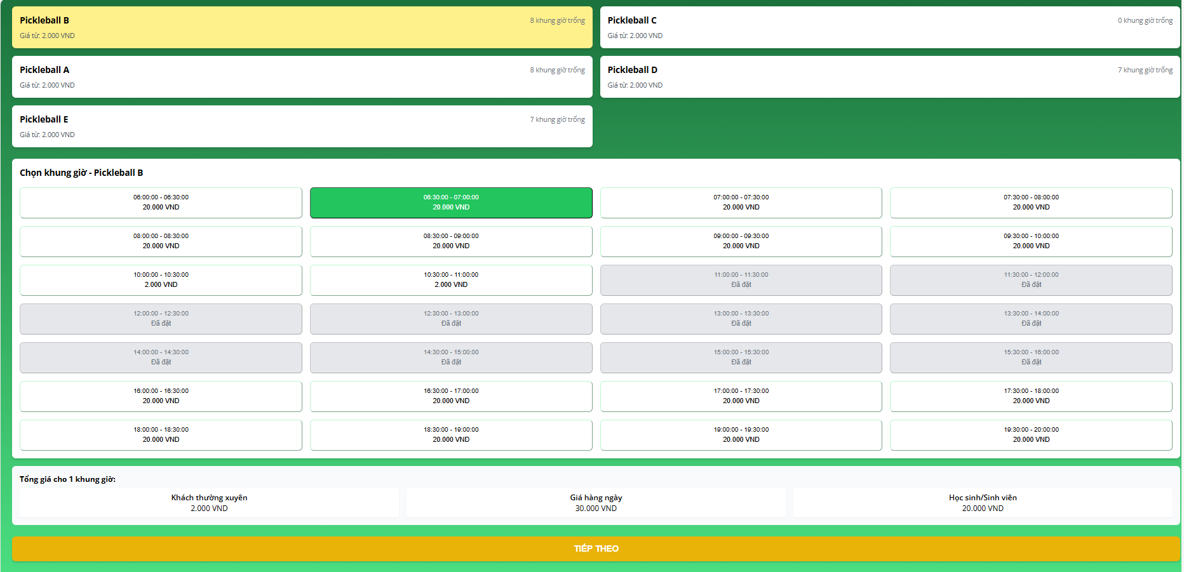

**Step 4:** Choose court and slottime want booking

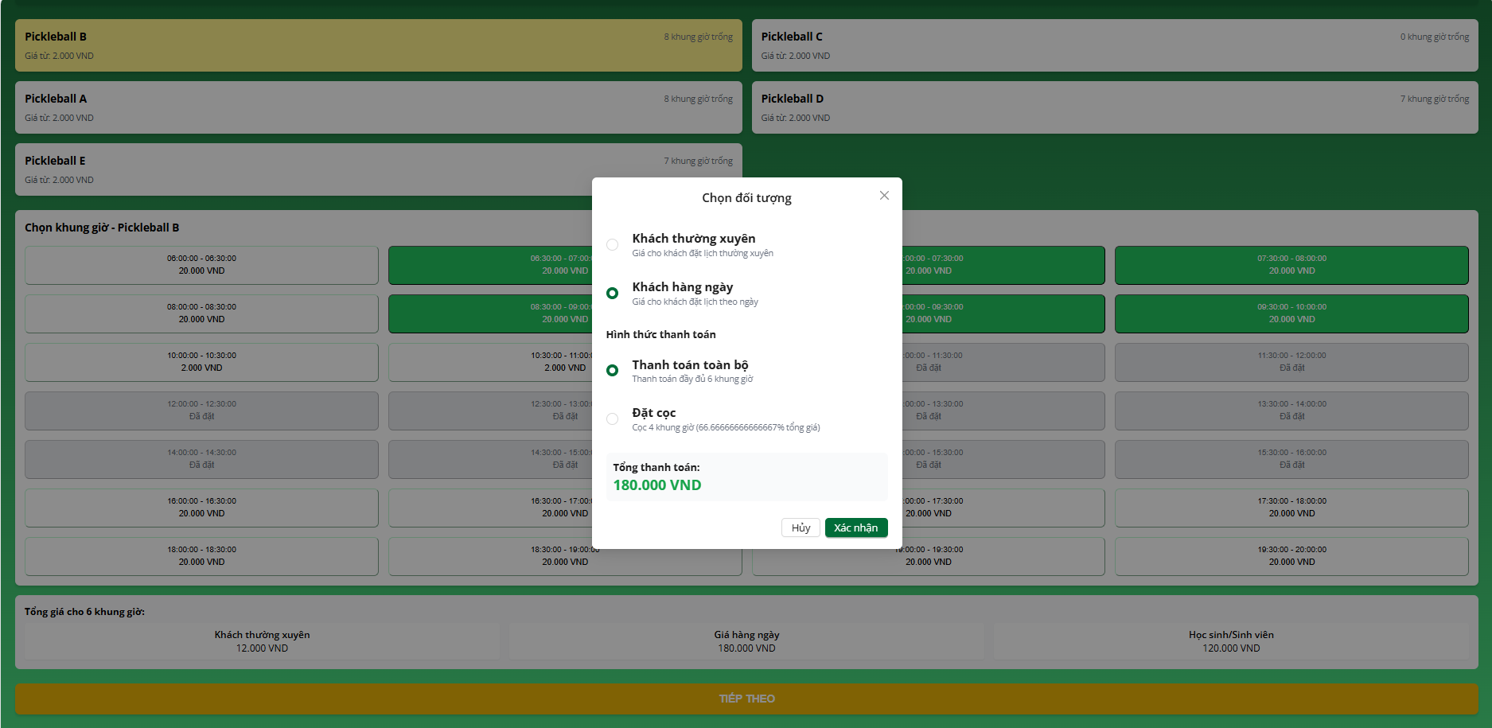

**Step 5:** Choose “ Thanh toán toàn bộ” or “Đặt cọc”

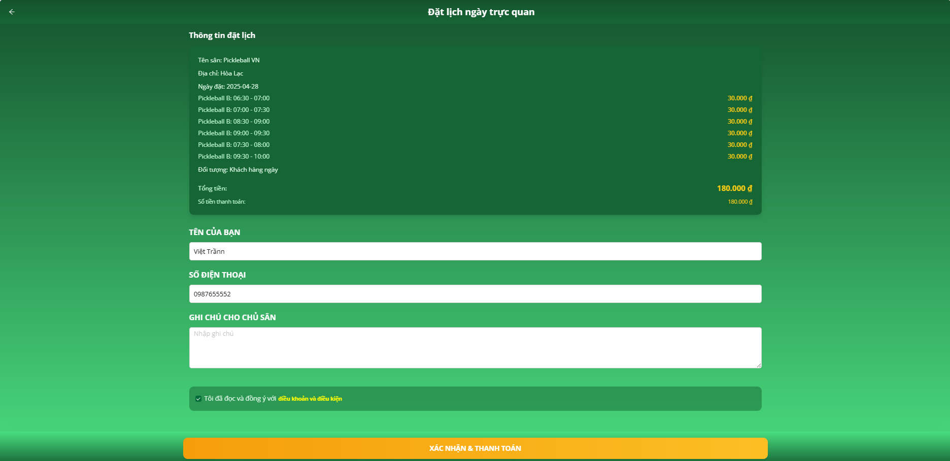

**Step 6:** Input Name, Phone Number or note and agree to terms

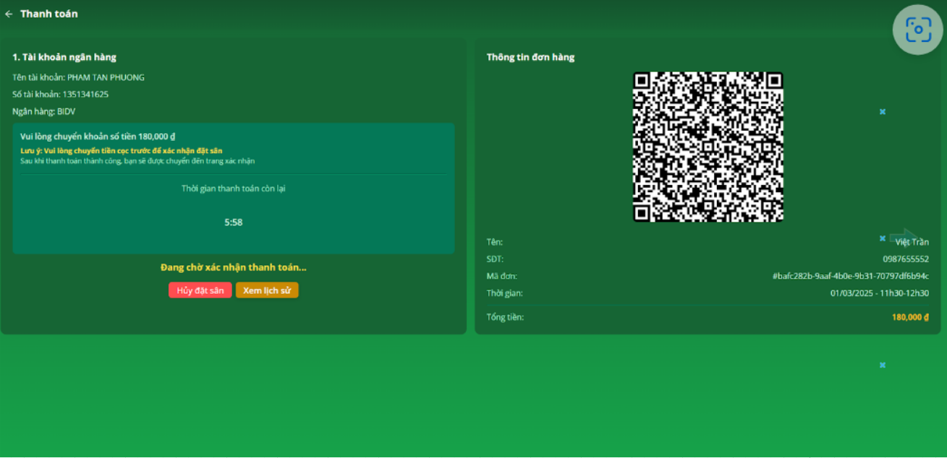

**Step 7:** Scan QR code and complete payment or deposit

### 3.4.2 Booking Regular



**Step 1:** Click on the “List Courts” button



**Step 2:** Click on the “Chi tiết” button

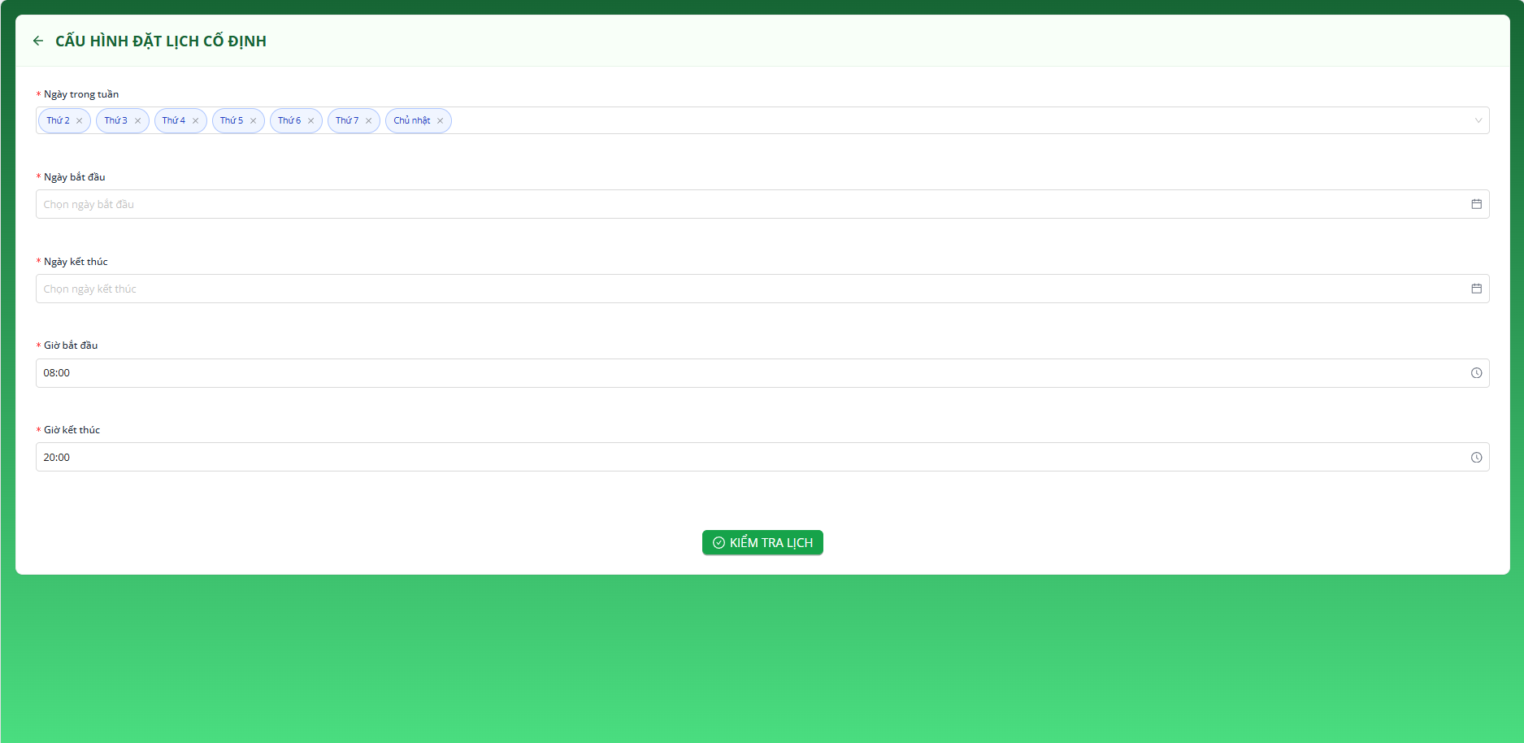

**Step 3:** Click on the “Đặt lịch cố định” button

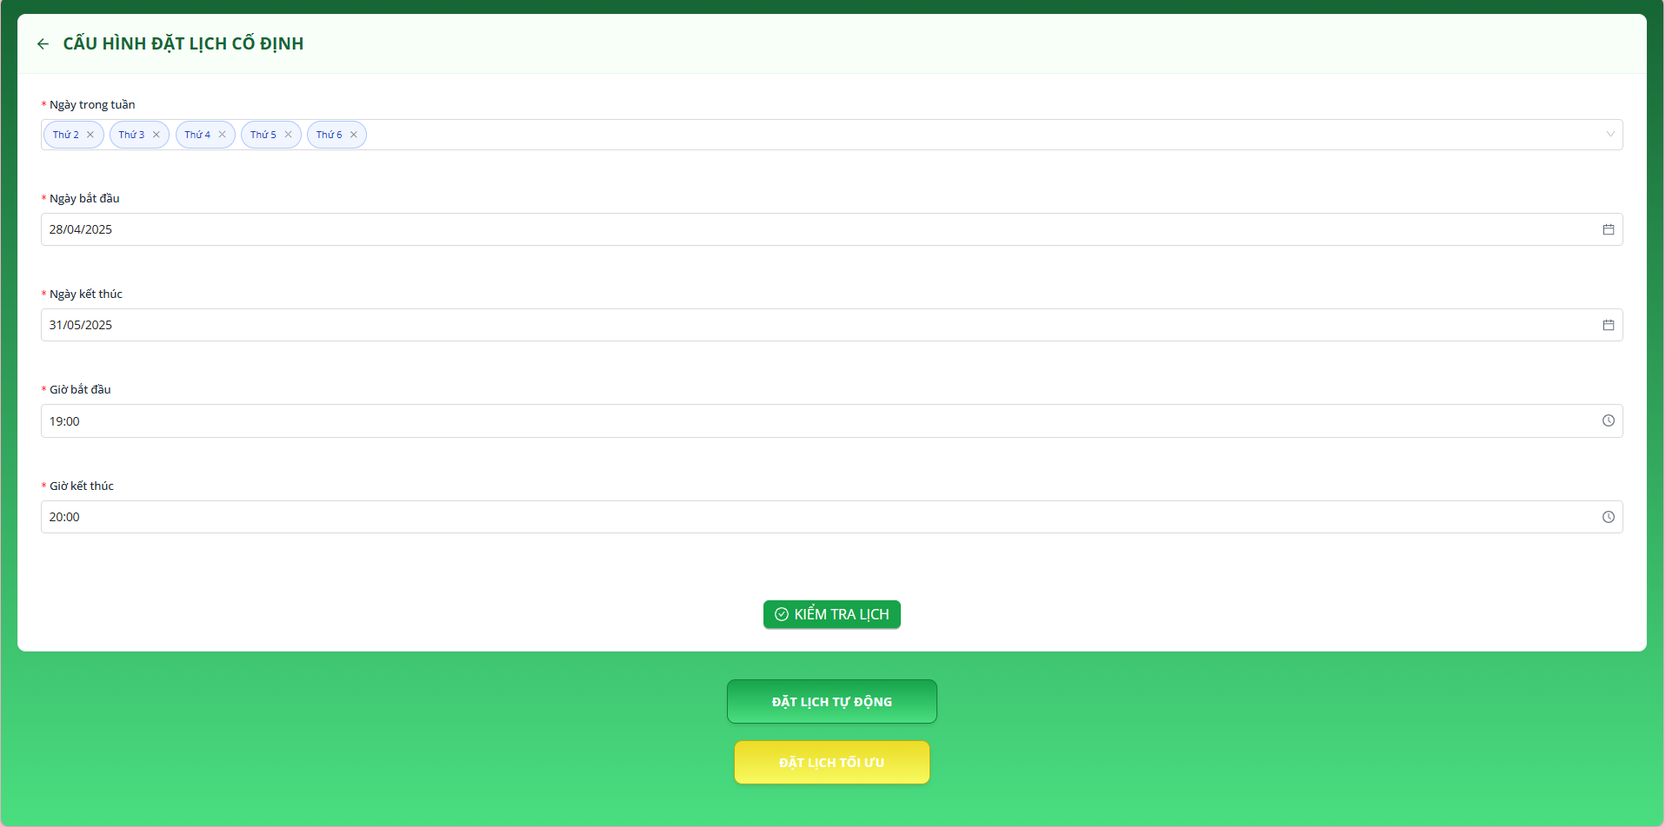

**Step 4:** Input information booking

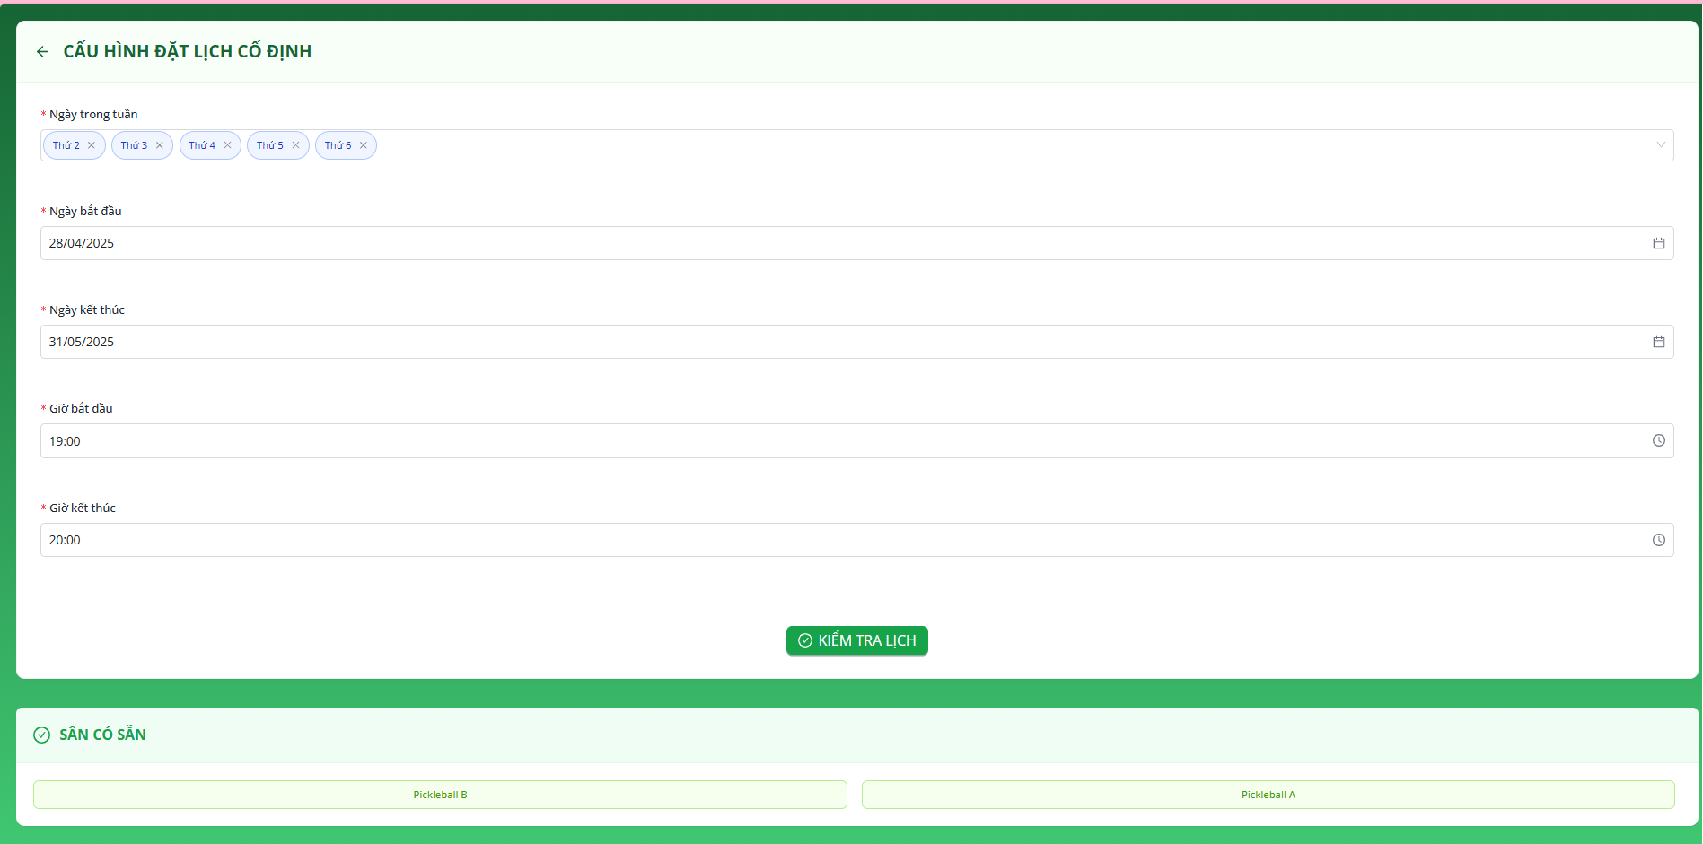

**Step 5:** Click on the “Đặt lịch Đặt lịch Tự Động” button

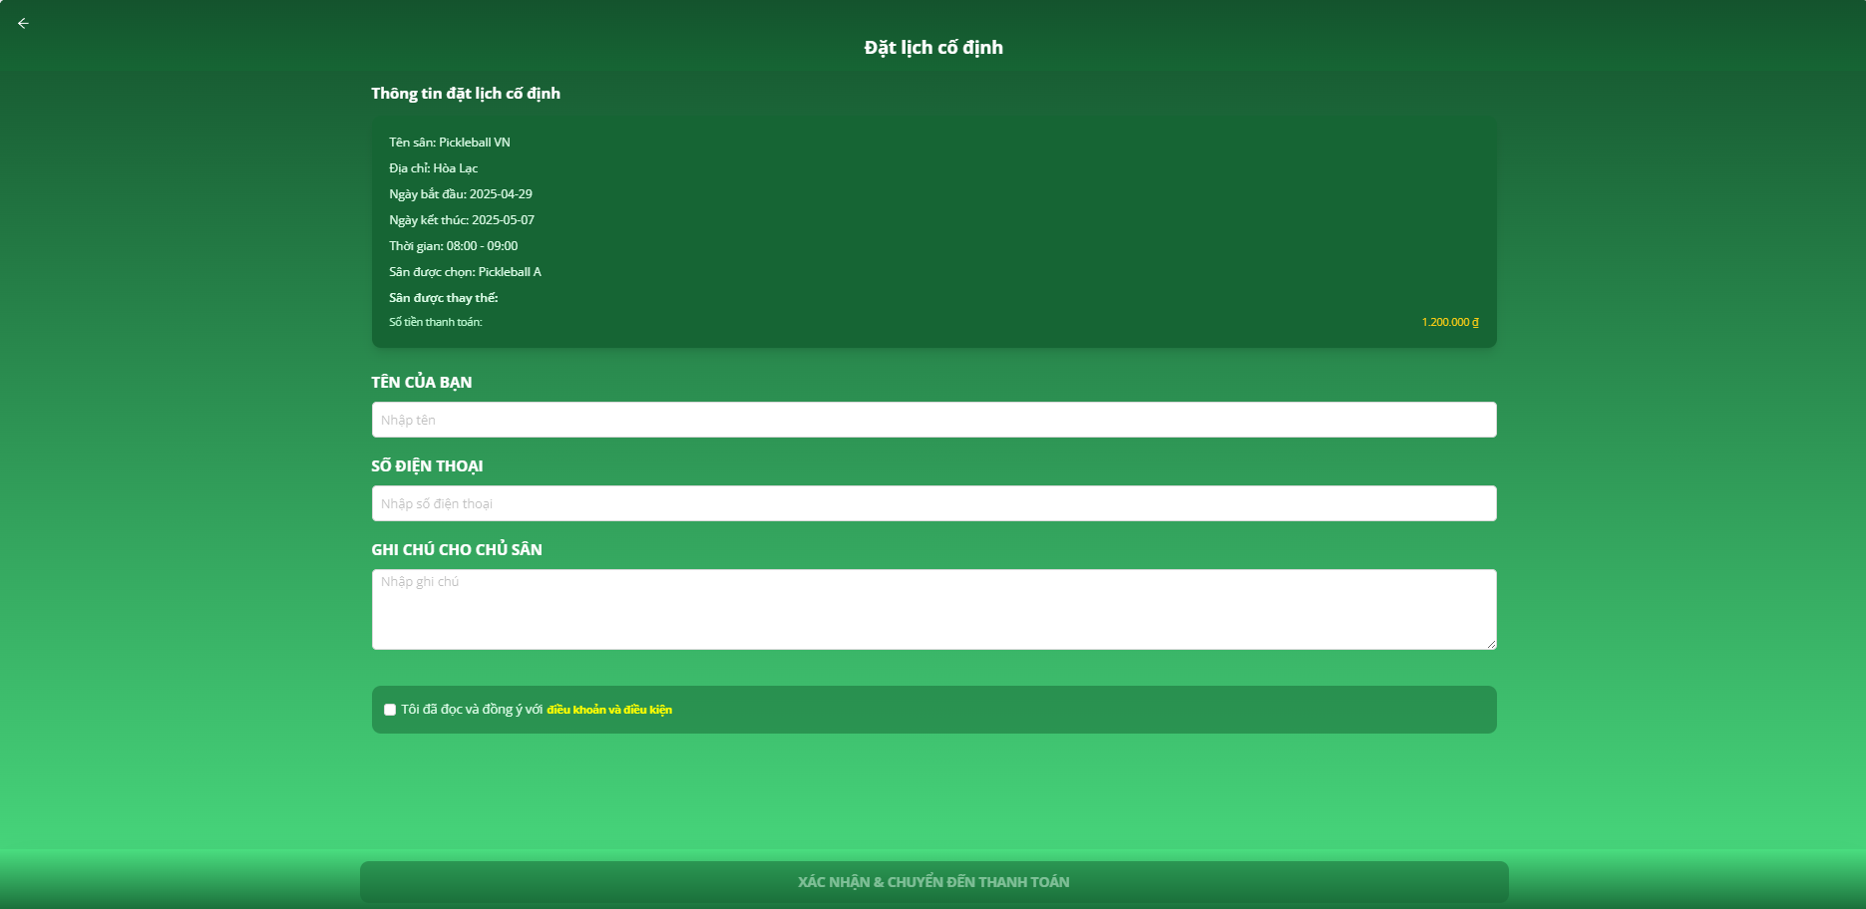

**Step 6:** Click on the “Xác nhận đặt lịch” button

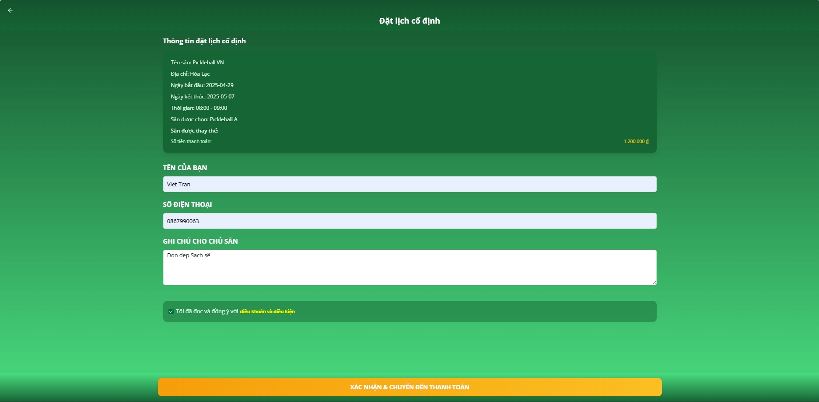

**Step 7:** Input Name, Phone Number or note and agree to terms

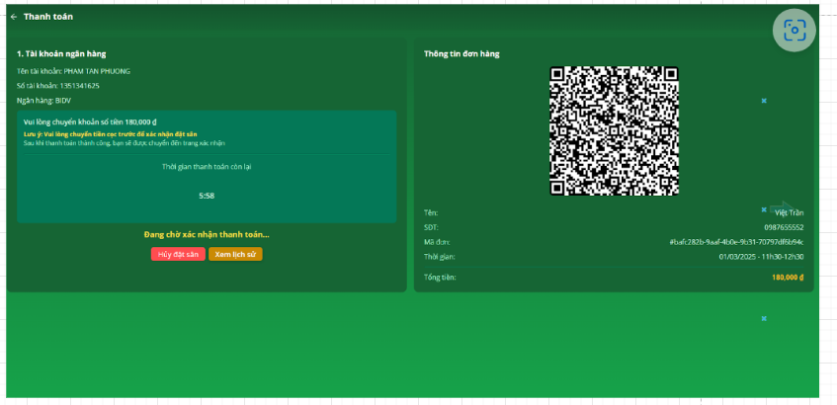

**Step 8:** Scan QR code and complete payment or deposit

### 

### 

### 3.4.3 Cancel Booking



**Step 1:** Click on the “Profile” button



**Step 2:** Click on the “Lịch sử đặt hàng” button



**Step 3:** Click on the “Xem chi tiết” button

**Step 4:** Click on the “Hủy đặt lịch” button

### 3.4.4 Change Booking



**Step 1:** Click on the “Profile” button



**Step 2:** Click on the “Lịch sử đặt hàng” button



**Step 3:** Click on the “Xem chi tiết” button

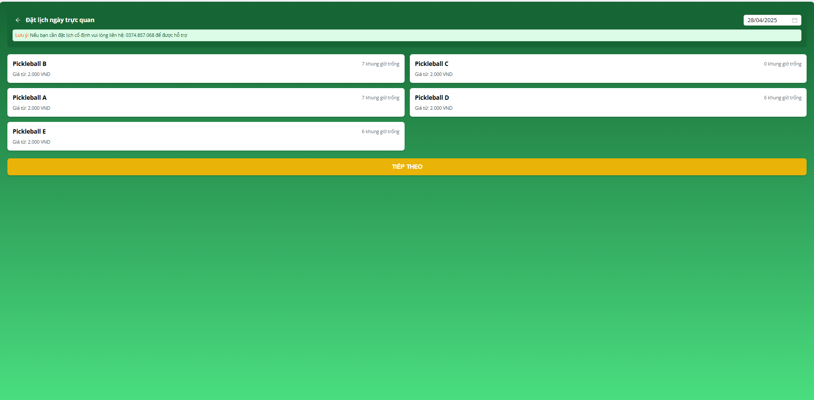

**Step 4:** Click on the “Đổi lịch” button

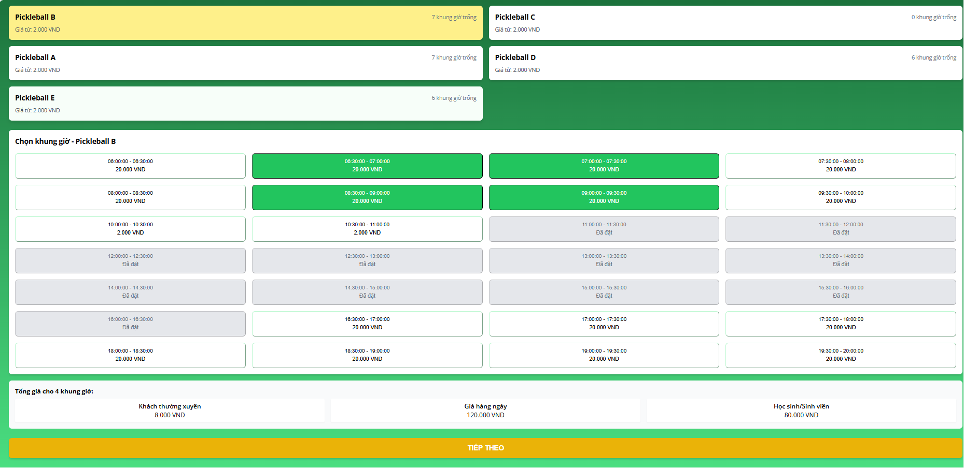

**Step 5:** Select the course and time you want to change

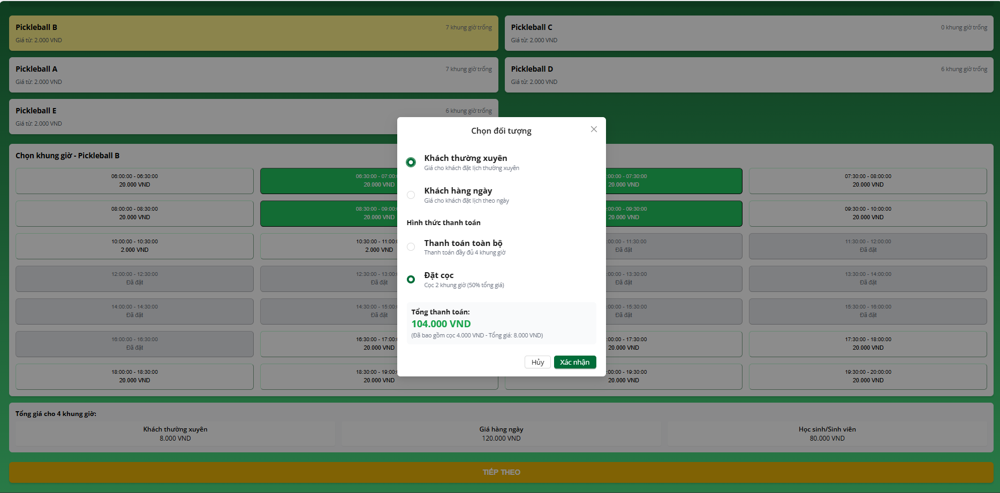

**Step 5:** Choose “ Thanh toán toàn bộ” or “Đặt cọc”

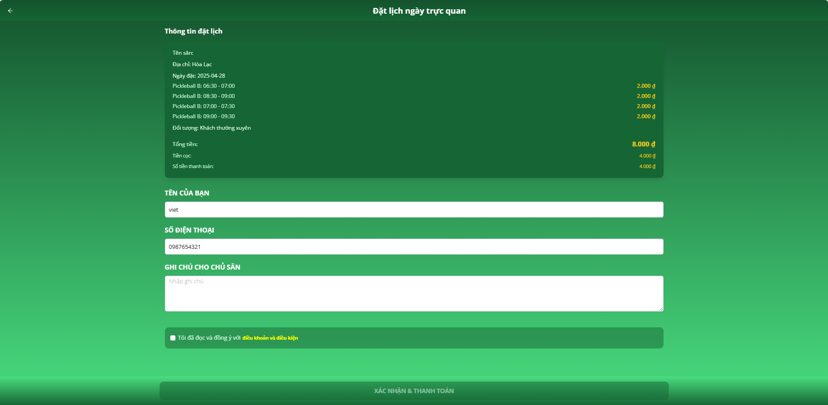

**Step 6:** Input Name, Phone Number or note and agree to terms

**Step 7:** Scan QR code and complete payment or deposit

### 3.5 Workflow Report

### 

### 3.5.1 Statistics Dashboard

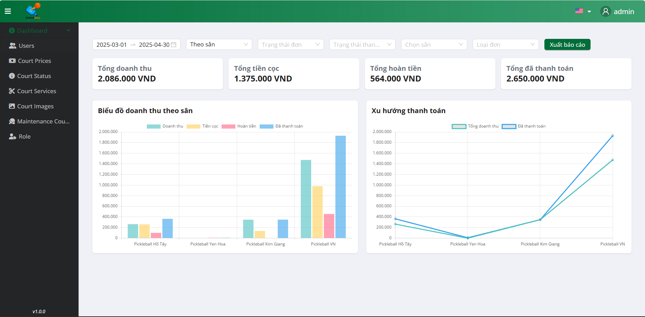

**Step 1:** Select StartDate - EndDate

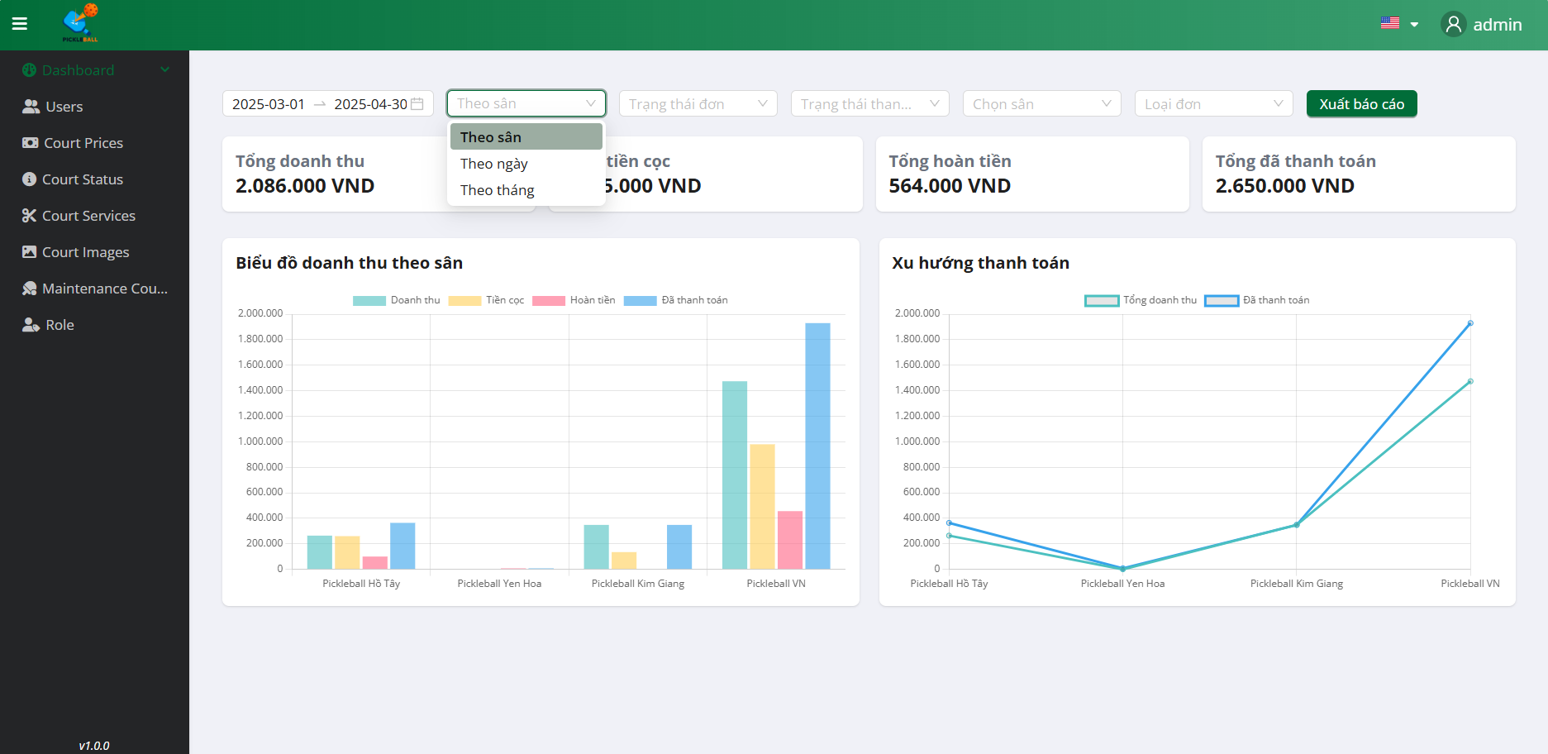

**Step 2:** Select Filter “ Theo sân”

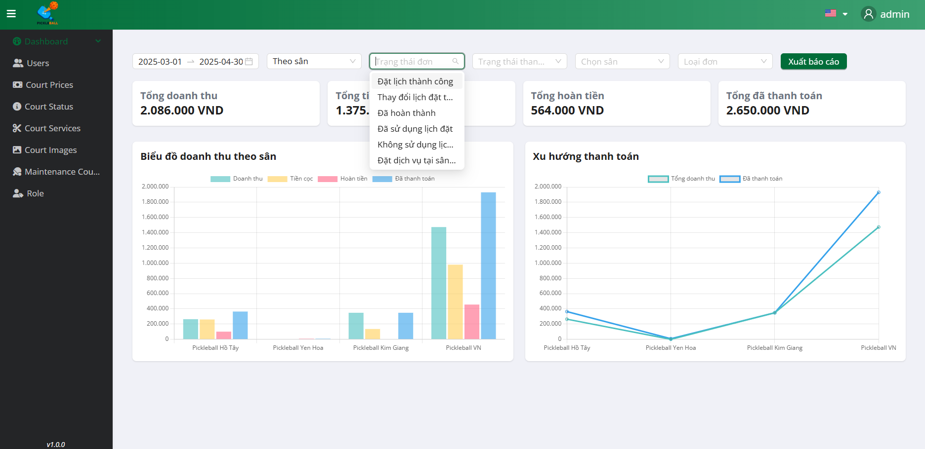

**Step 2:** Select Filter “Trạng thái đơn”, Choose status you want

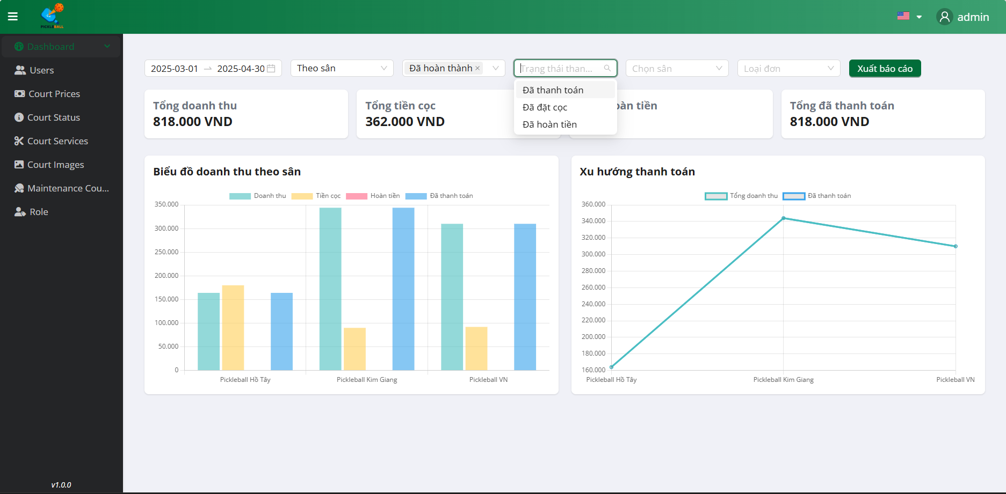

**Step 3:** Select Filter “Trạng thái thanh toán”, Choose status you want

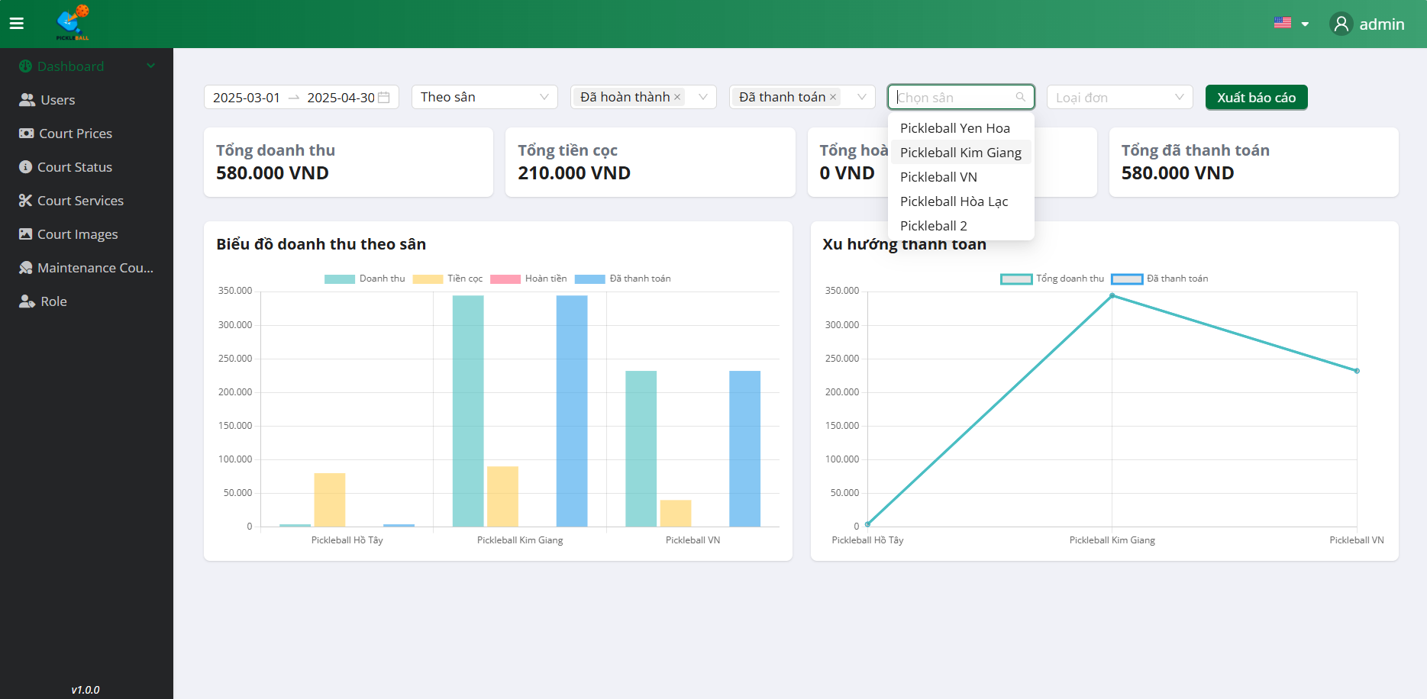

**Step 4:** Select Filter “Chọn sân”, Choose court you want

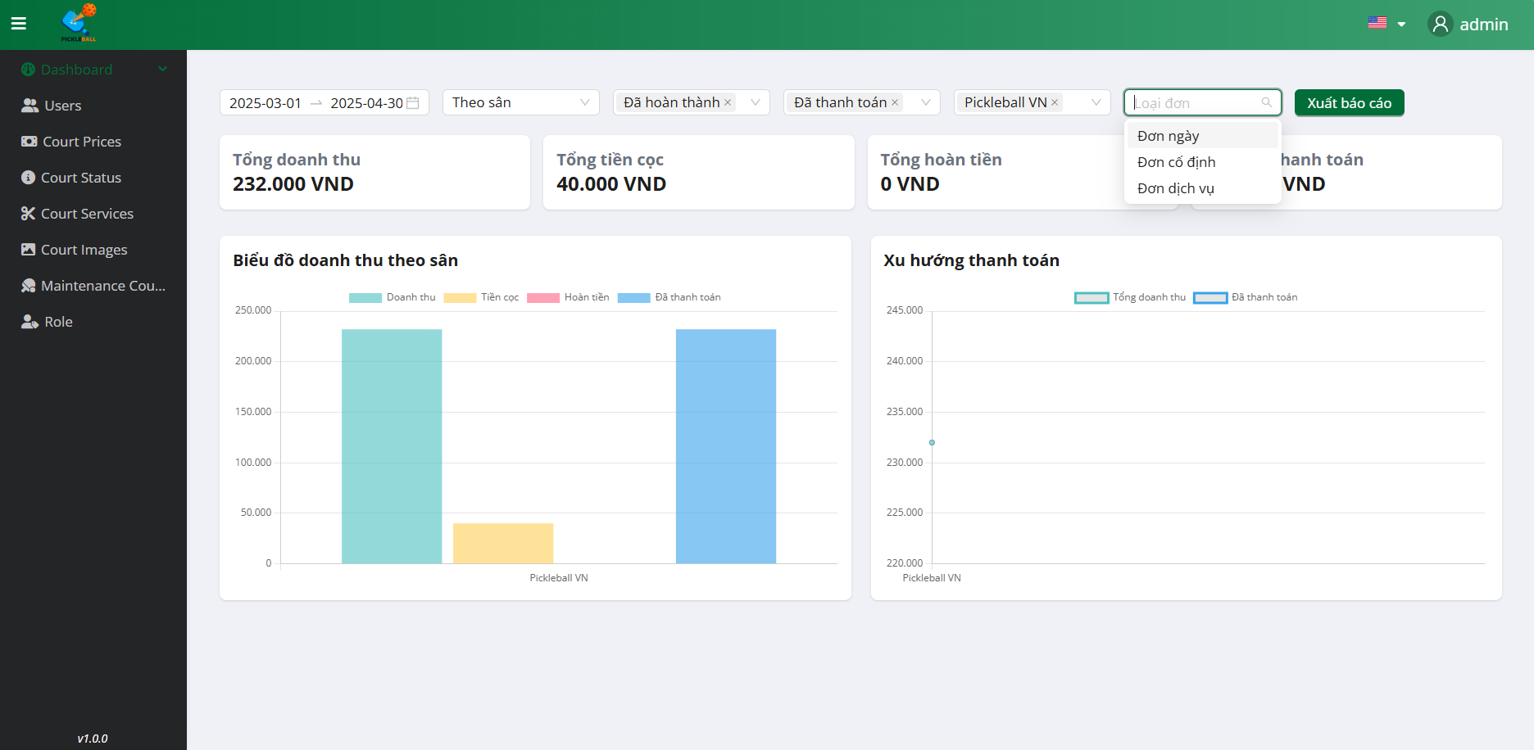

**Step 4:** Select Filter “Loại đơn”, Choose type Order you want

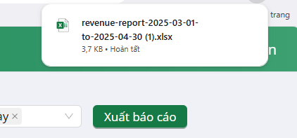

**Step 5:** Click on the”Xuất báo cáo”

### 3.5.2 Analysis Dashboard

### 

**Step 1:** Click on the”Analysis”

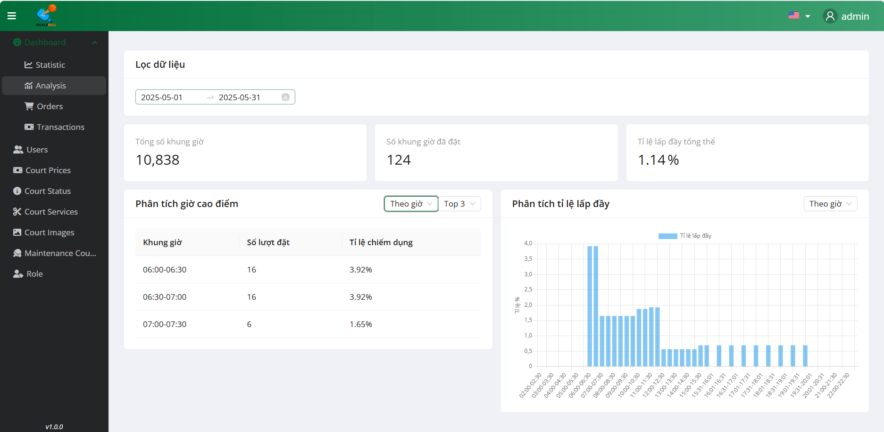

**Step 2:** Select StartDate - EndDate

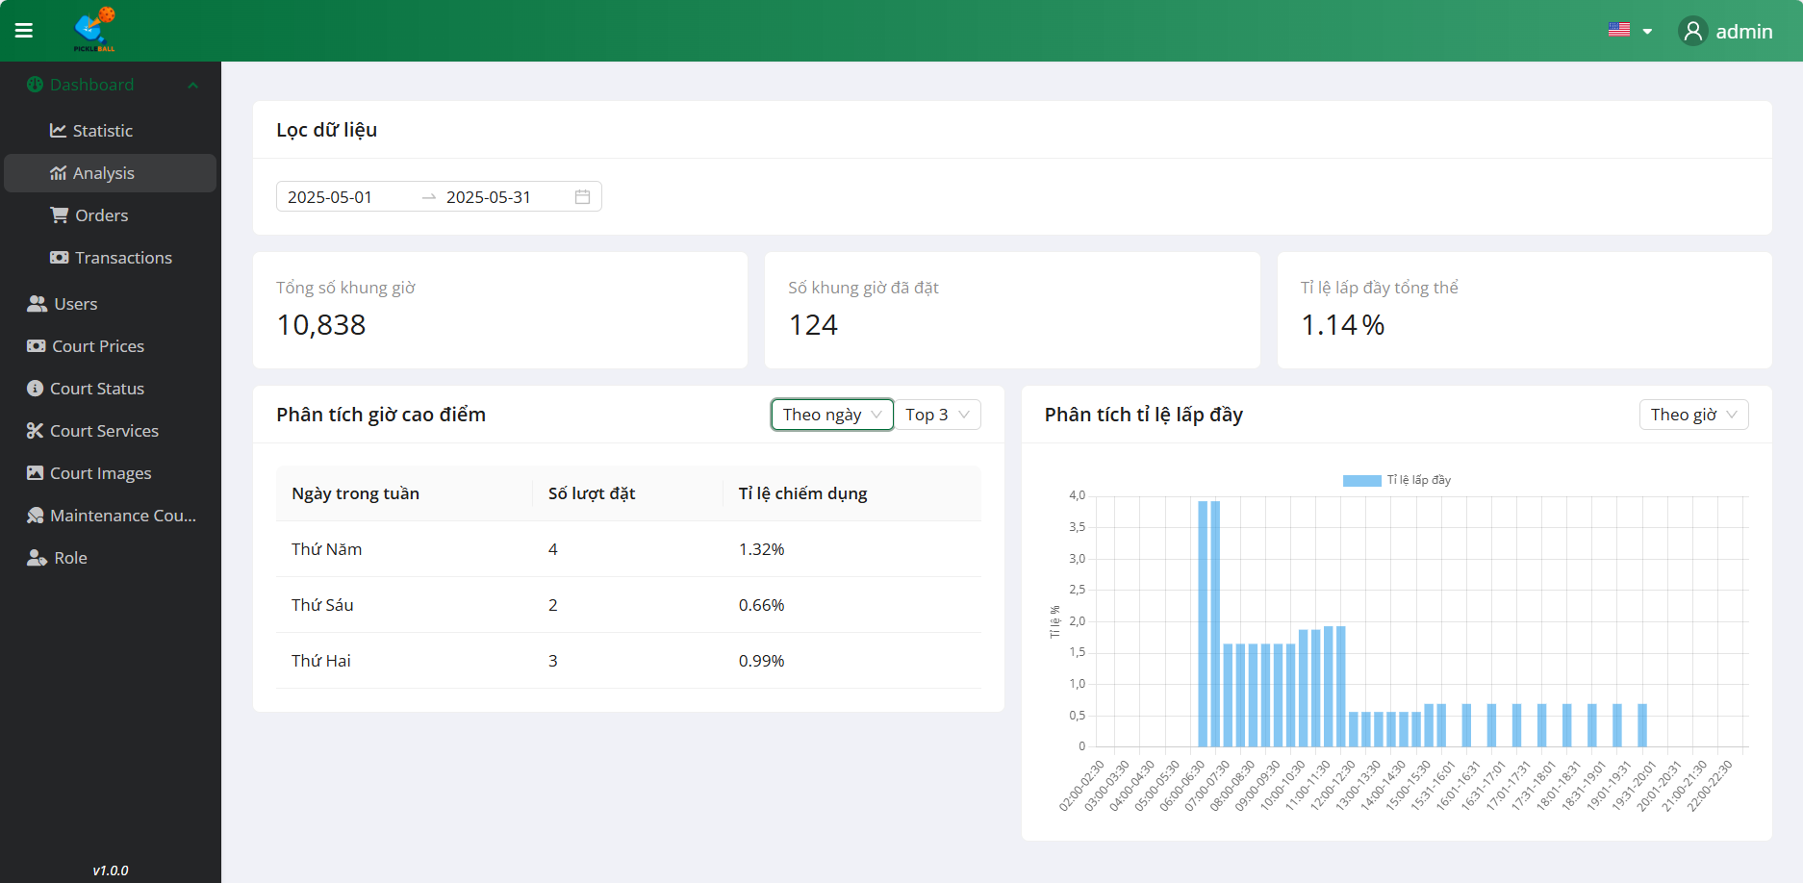

**Step 4:** Select Filter “Theo ngày”

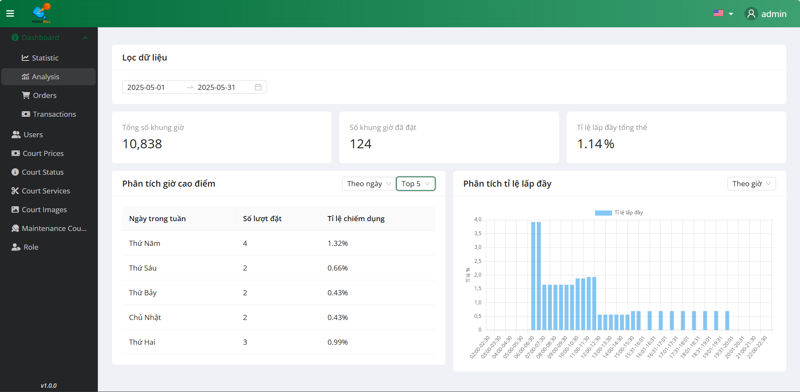

**Step 5:** Select Filter “Top 10”

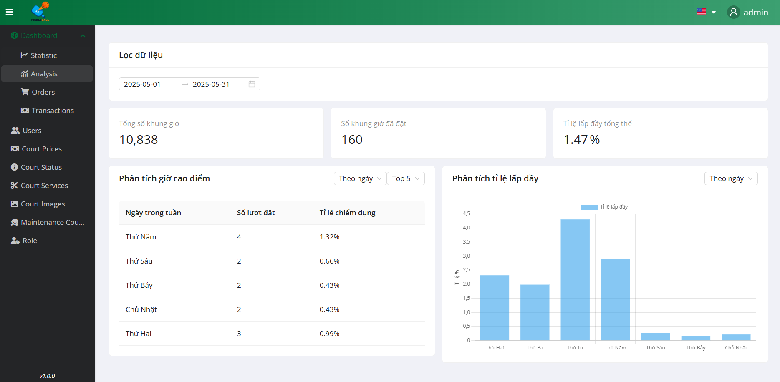

**Step 6:** Select Filter “Theo ngày”

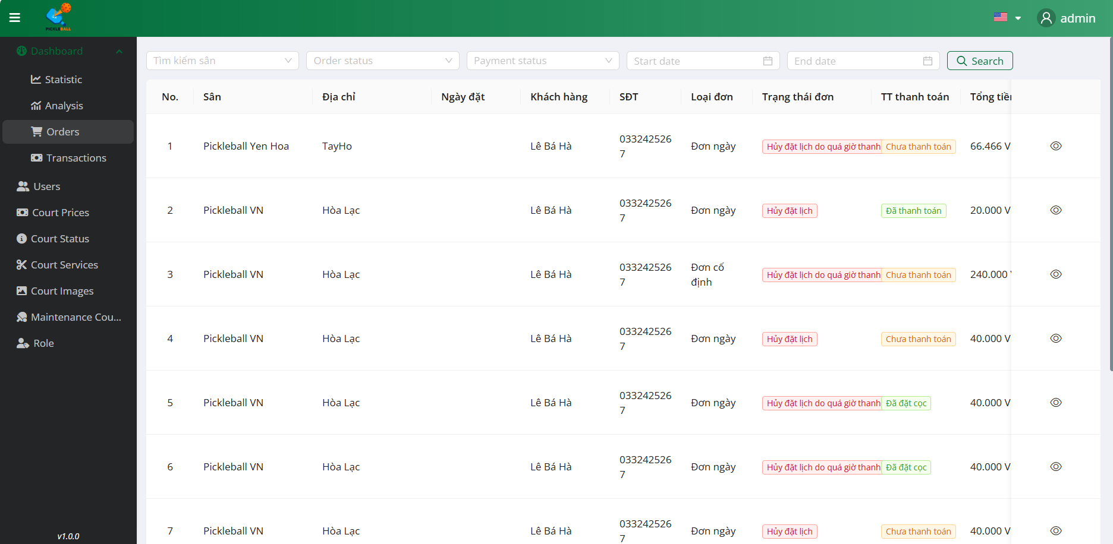

### 3.5.3 Order Dashboard

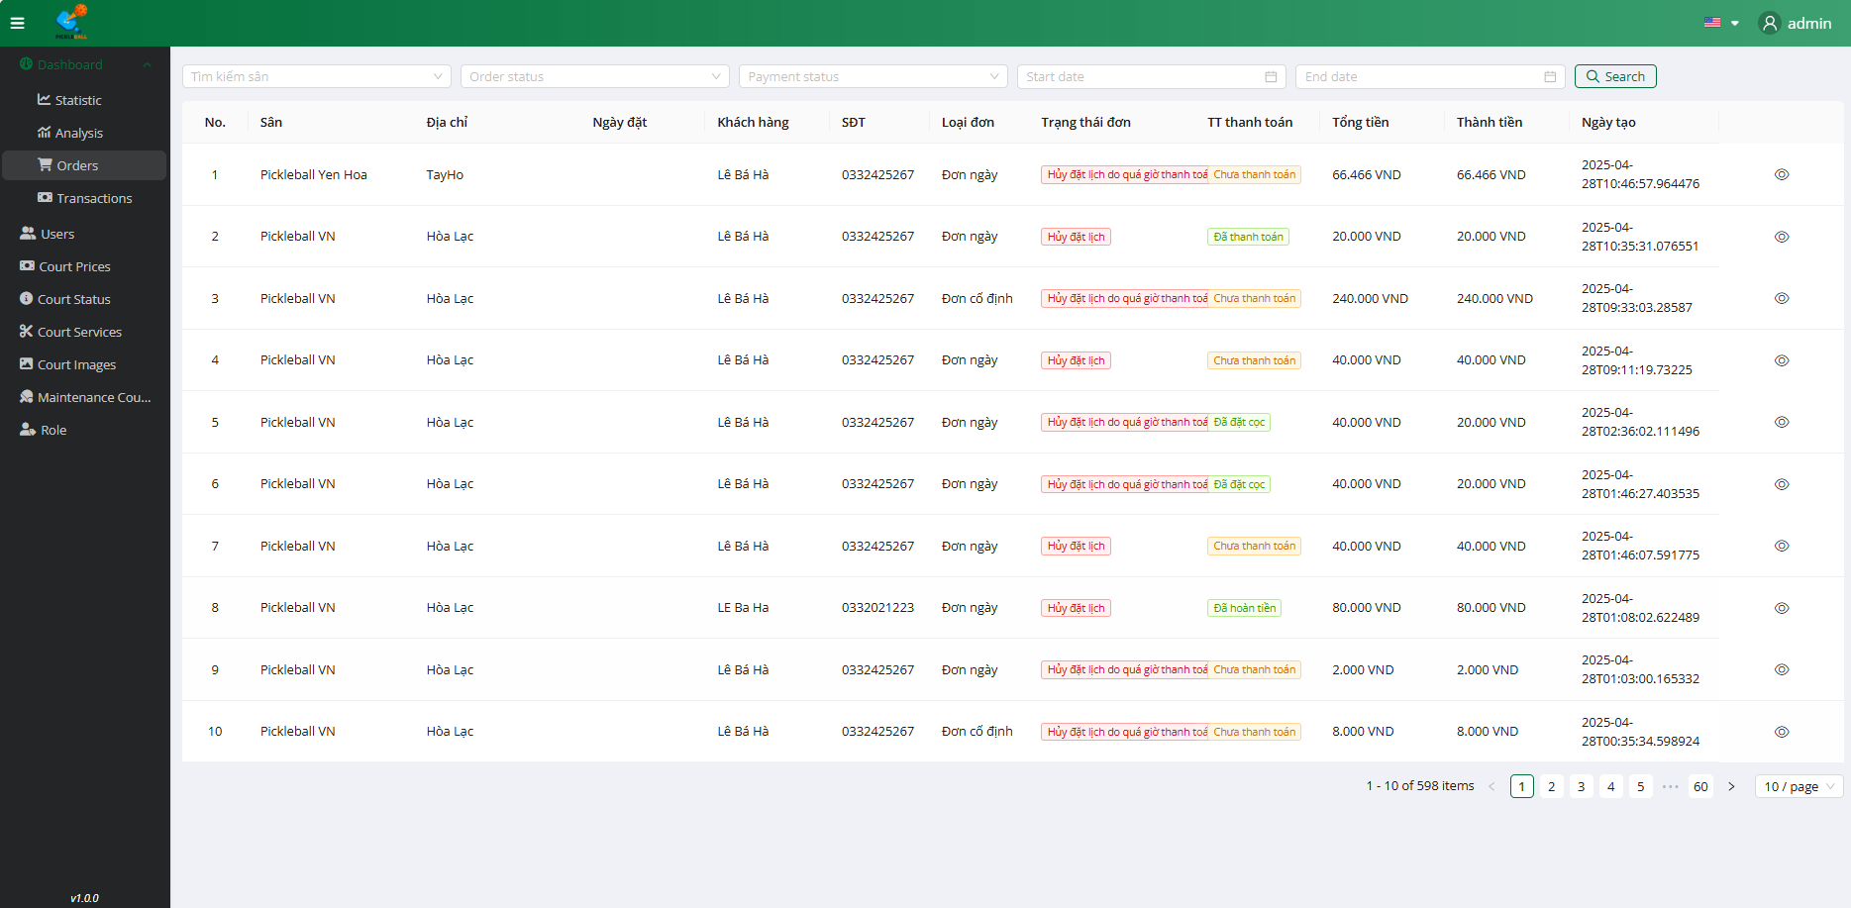

**Step 1:** Click on the ”Order” 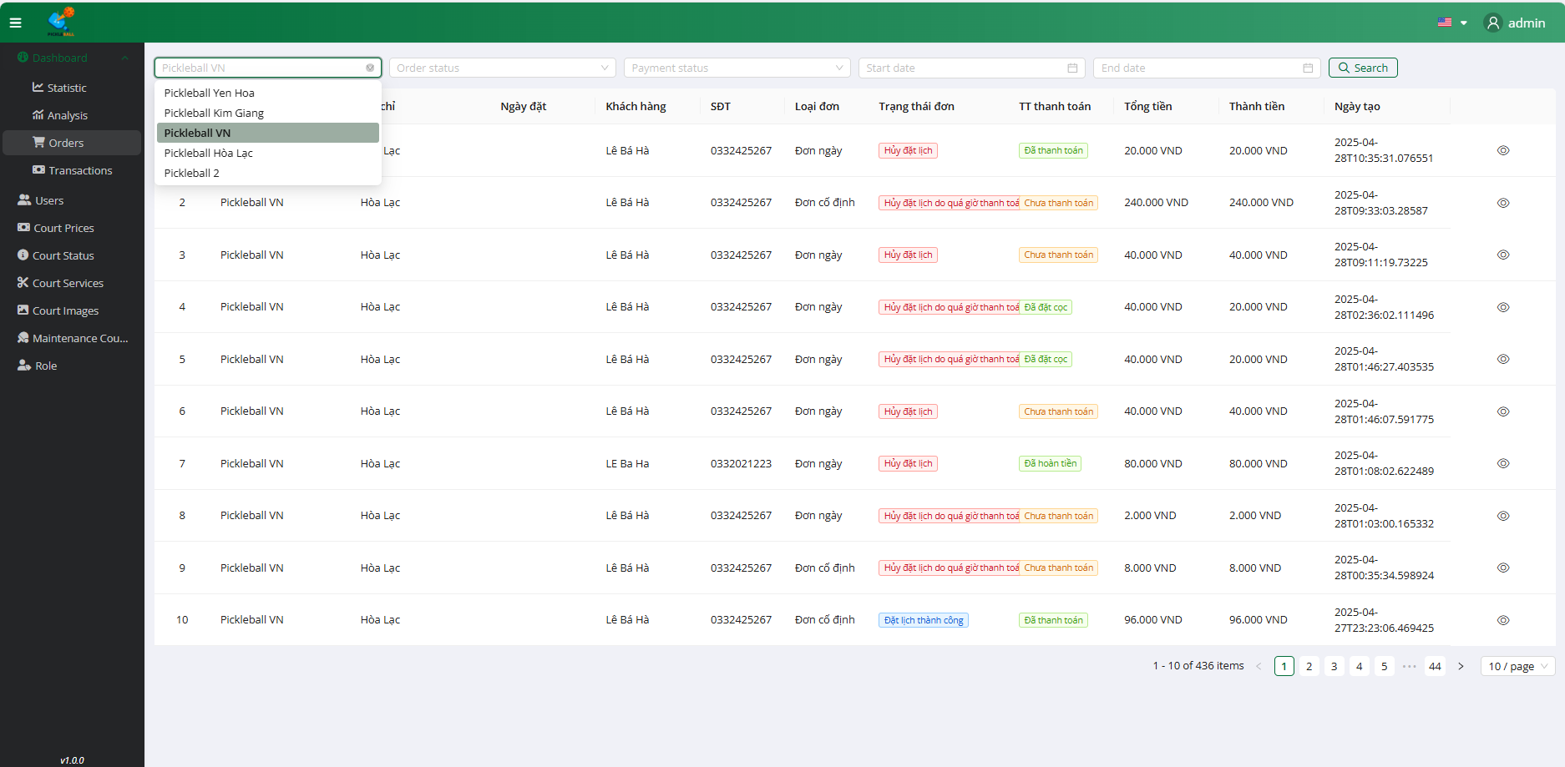

**Step 2:** Select Filter by Court

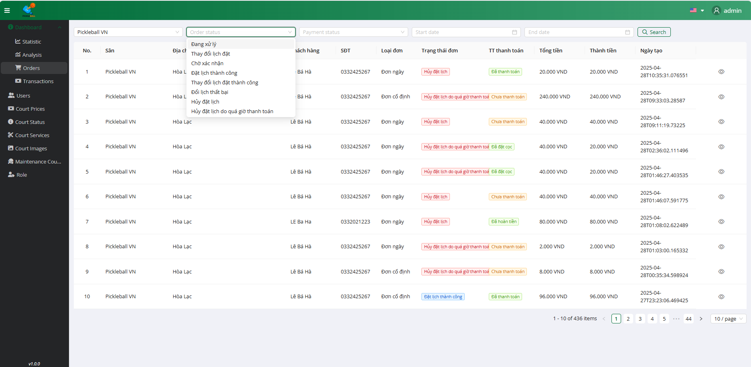

**Step 3:** Select Filter by Order Status

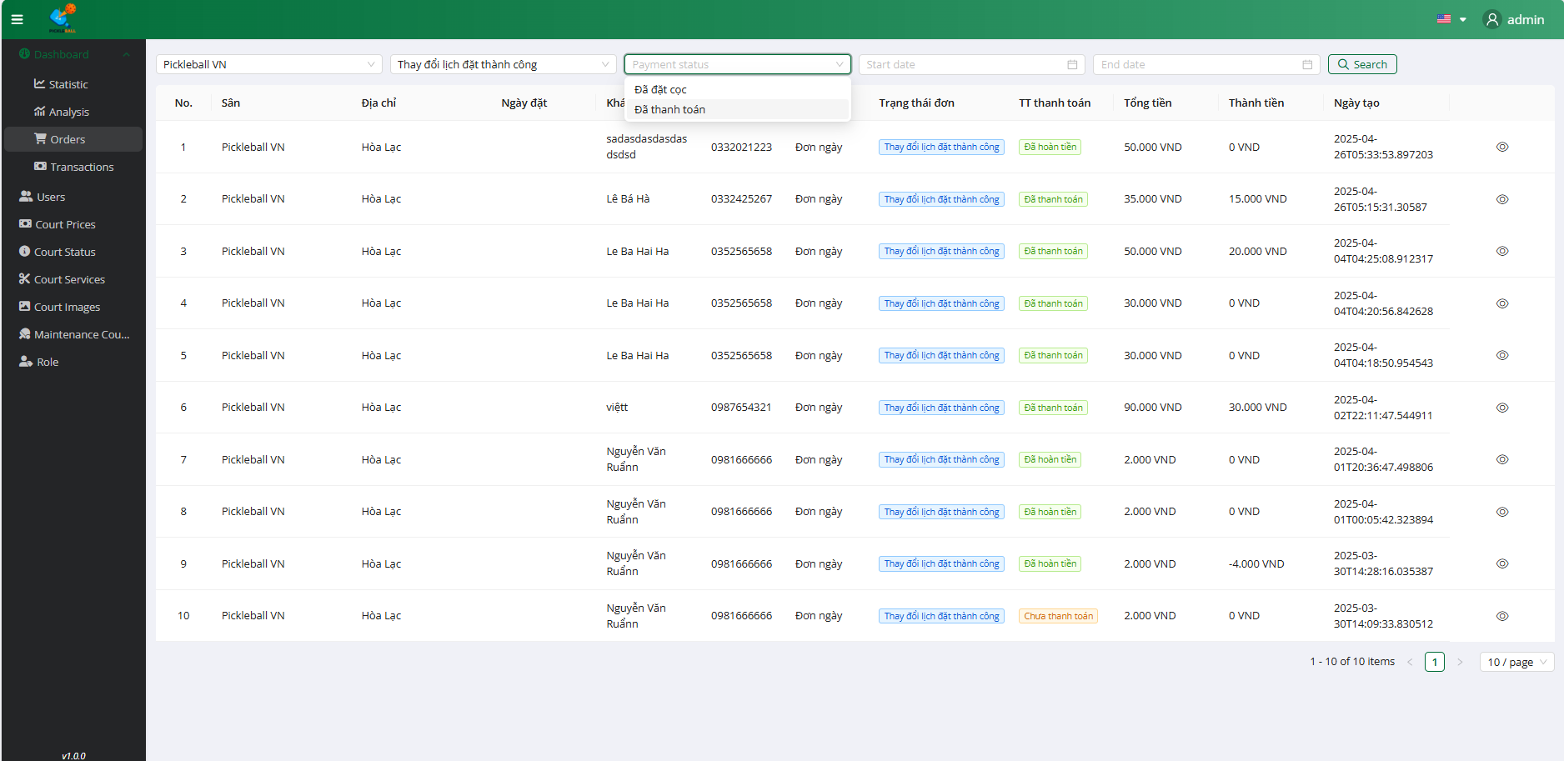

**Step 4:** Select Filter by Payment Status

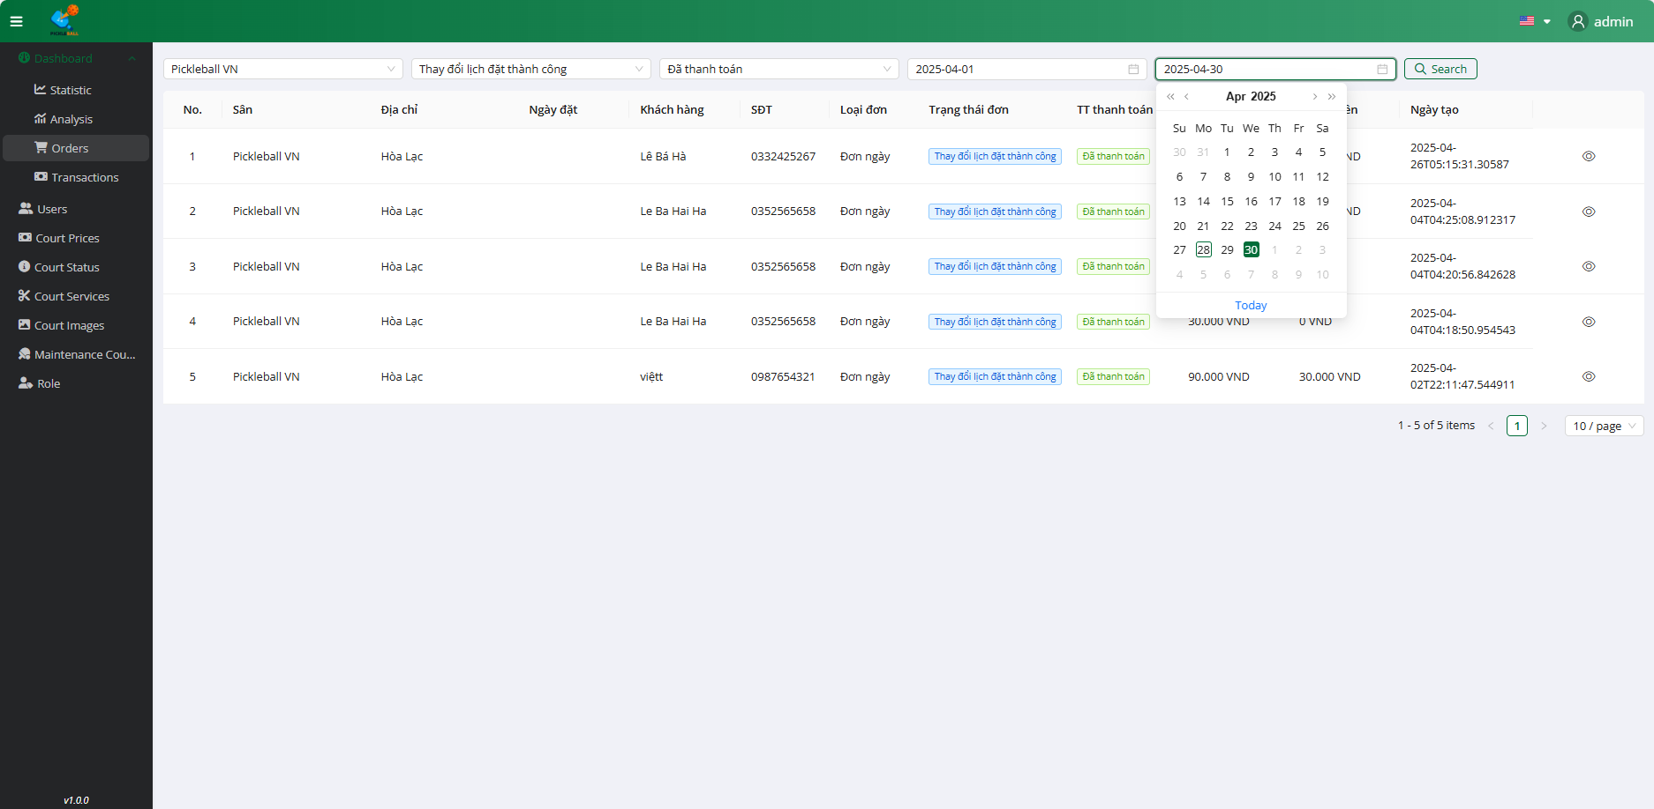

**Step 5:** Select StartDate - EndDate

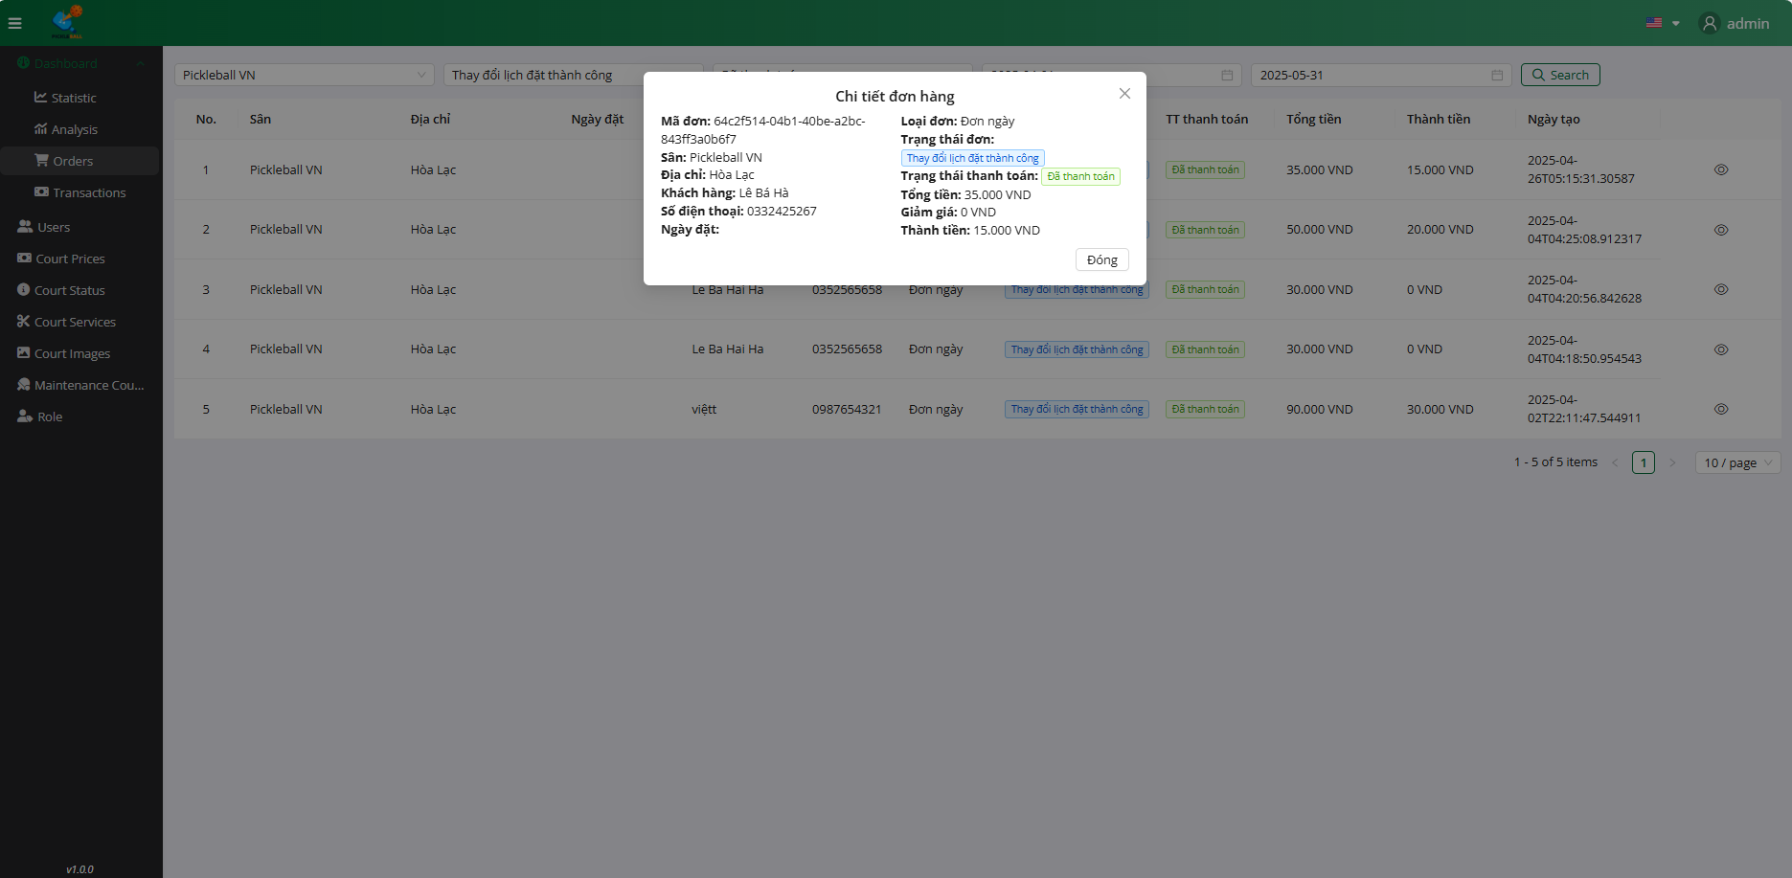

**Step 6:** Click on the button “Xem chi tiết”

### 3.5.4 Transaction Dashboard

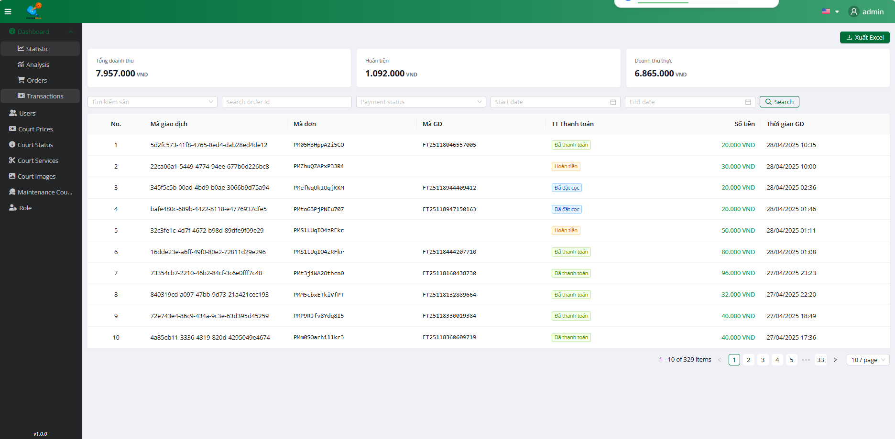

**Step 1:** Click on the ”Court Name” 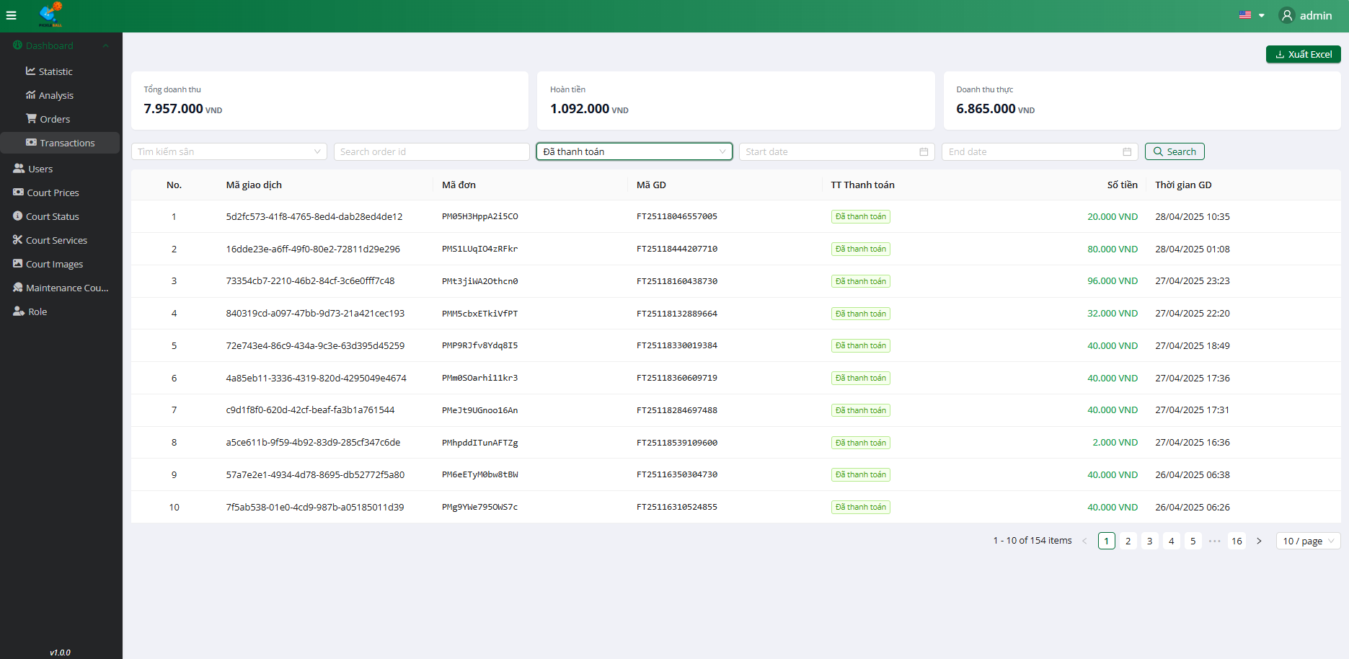

**Step 2:** Select Filter by Paymentstatus

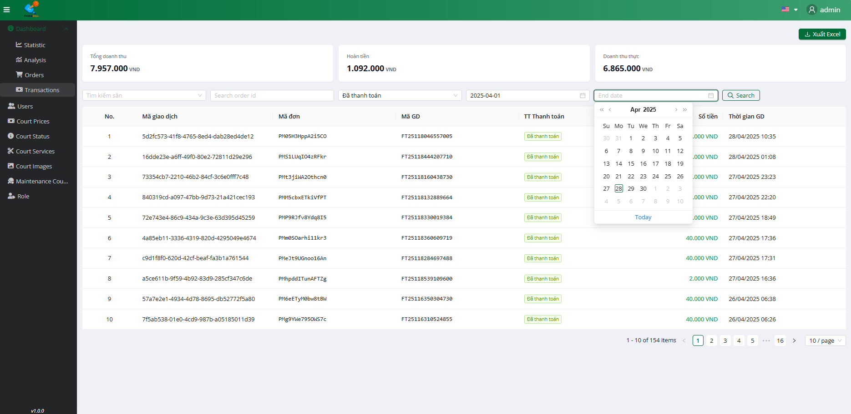

**Step 3:** Select StartDate - EndDate



**Step 4:** Select Filter by Payment Status

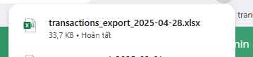

**Step 5:** Click on the”Xuất báo cáo”

### 3.6 Workflow Manage User

### 3.6.1 View User

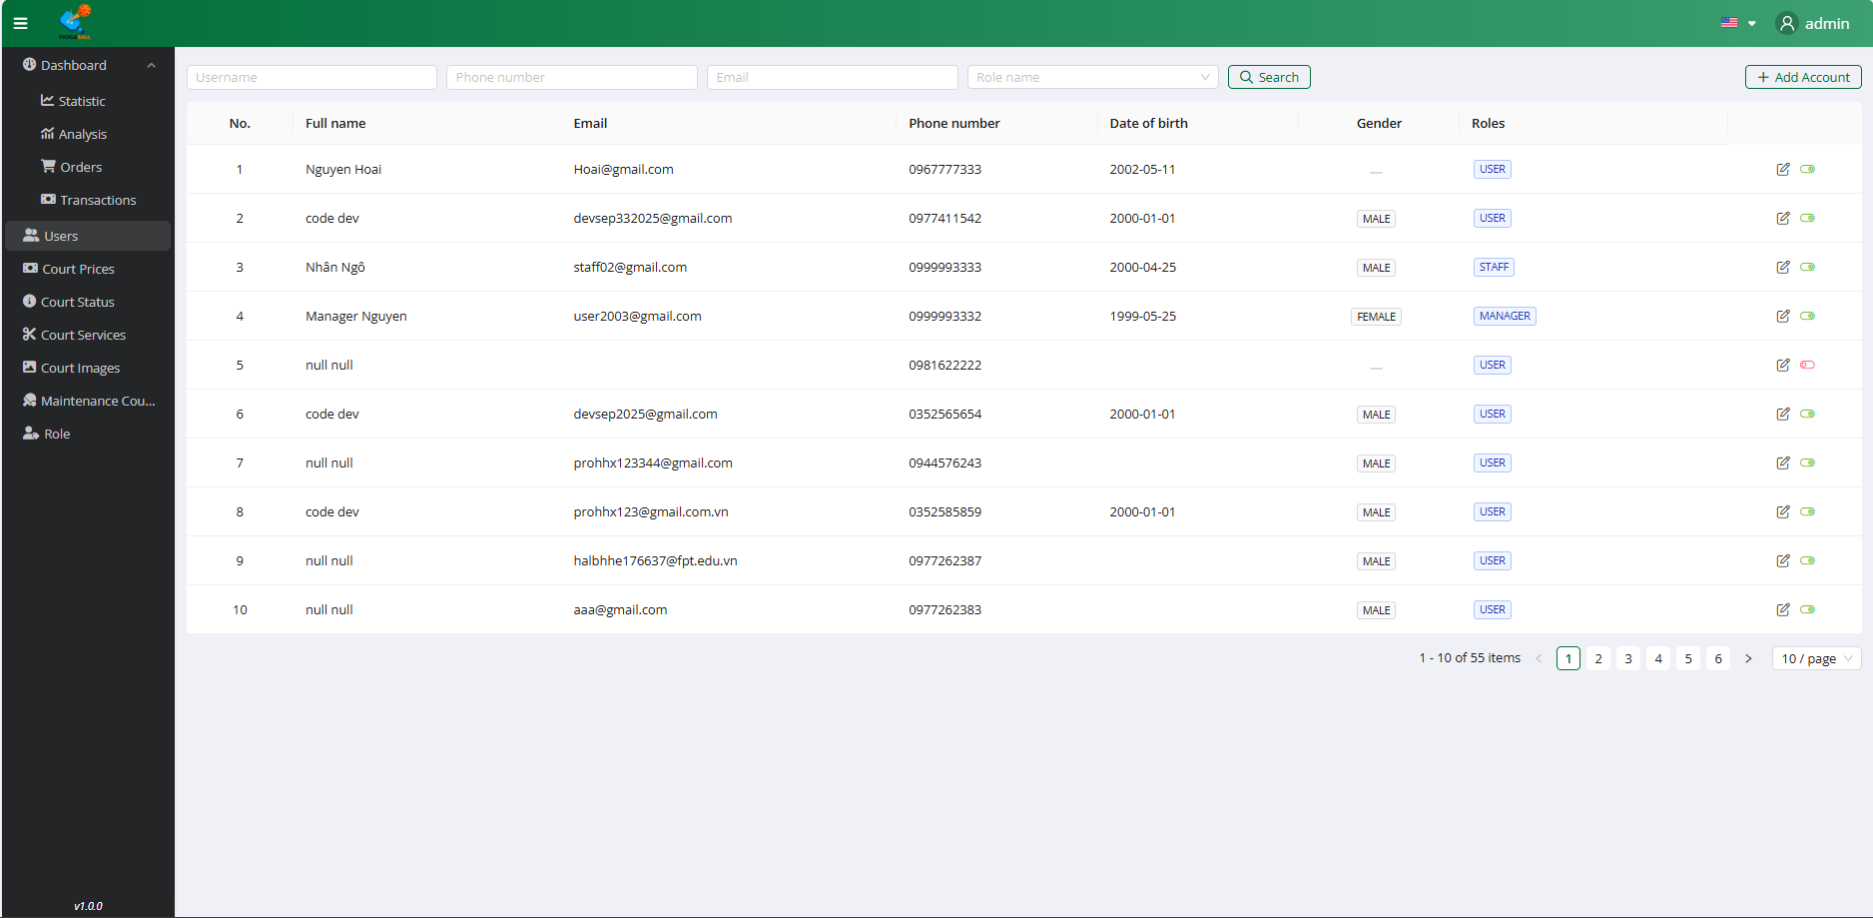

**Step 1:** Click on the button “Users”

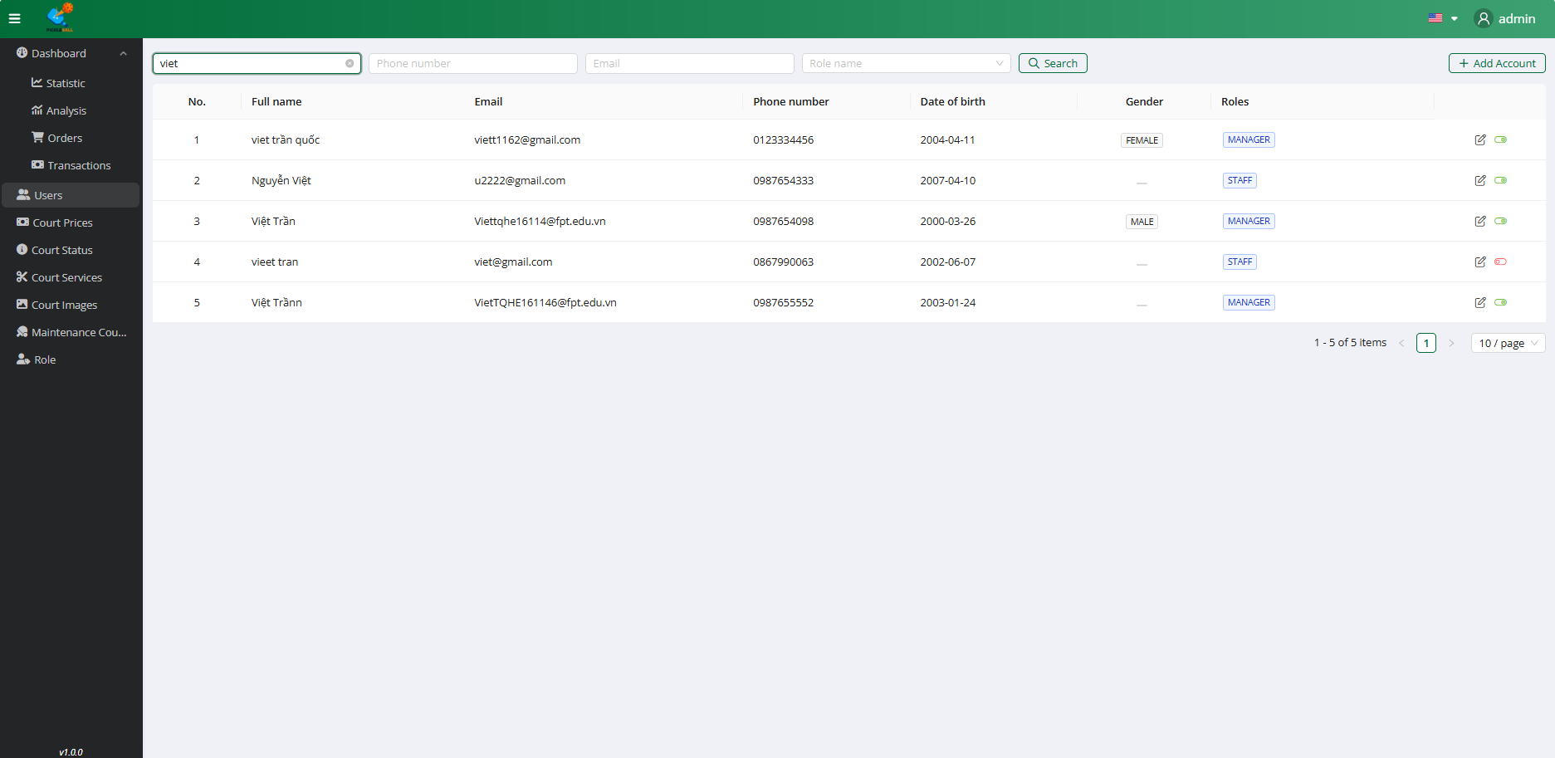

**Step 2:** Search User by Name

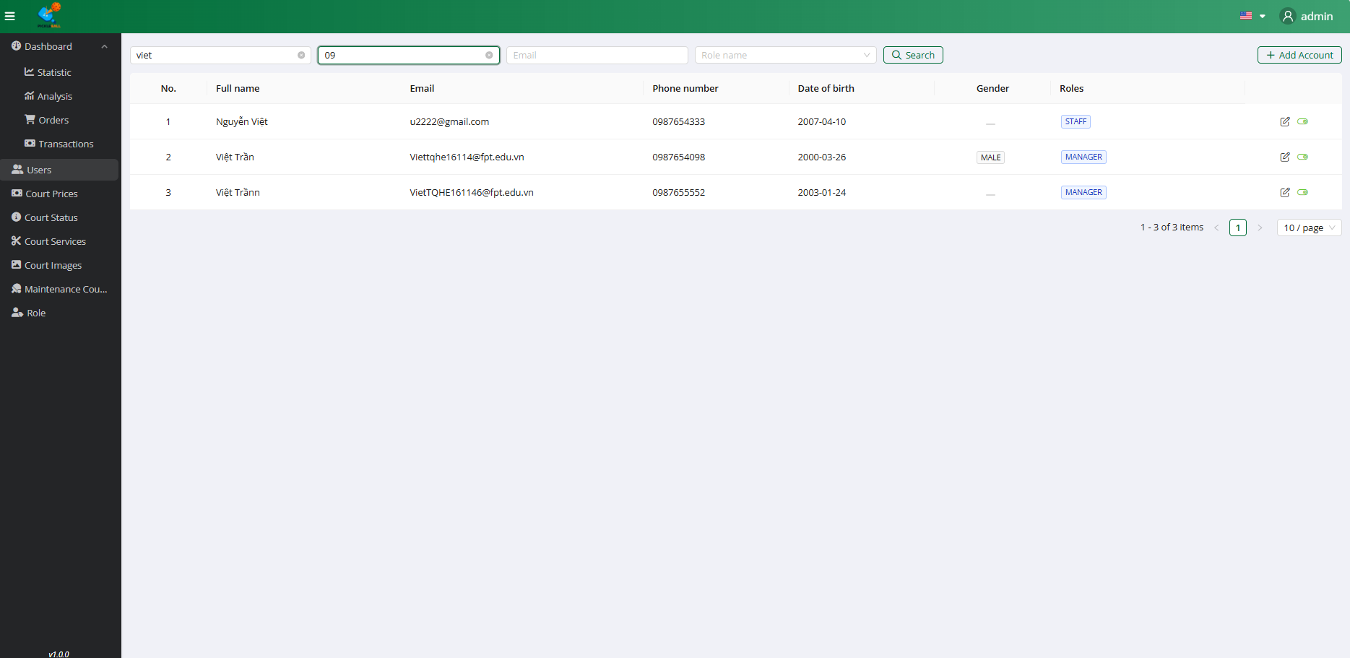

**Step 3:** Search User by Phone

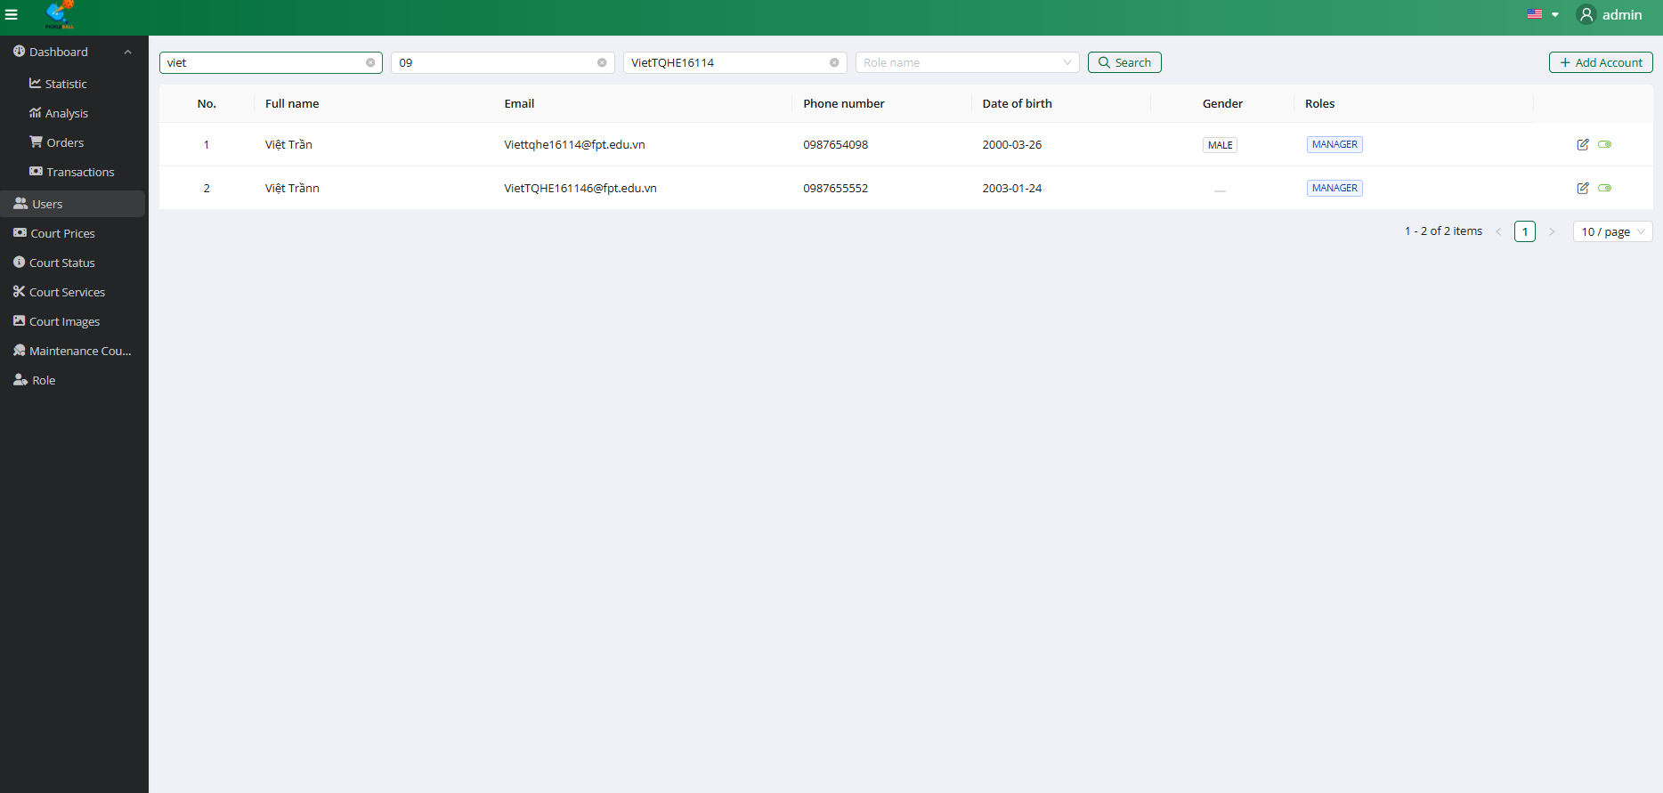

**Step 4:** Search User by Email

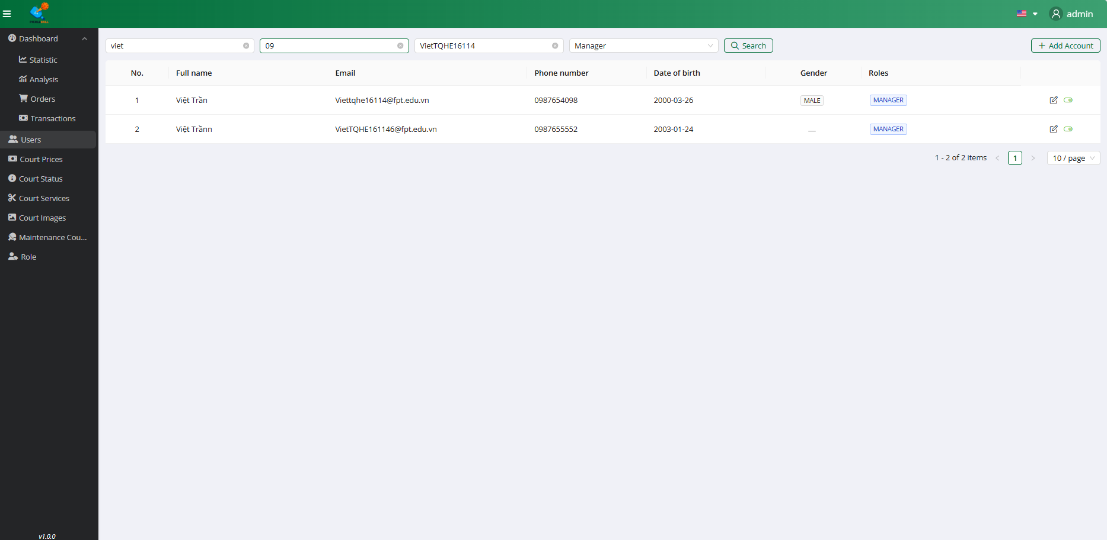

**Step 5:** Select Filter by Role

### 3.6.2 Add User



**Step 1:** Click on the button “Users”

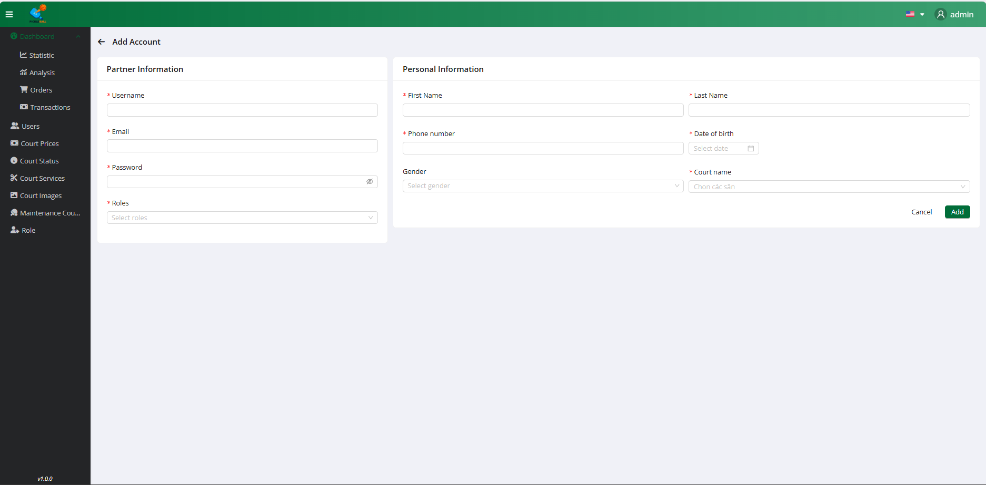

**Step 2:** Click on the button “Add account”

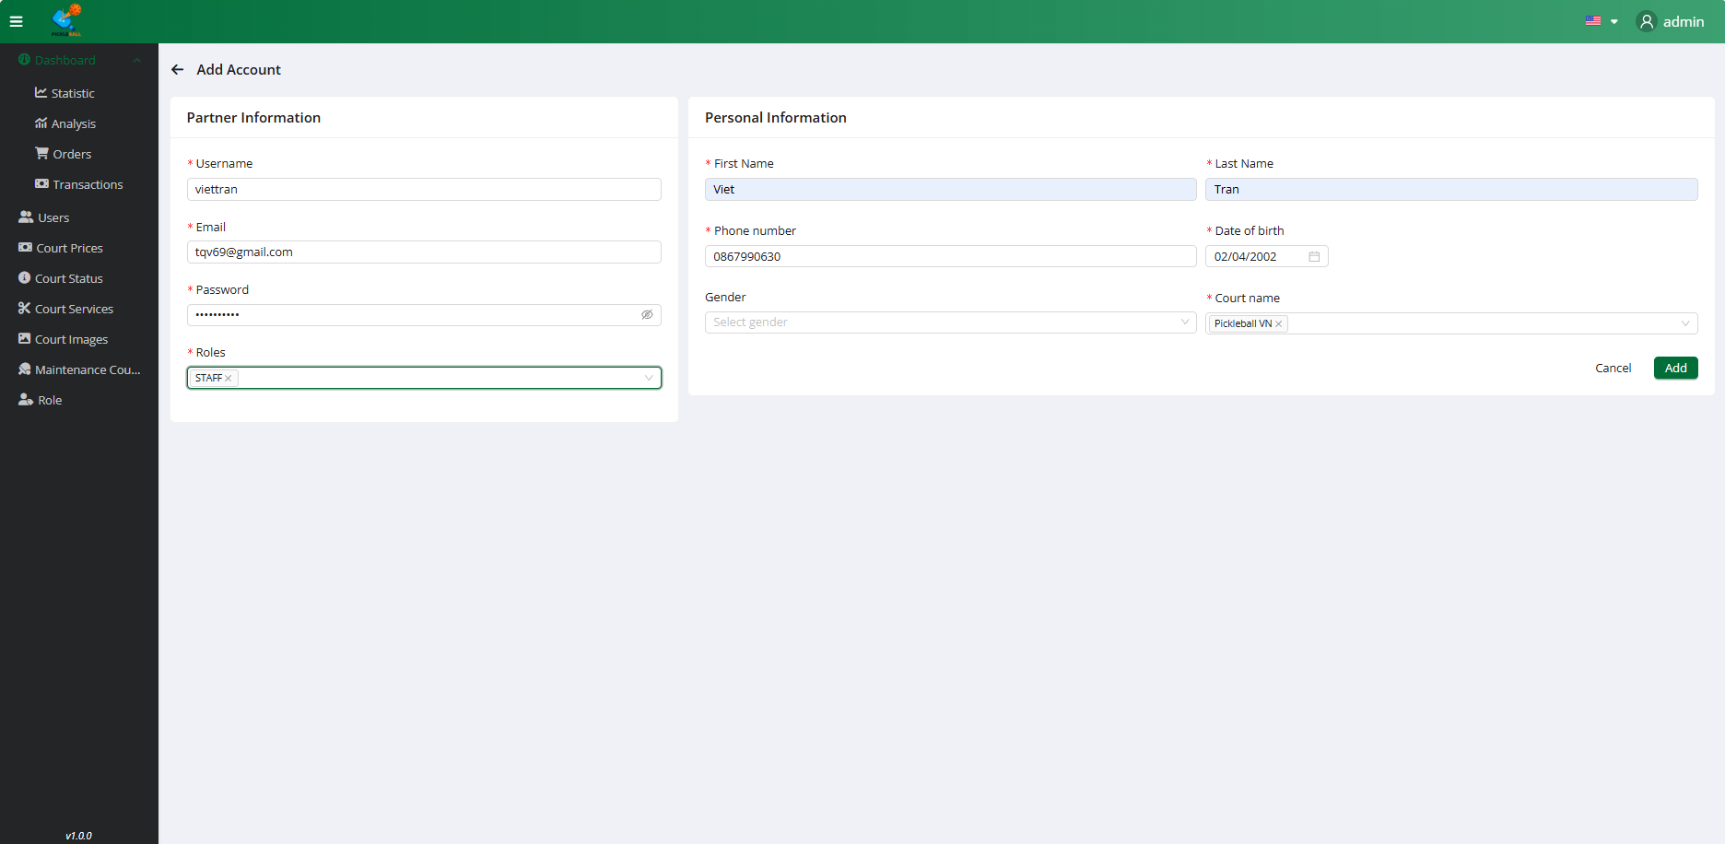

**Step 3:**Input all field valid to create account

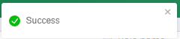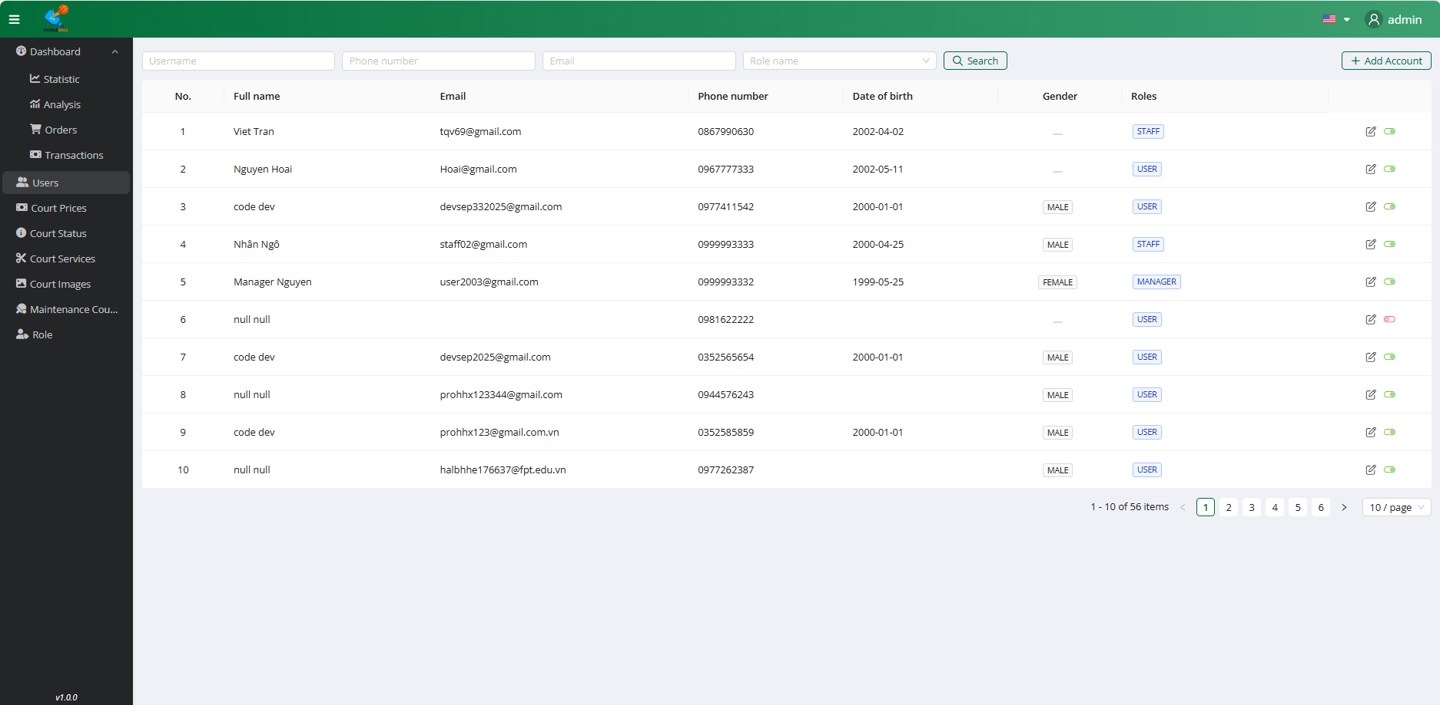

**Step 4:** Click on the “Add” button

### 3.6.3 Edit User



**Step 1:** Click on the button “Users”

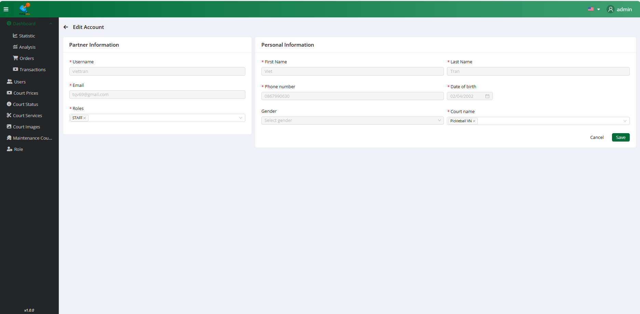

**Step 2:** Click on the button “Edit”

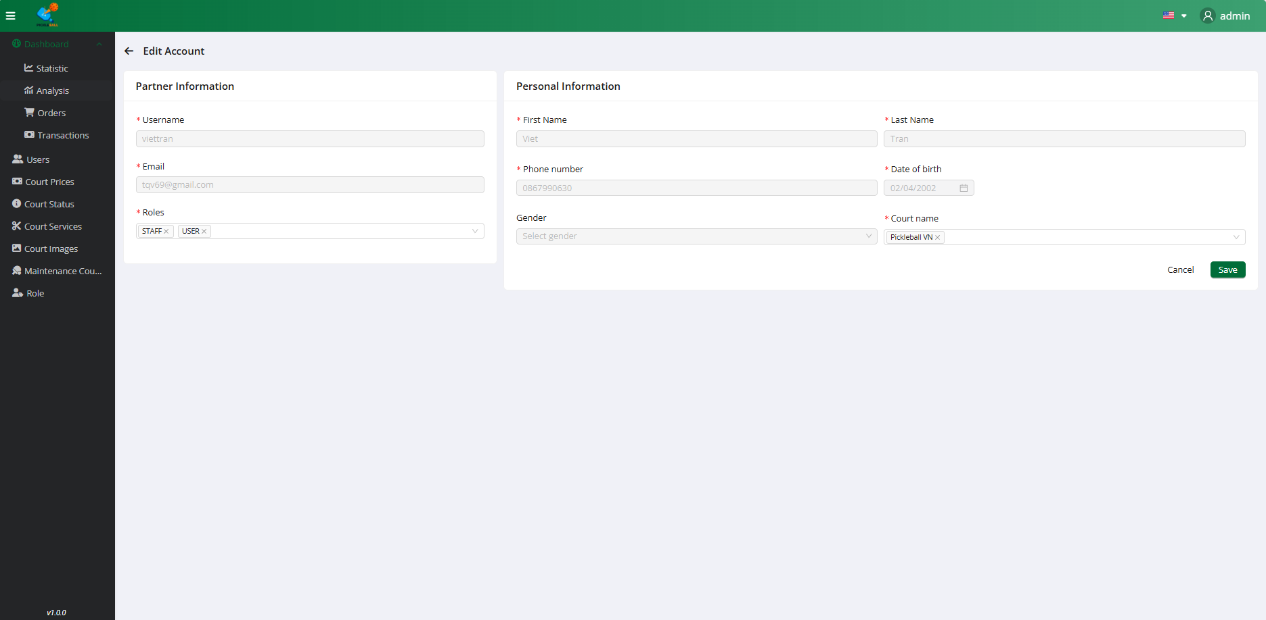

**Step 3:**Select all field valid to account

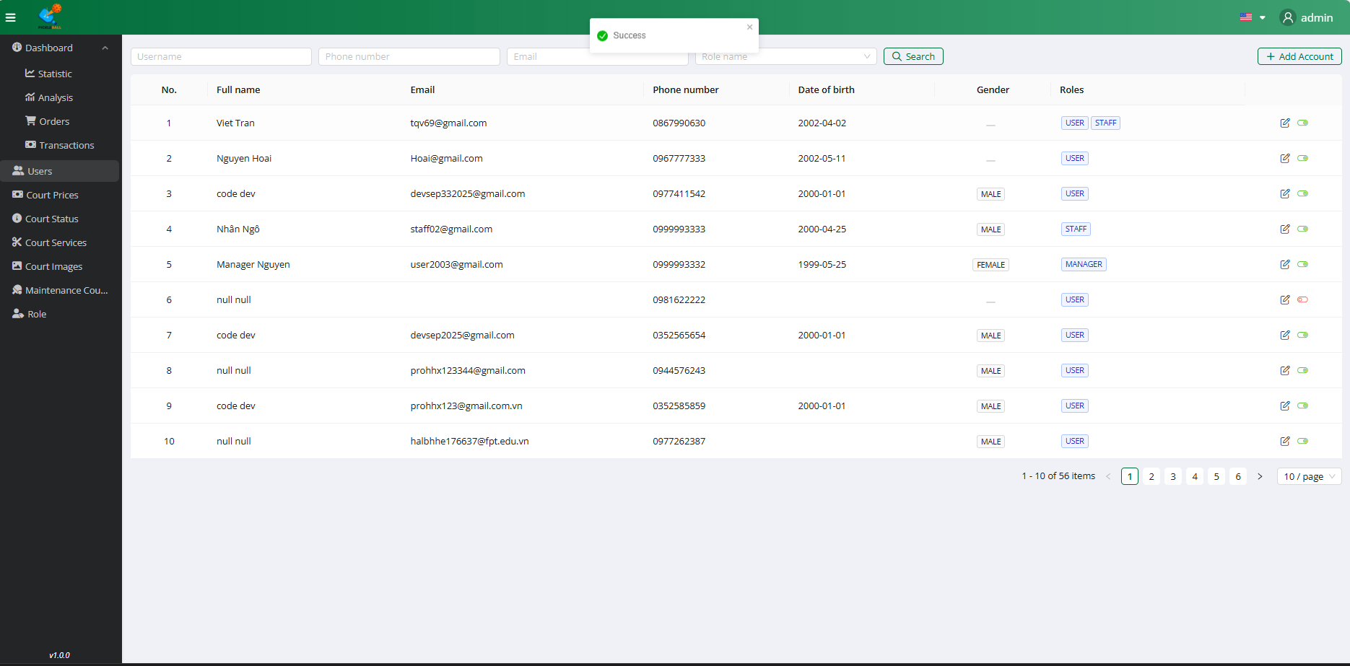

**Step 4:** Click on the “Save” button

### 3.6.4 Change Status User



**Step 1:** Click on the button “Users”

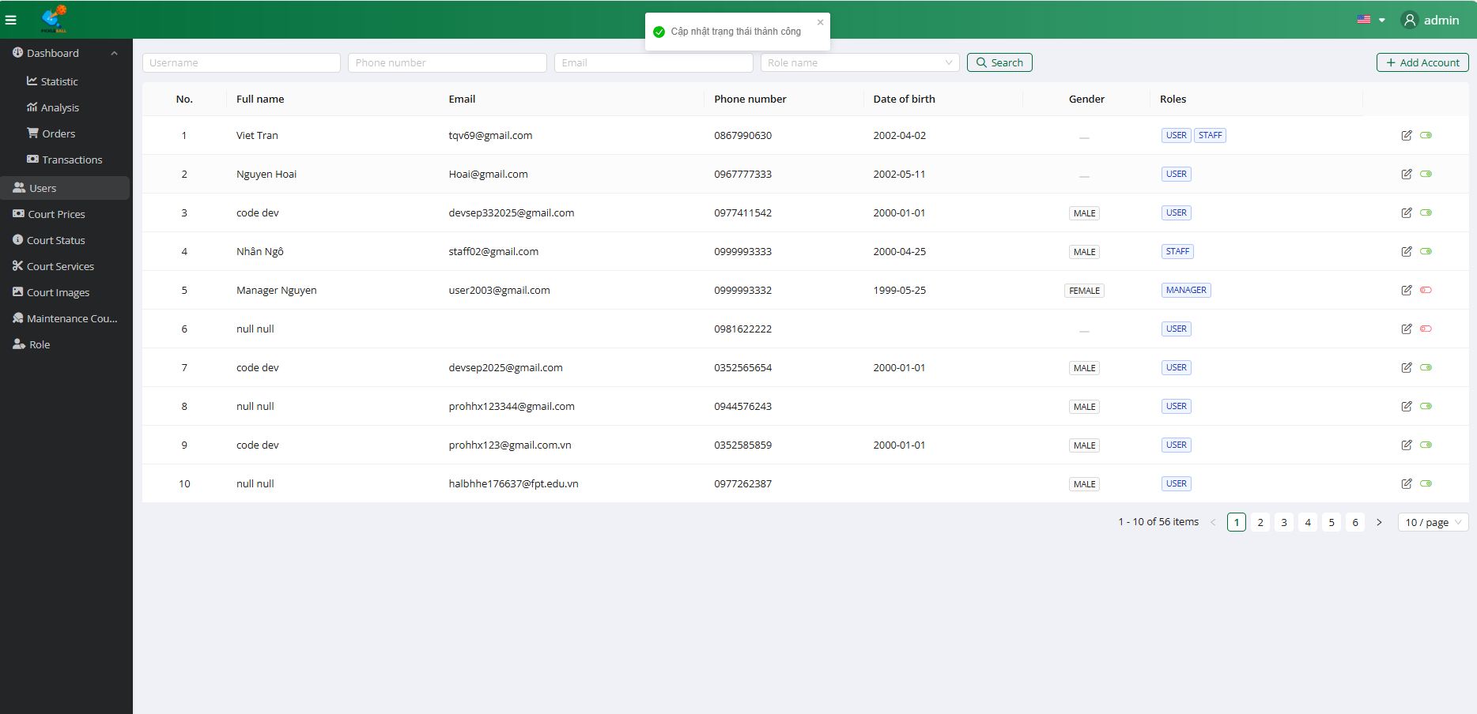

**Step 2:** Click on the button “Status”

### 3.7 Workflow Manage Court

### 3.7.1 View Court

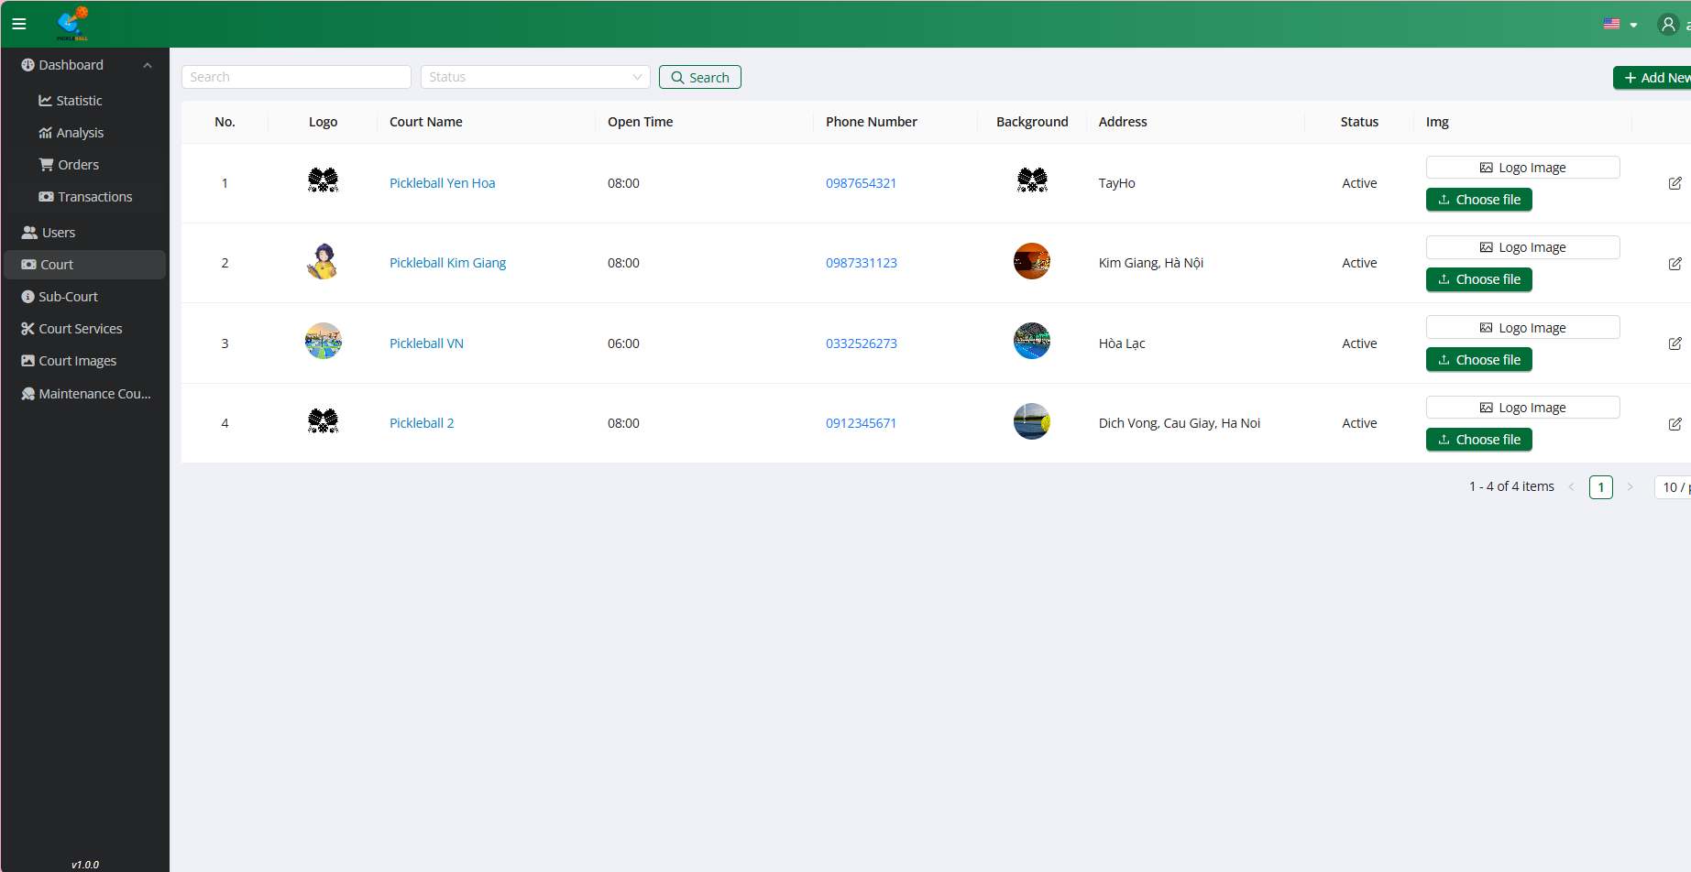

**Step 1:** Click on the button “Court”

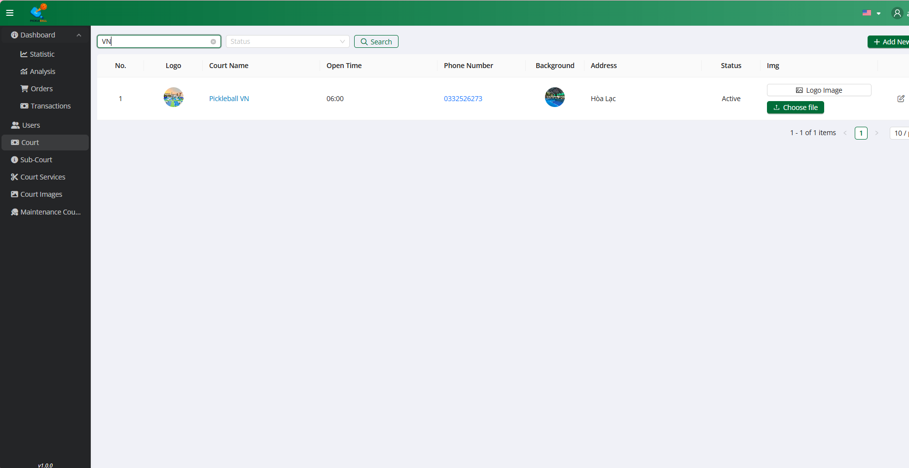

**Step 2:** Search Court by Name

### 3.7.2 Add Court

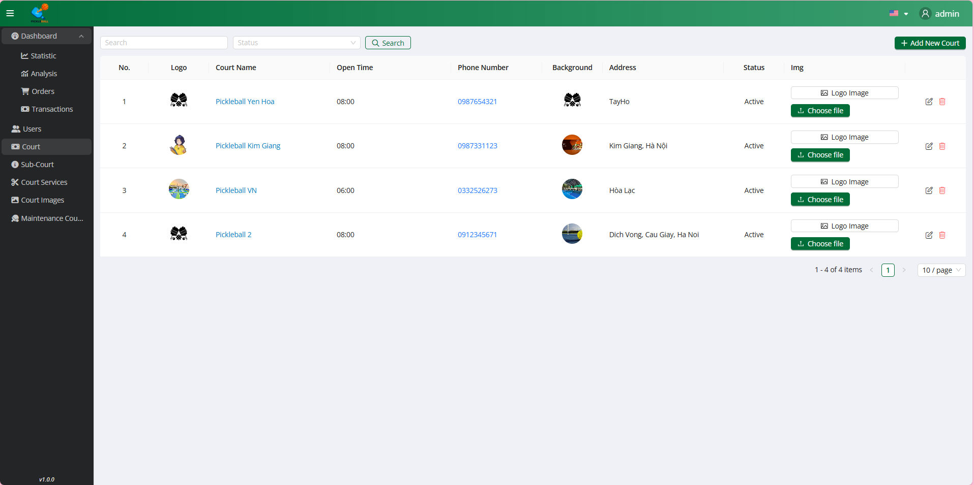

**Step 1:** Click on the button “Court”

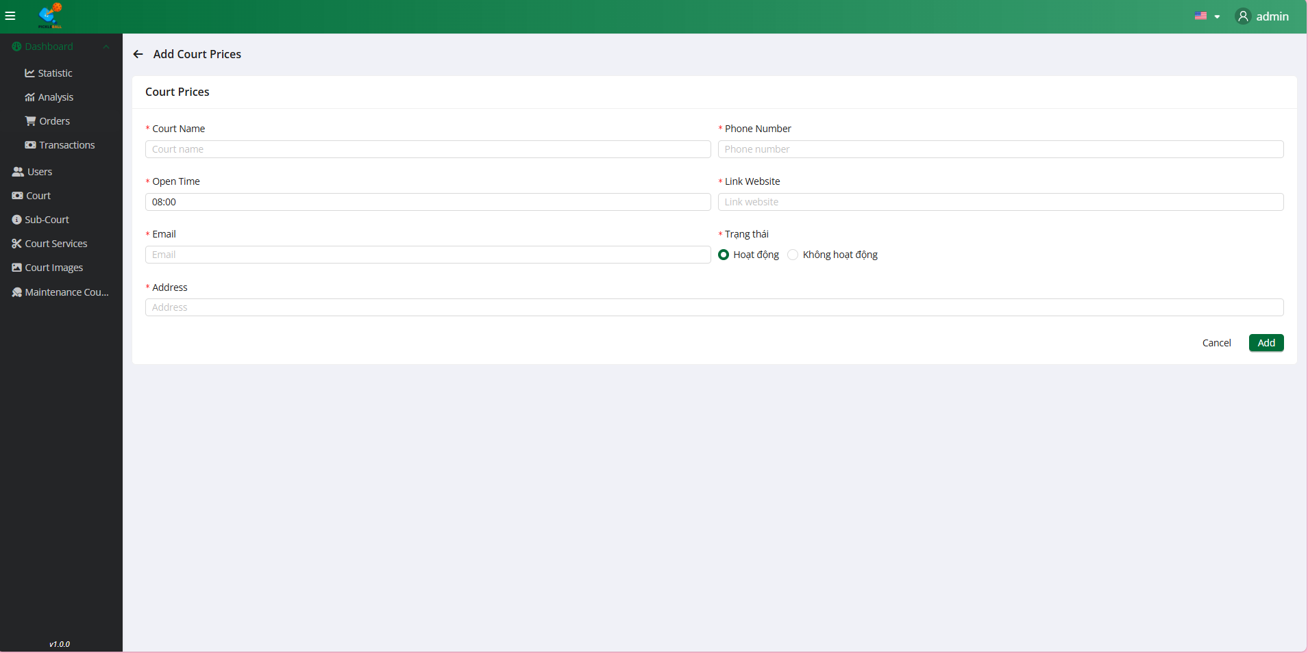

**Step 2:** Click on the button “Add New Court”

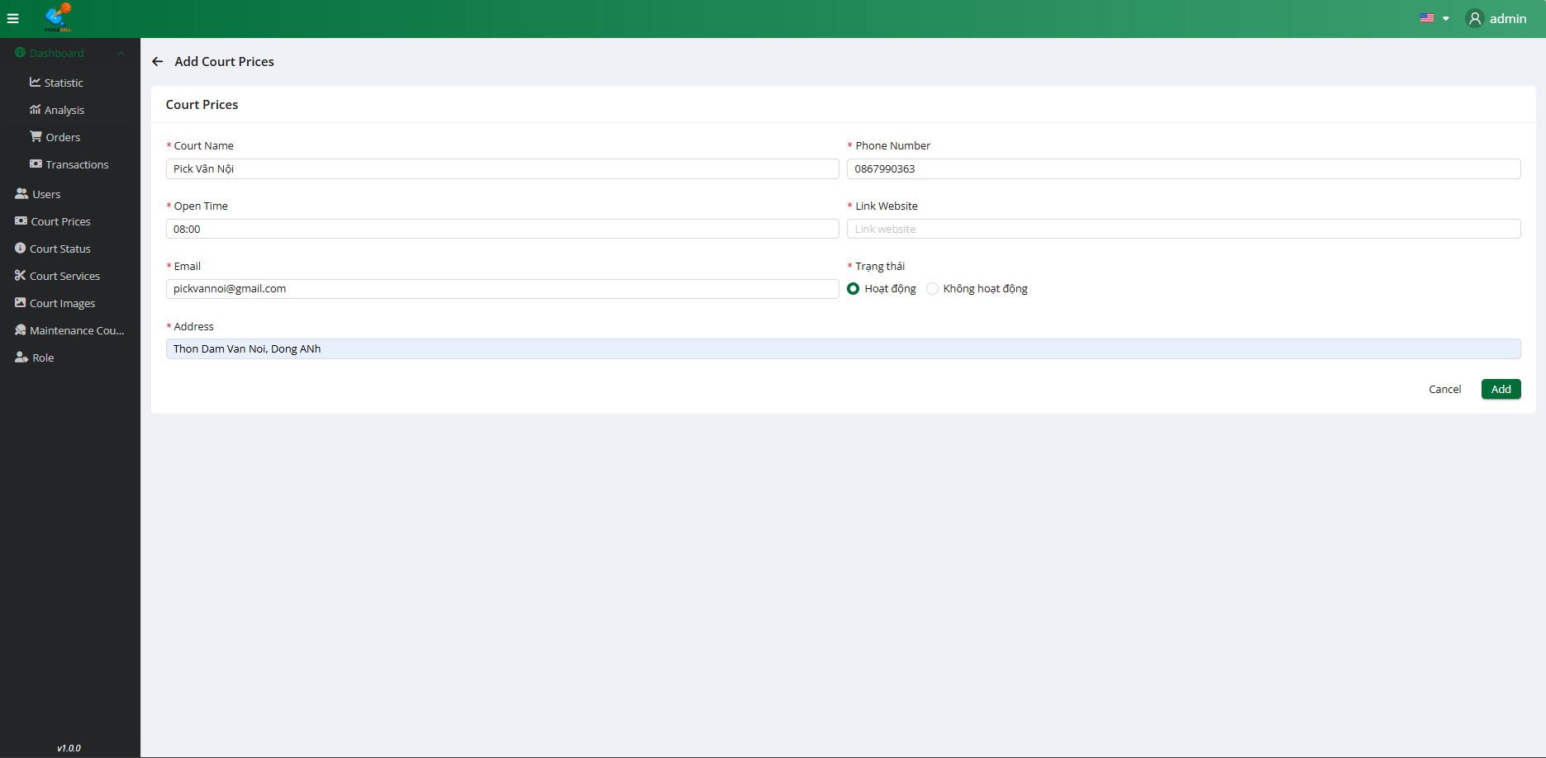

**Step 3:**Input all field valid to create Court

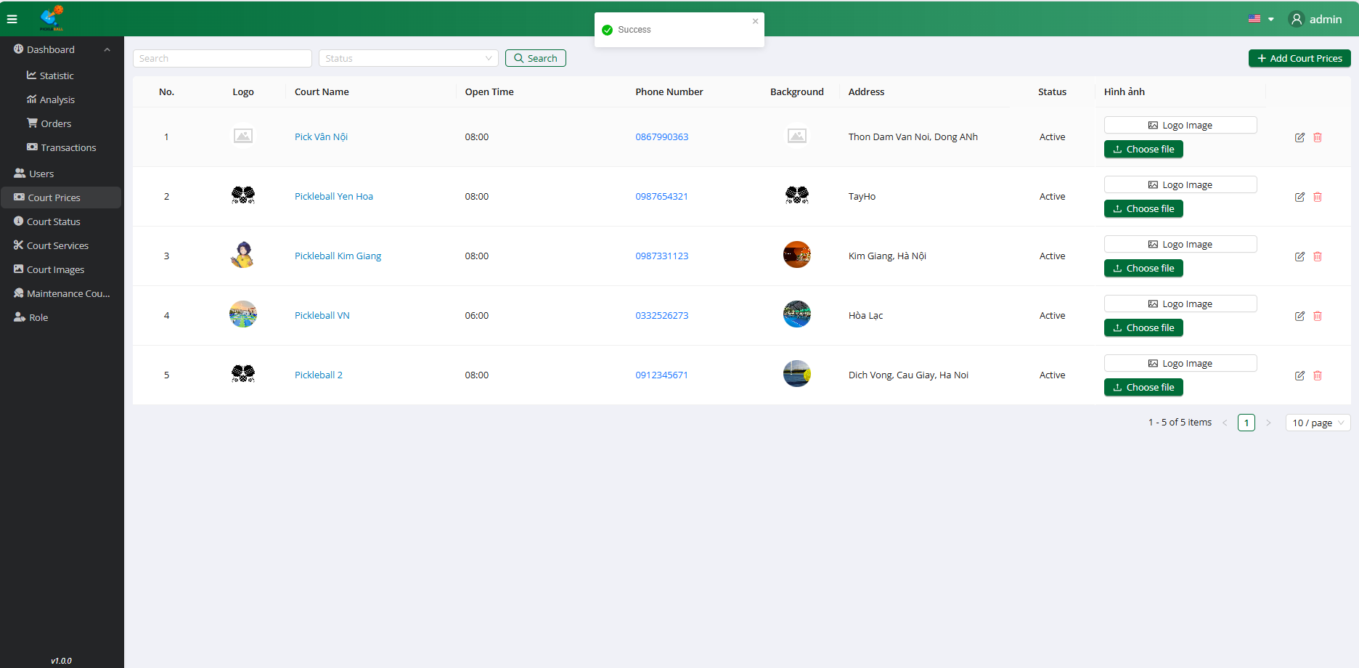

**Step 4:** Click on the “Add” button

### 3.7.3 Edit Court

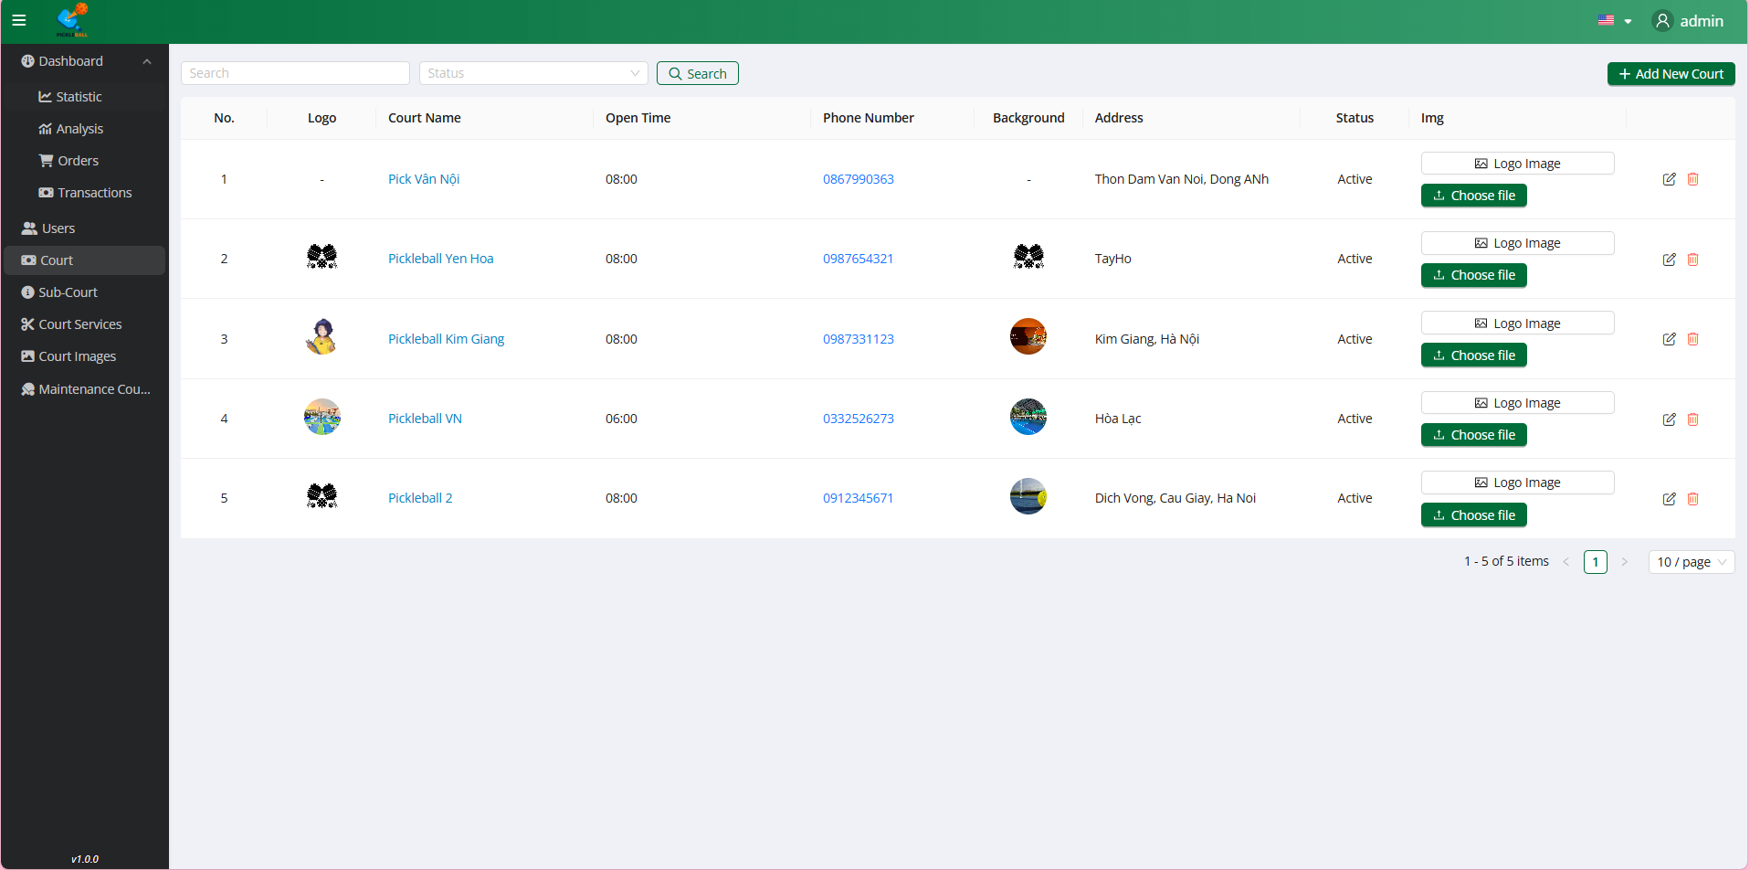

**Step 1:** Click on the button “Courts”

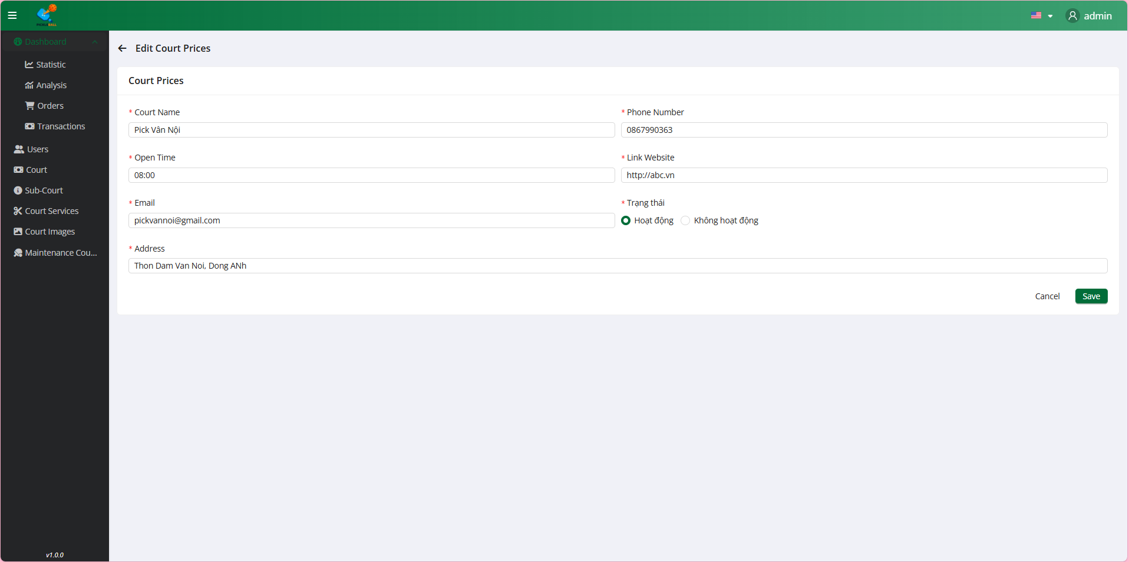

**Step 2:** Click on the button “Edit”

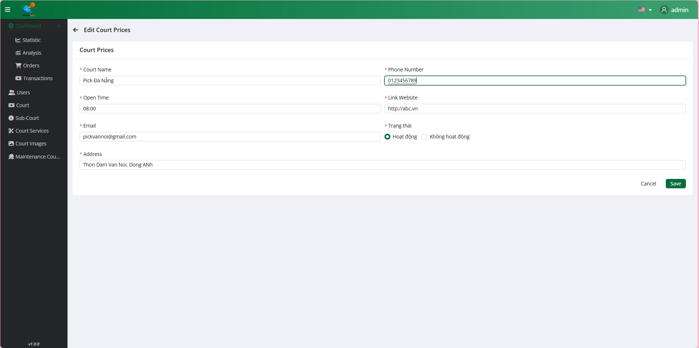

**Step 3:**Select all field valid to court

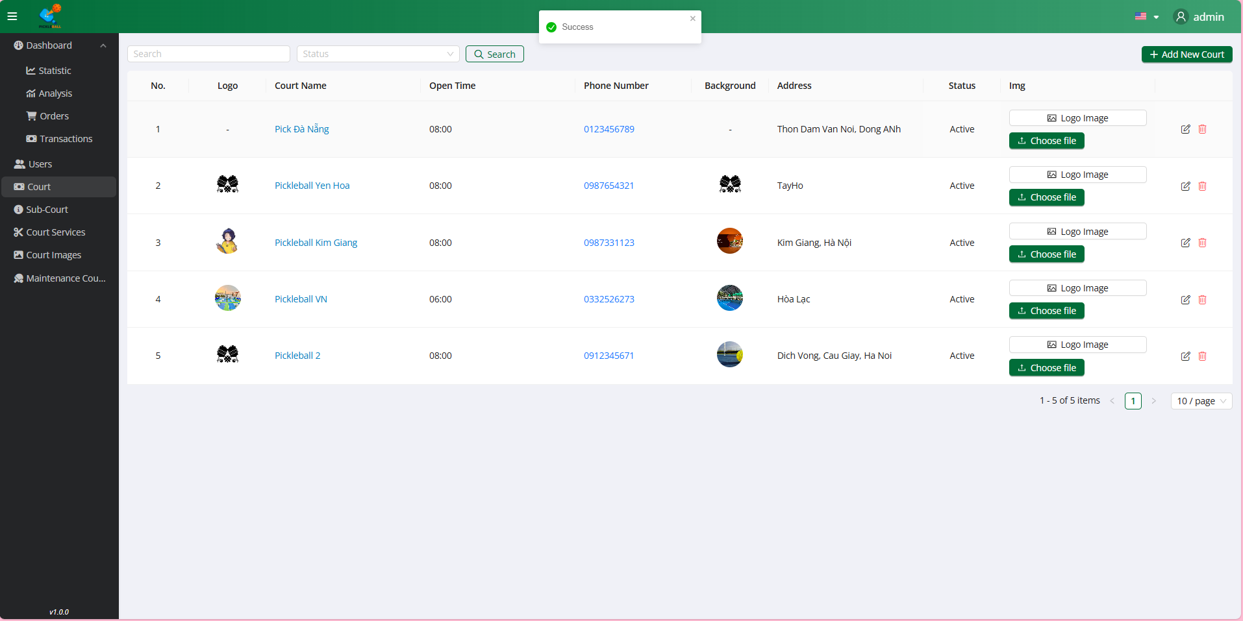

**Step 4:** Click on the “Save” button

### 3.7.4 Upload Logo Image



**Step 1:** Click on the button “Courts”

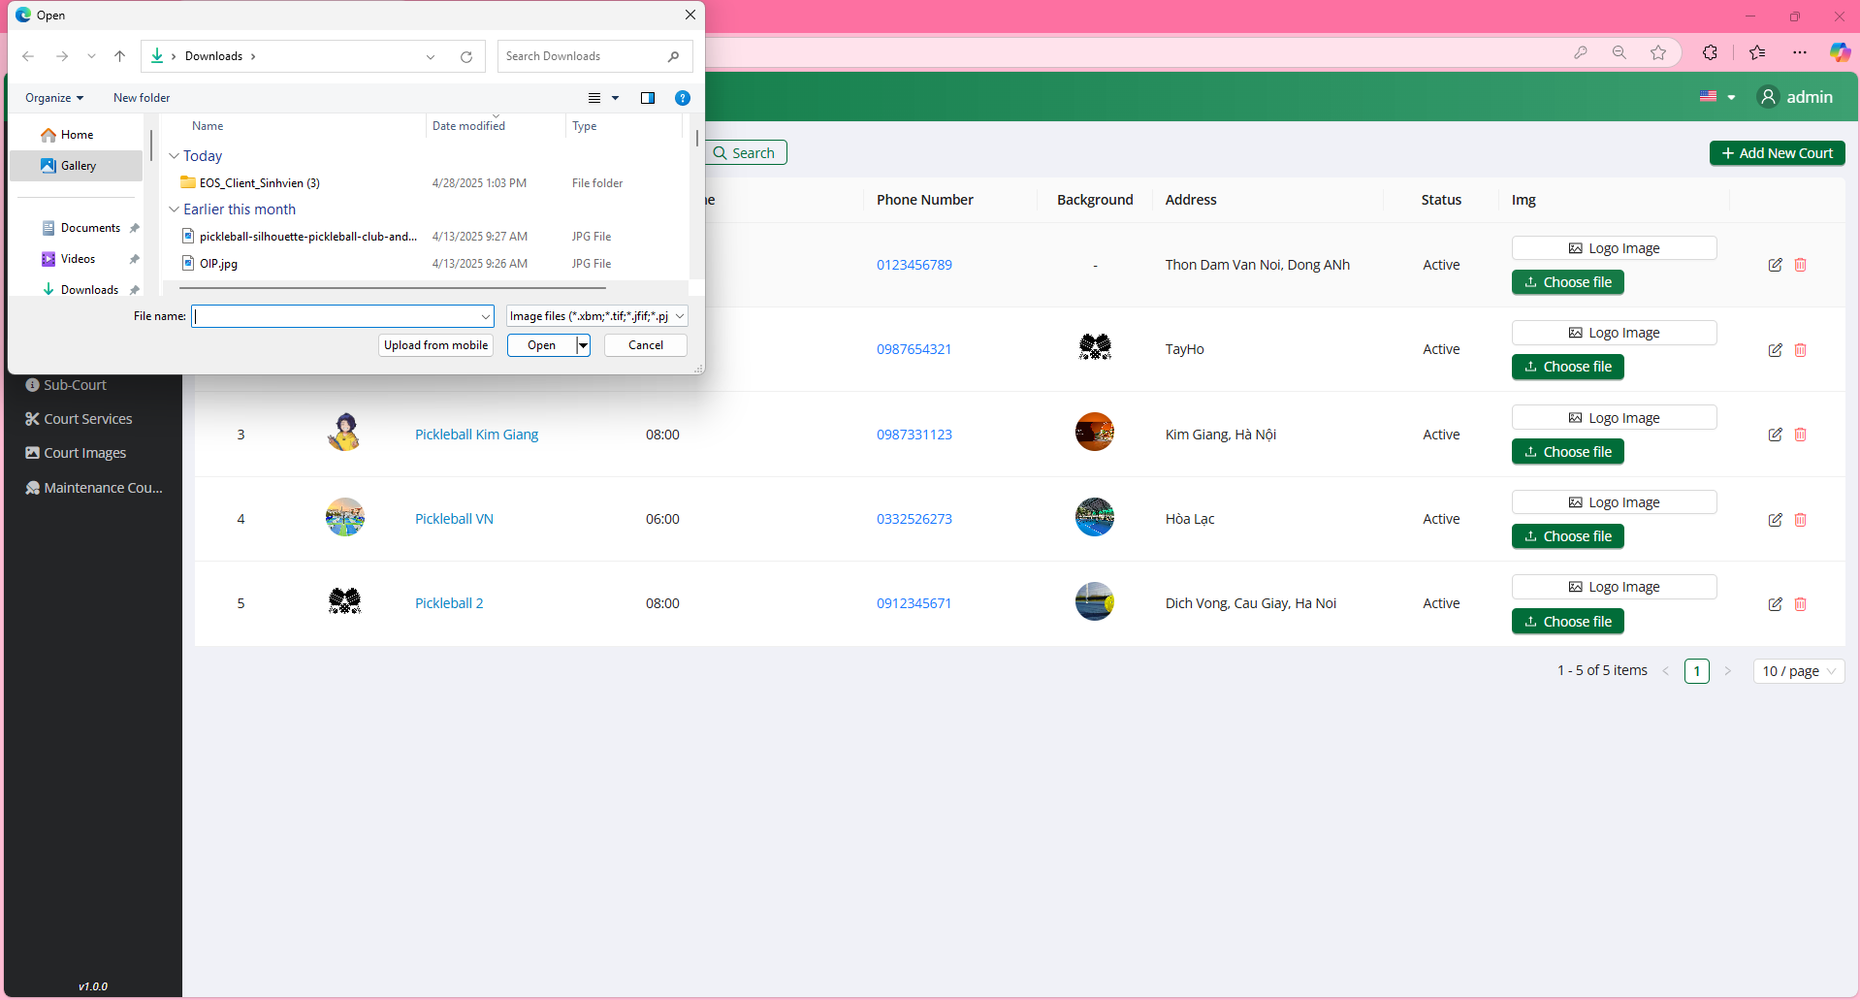

**Step 2:** Click on the button “Choose file”

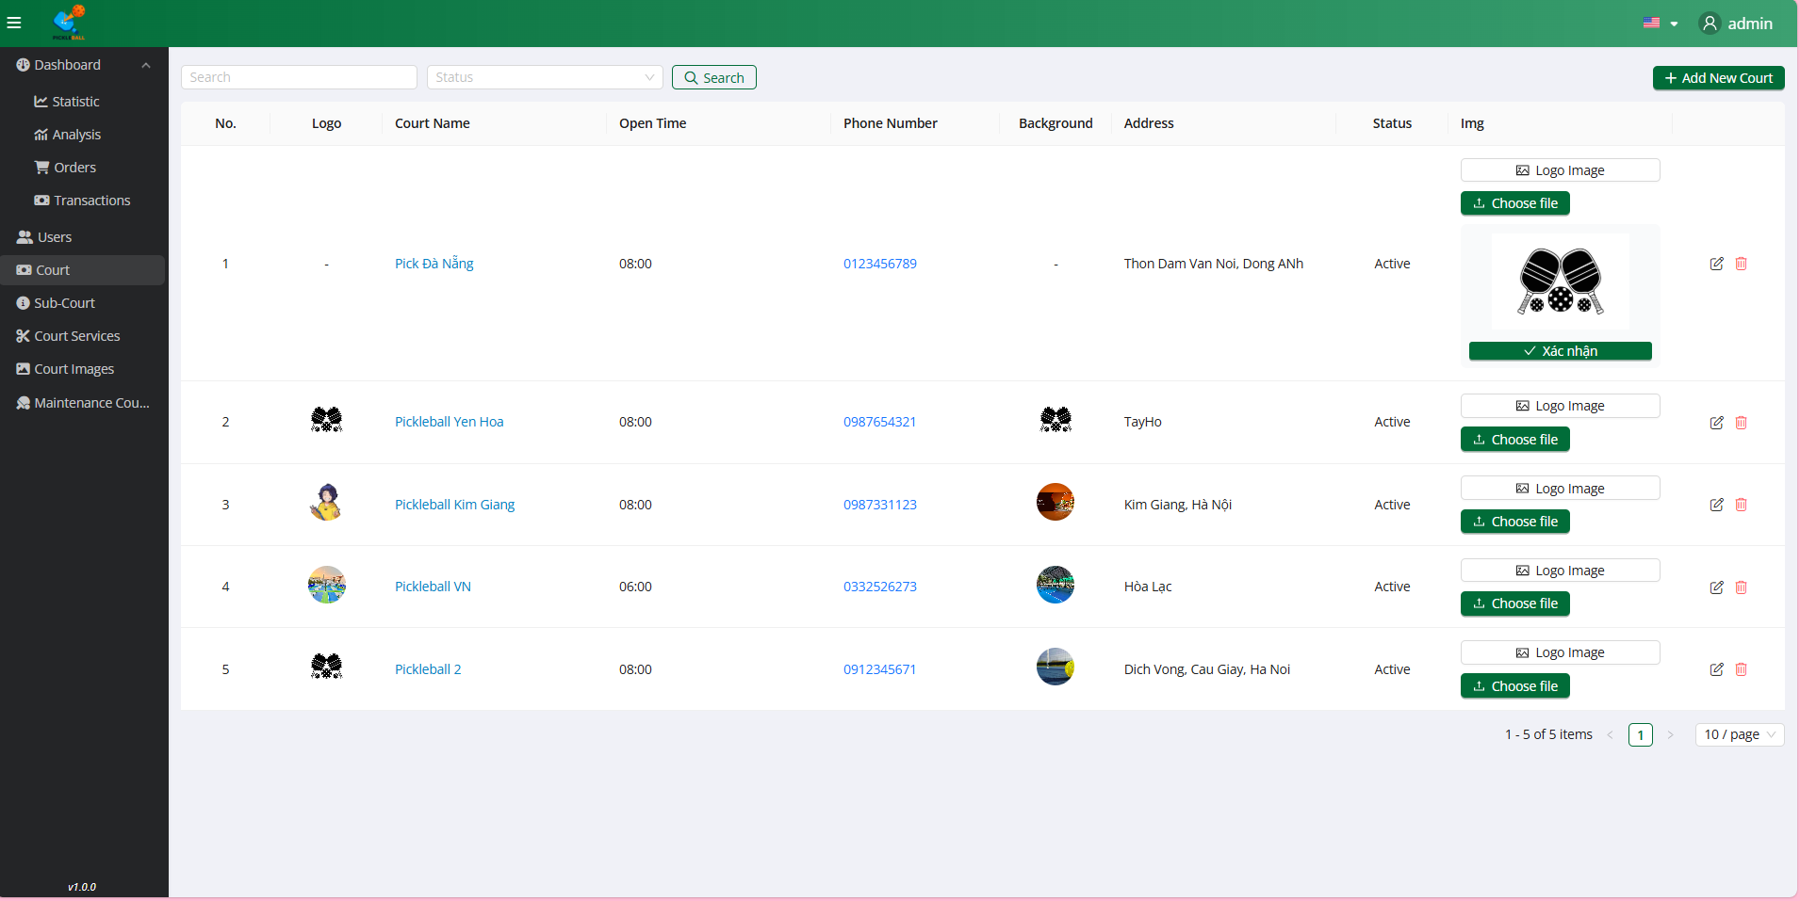

**Step 3:** Choose file, click on the button “Open”

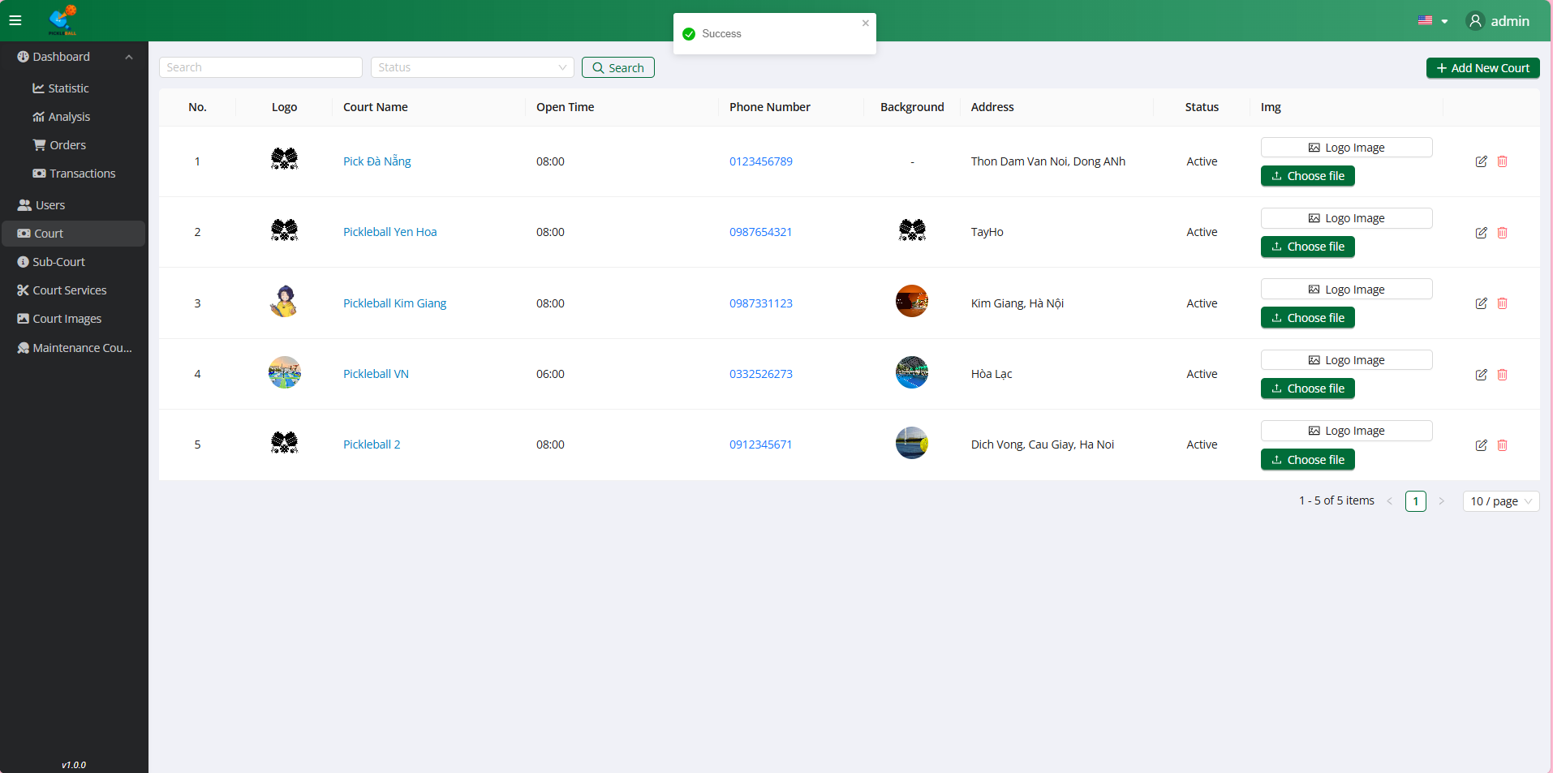

**Step 4:** Click on the button “Xác nhận”

### 3.7.5 Upload Background Image



**Step 1:** Click on the button “Courts”

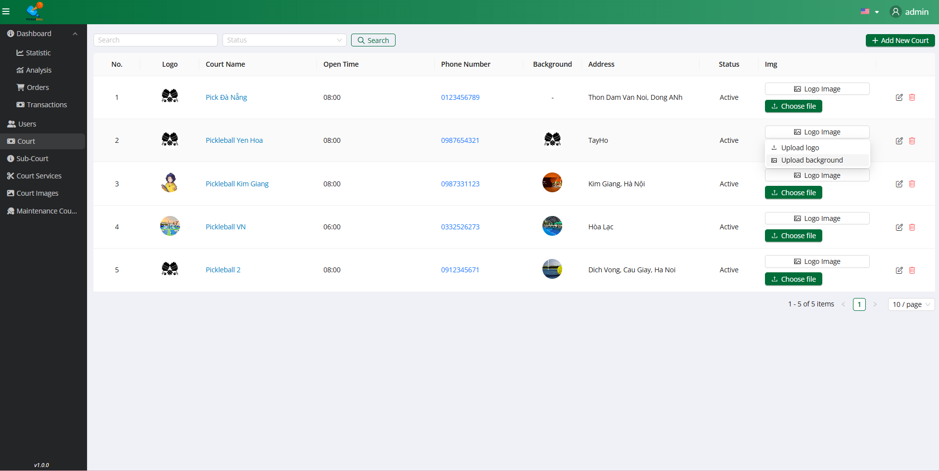

**Step 2:** Click on the button “Logo Image”

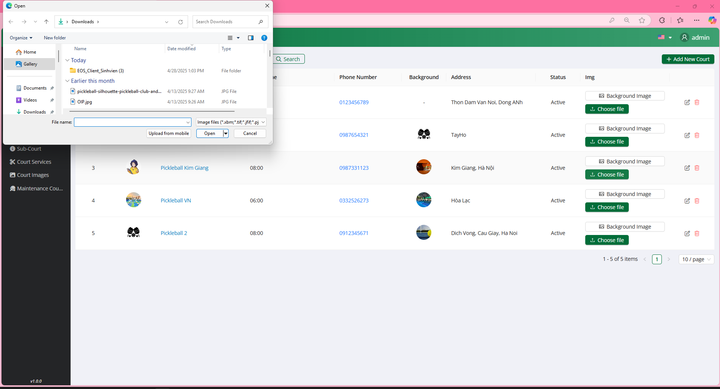

**Step 3:** Click on the button “Choose file”

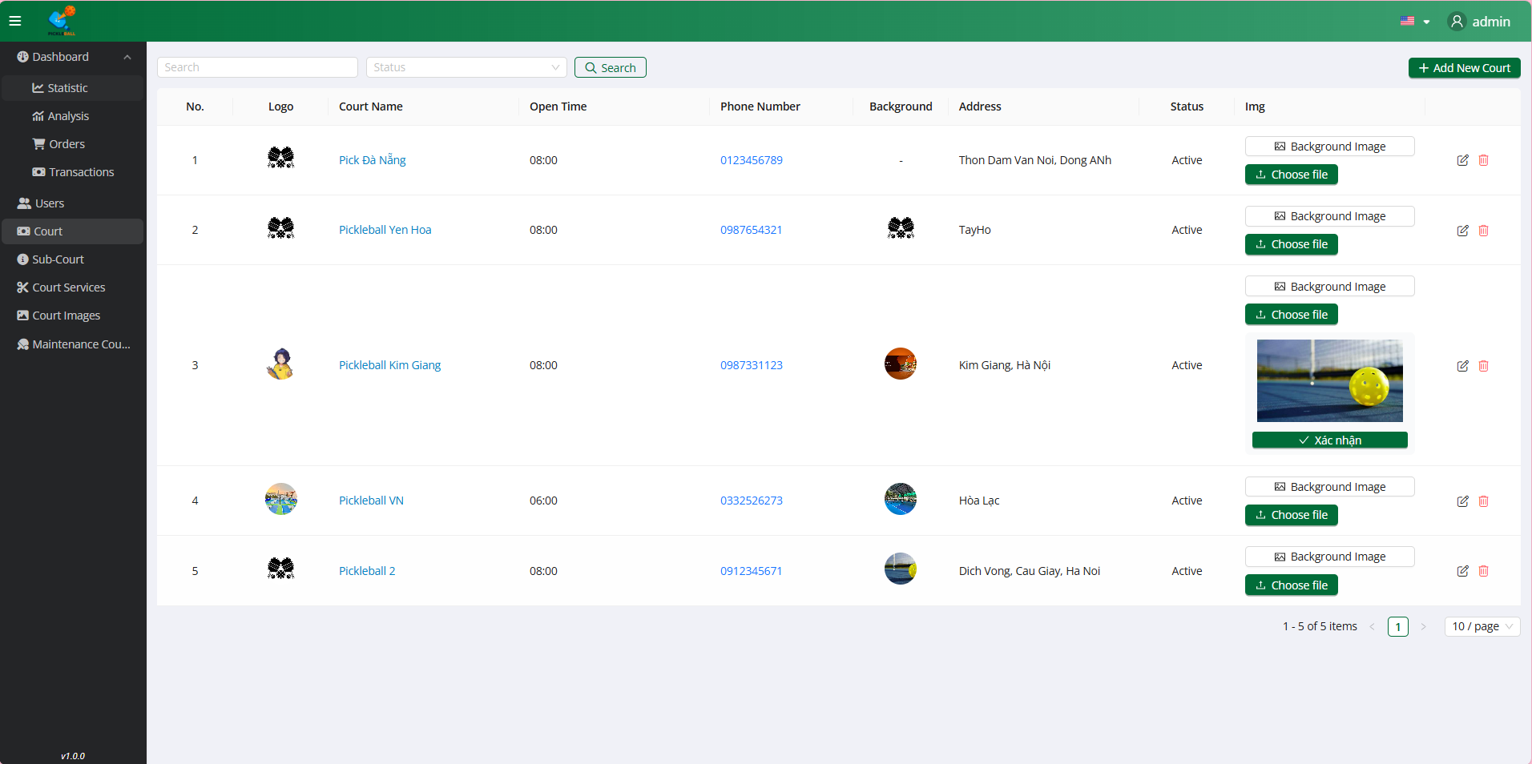

**Step 3:** Choose file, click on the button “Open”



**Step 4:** Click on the button “Xác nhận”

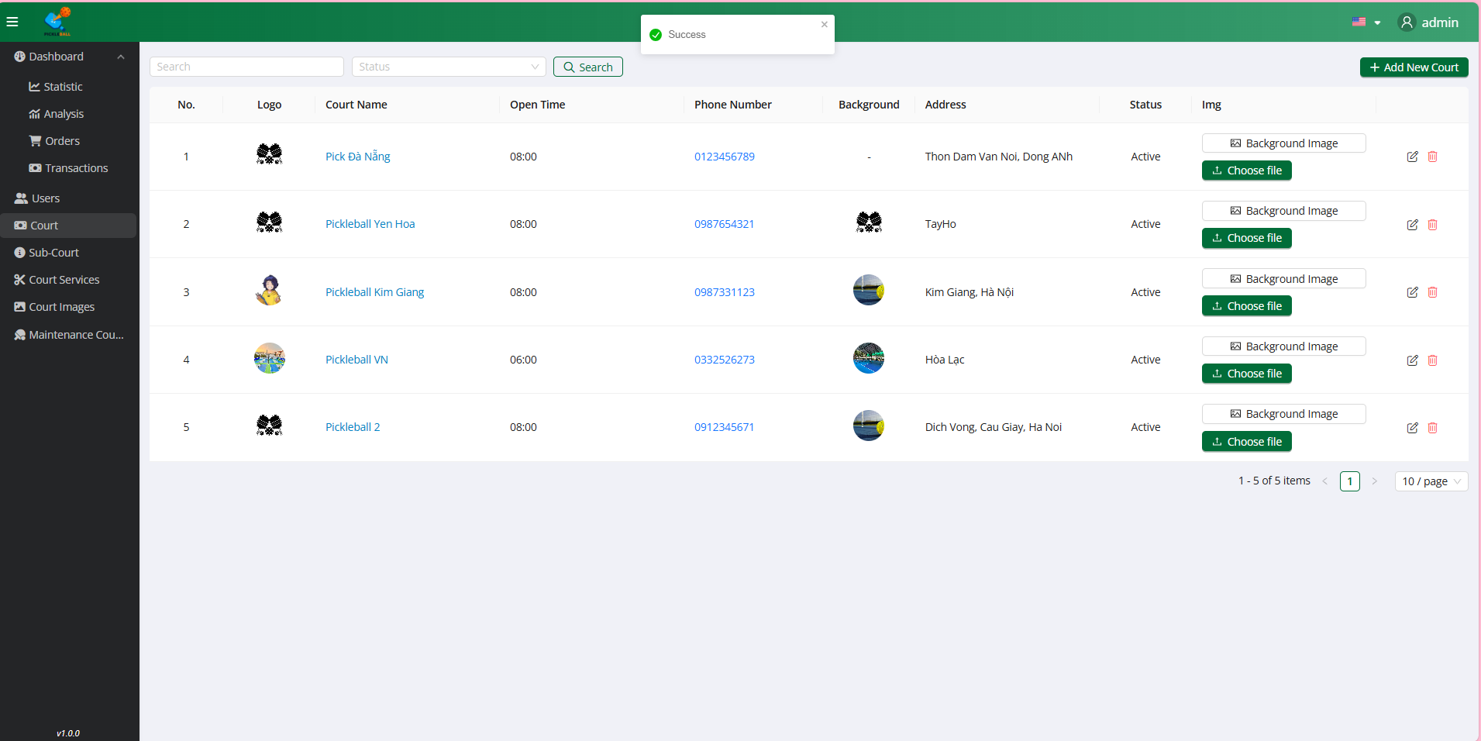

### 

### 

### 

### 

### 

### 

### 3.7.6 View Sub-Court

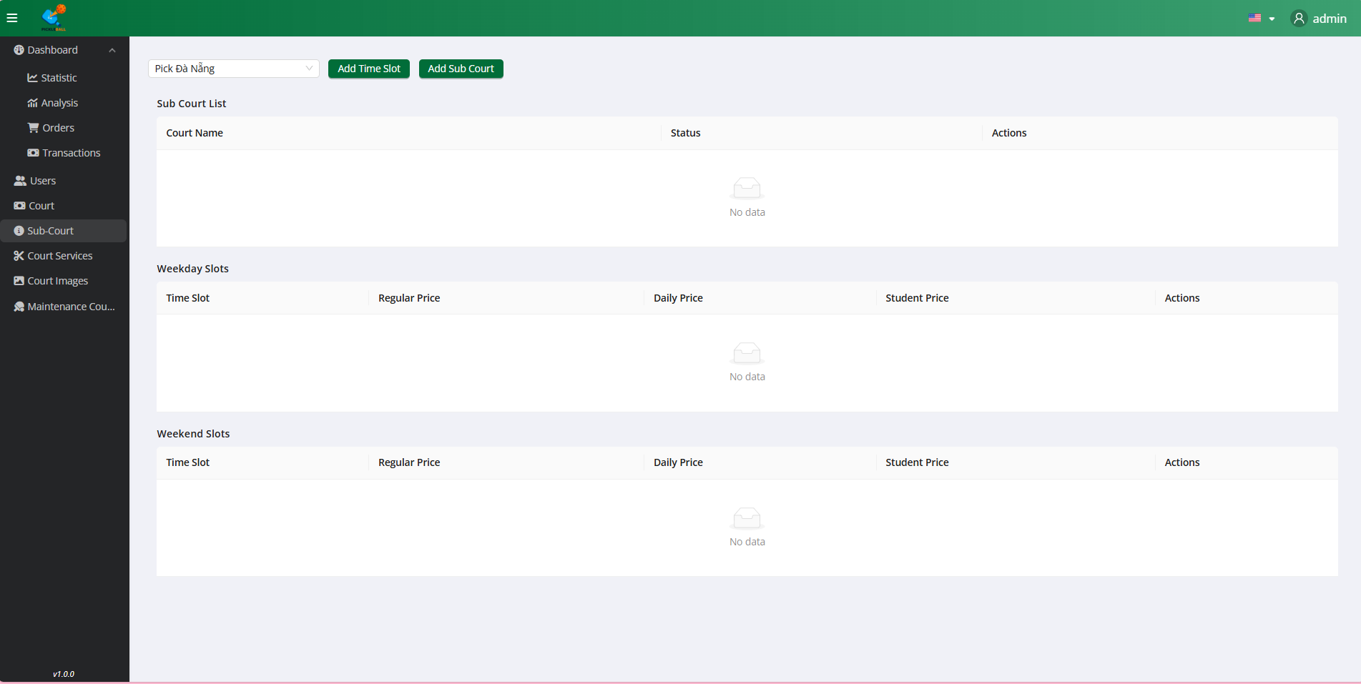

**Step 1:** Click on the button “Sub-Court”

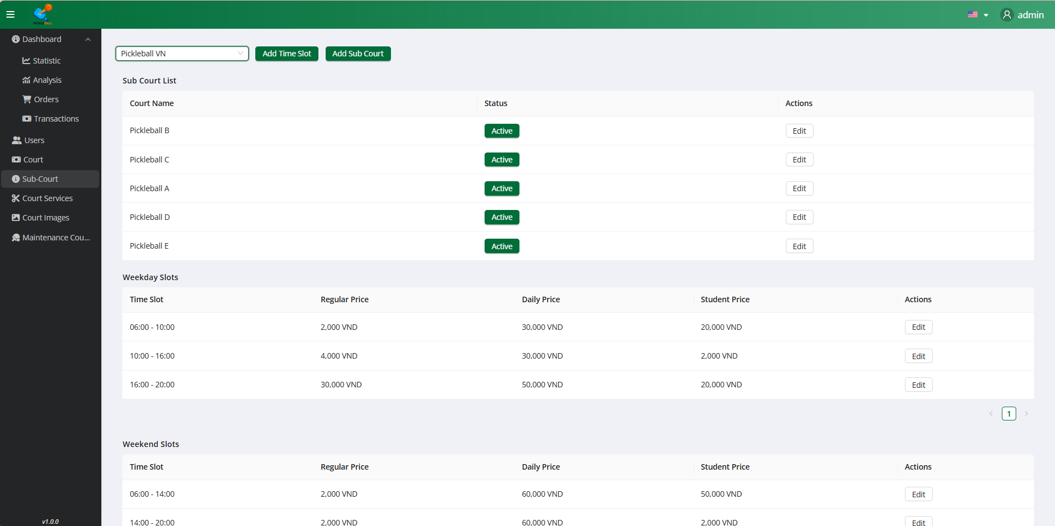

**Step 2:** Filter by Sub-Count

### 3.7.7 Add Sub-Court



**Step 1:** Click on the button “Sub-Court”



**Step 2:** Filter by Sub-Count

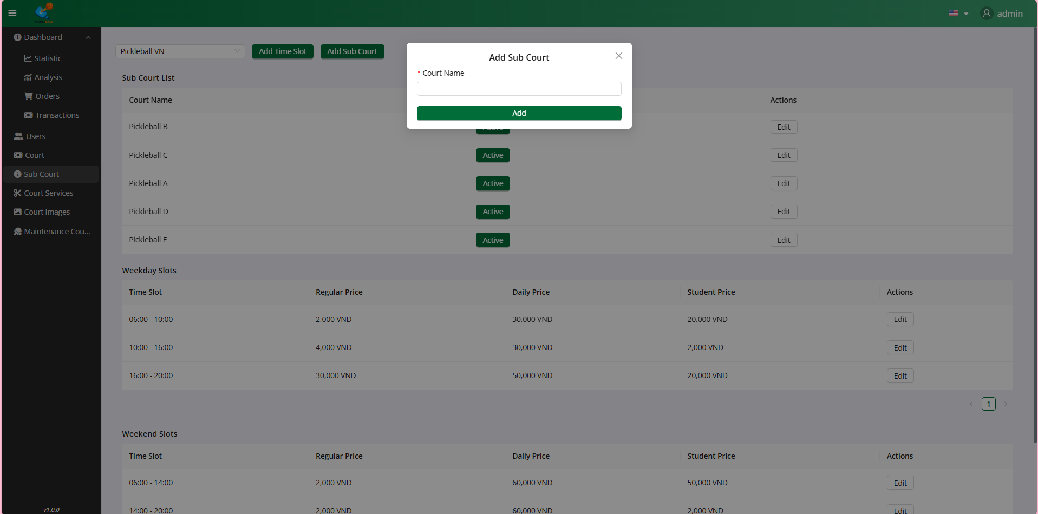

**Step 3:** Click on the button “Add Sub-Court”

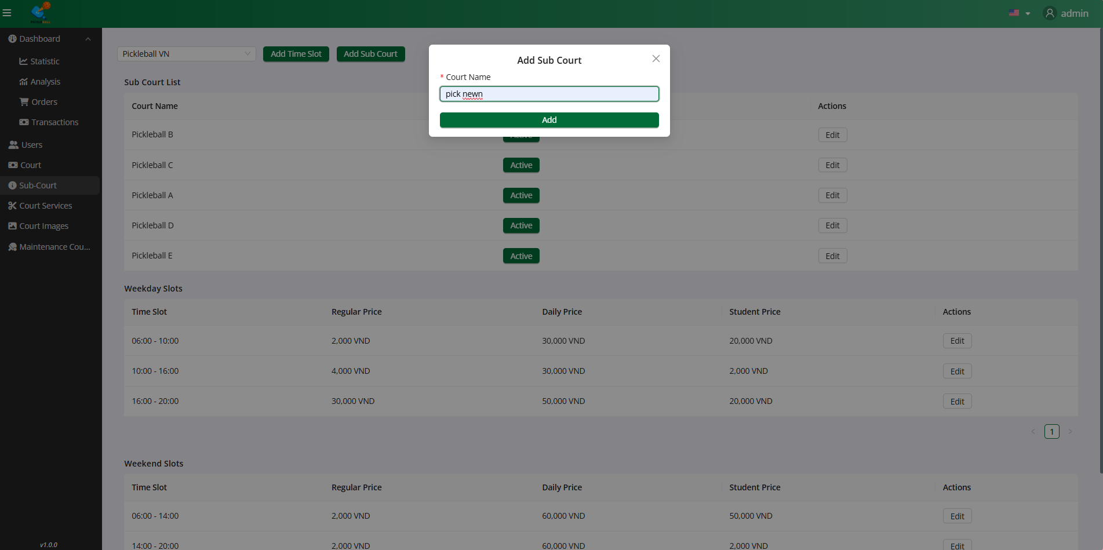

**Step 4:**Input all field valid to create Court

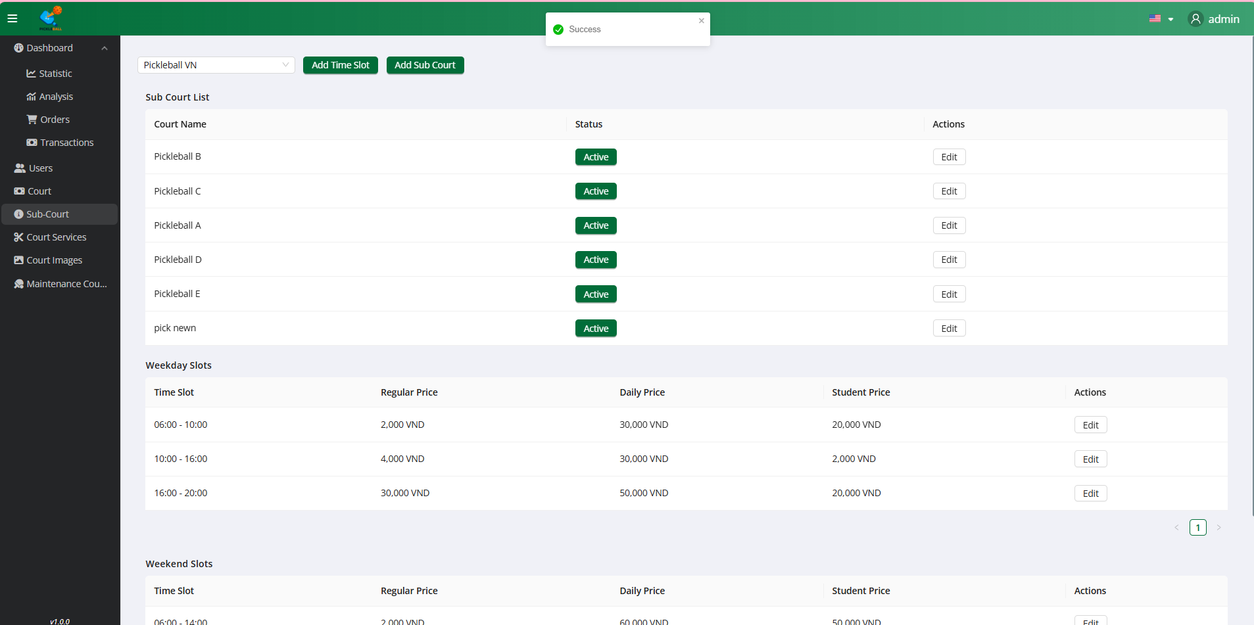

**Step 5:** Click on the “Add” button

### 3.7.8 Add TimeSlot



**Step 1:** Click on the button “Sub-Court”



**Step 2:** Filter by Sub-Count

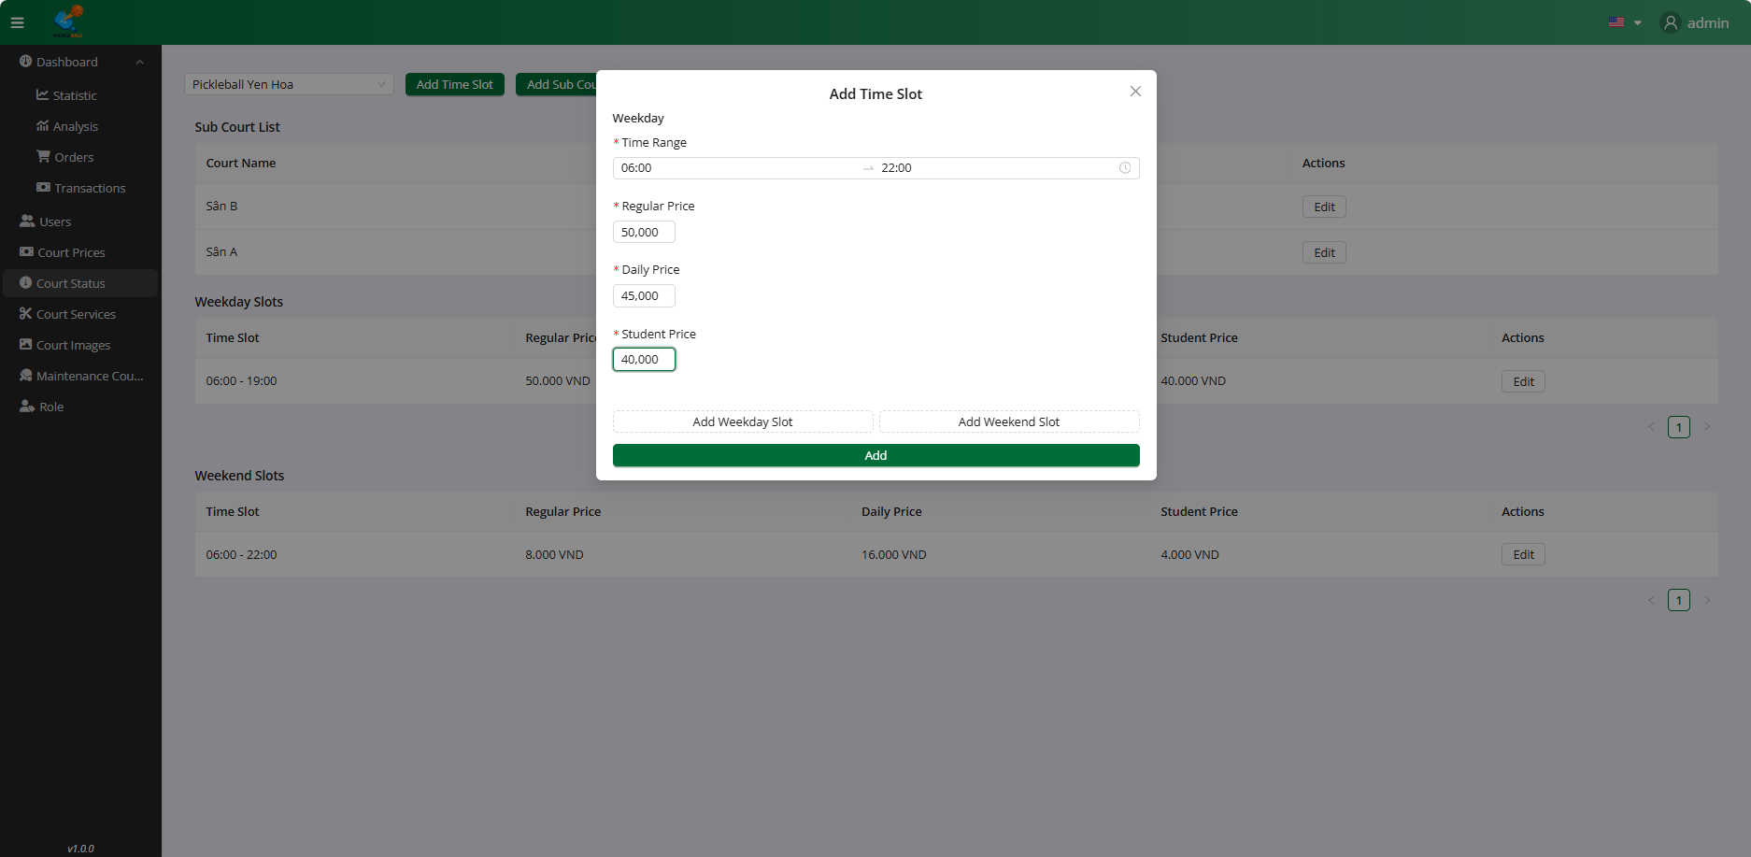

**Step 3:** Input all field valid to create Court

### 

**Step 4:** Click on the button “Add ”

### 3.7.9 Change Status Sub-Court



**Step 1:** Click on the button “Sub-Court”



**Step 2:** Filter by Sub-Count

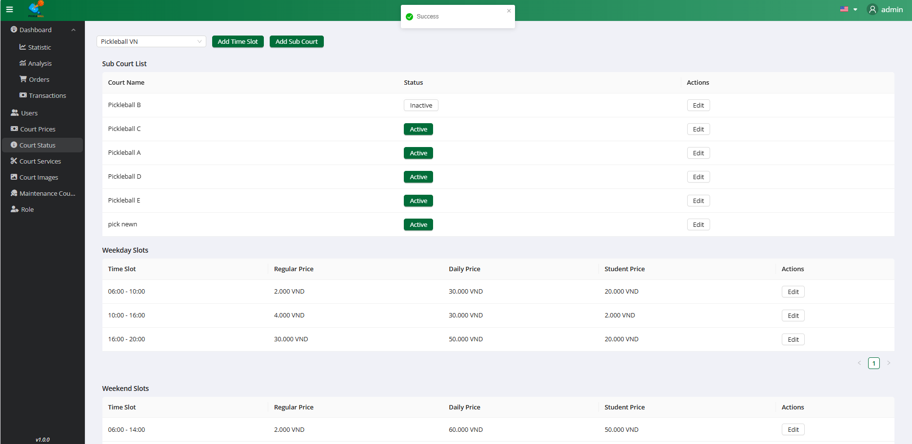

**Step 3:** Click on the button “Active”

### 3.7.10 Edit Sub-Court



**Step 1:** Click on the button “Sub-Court”



**Step 2:** Filter by Sub-Count

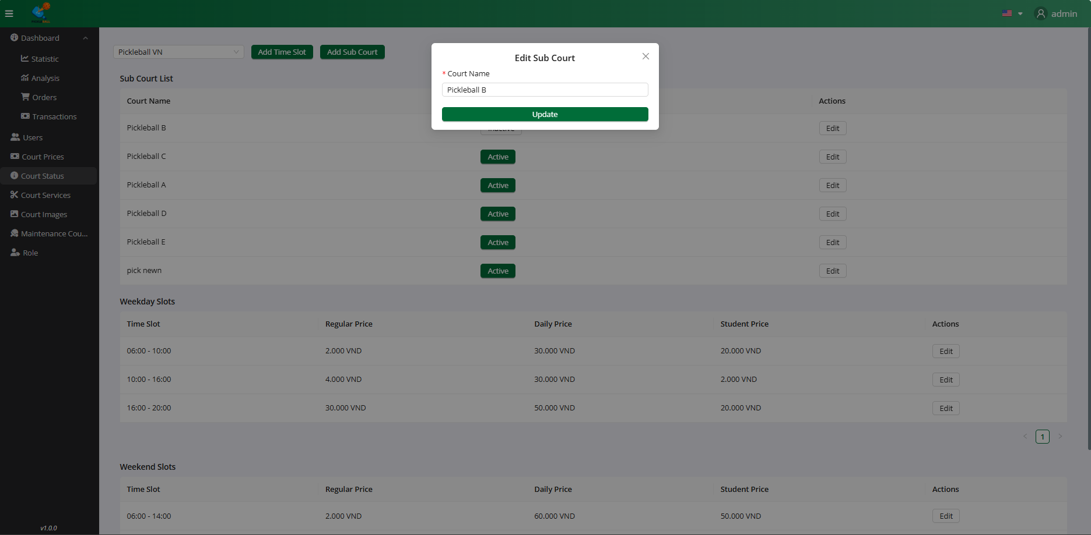

**Step 3:** Click on the button “Edit”

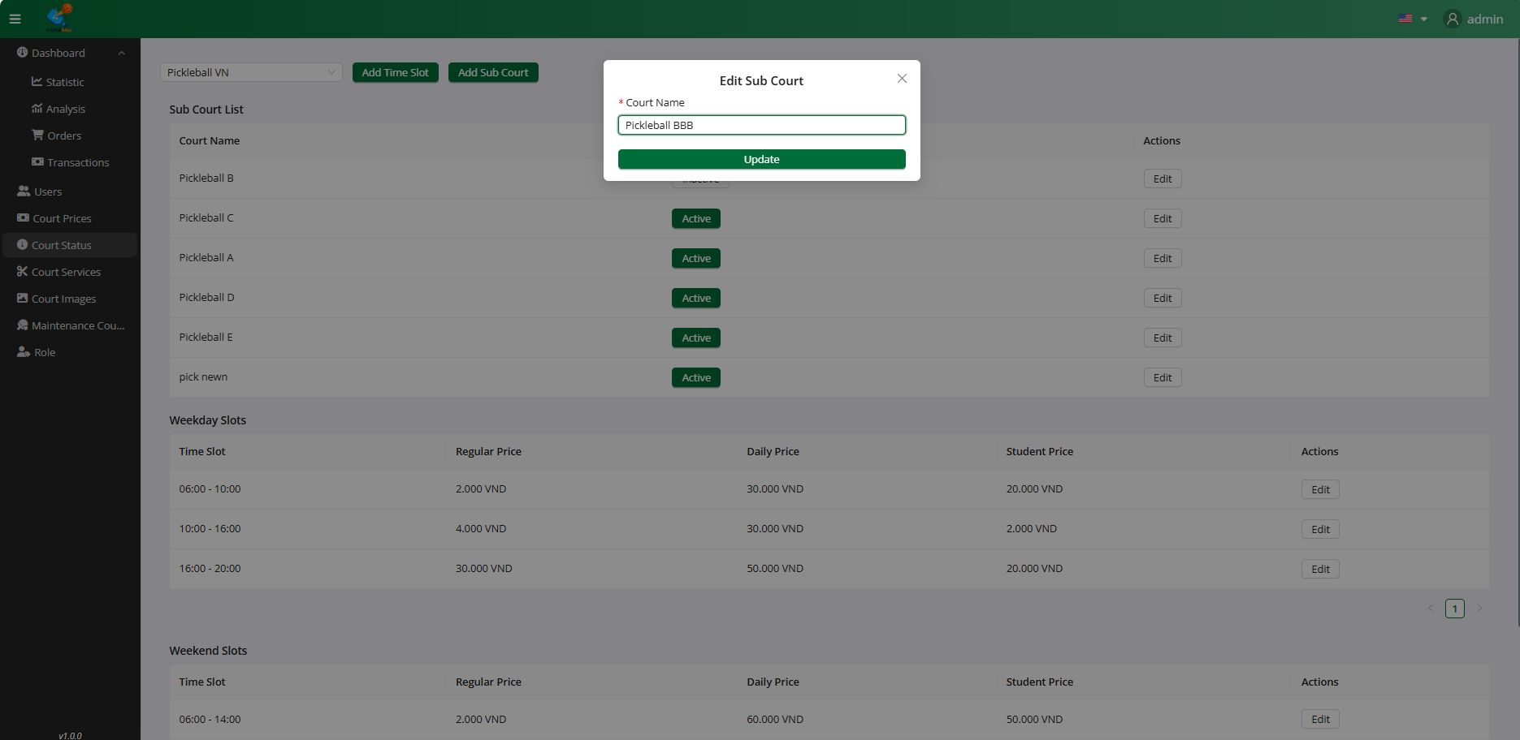

**Step 4:**Input all field valid to update Court

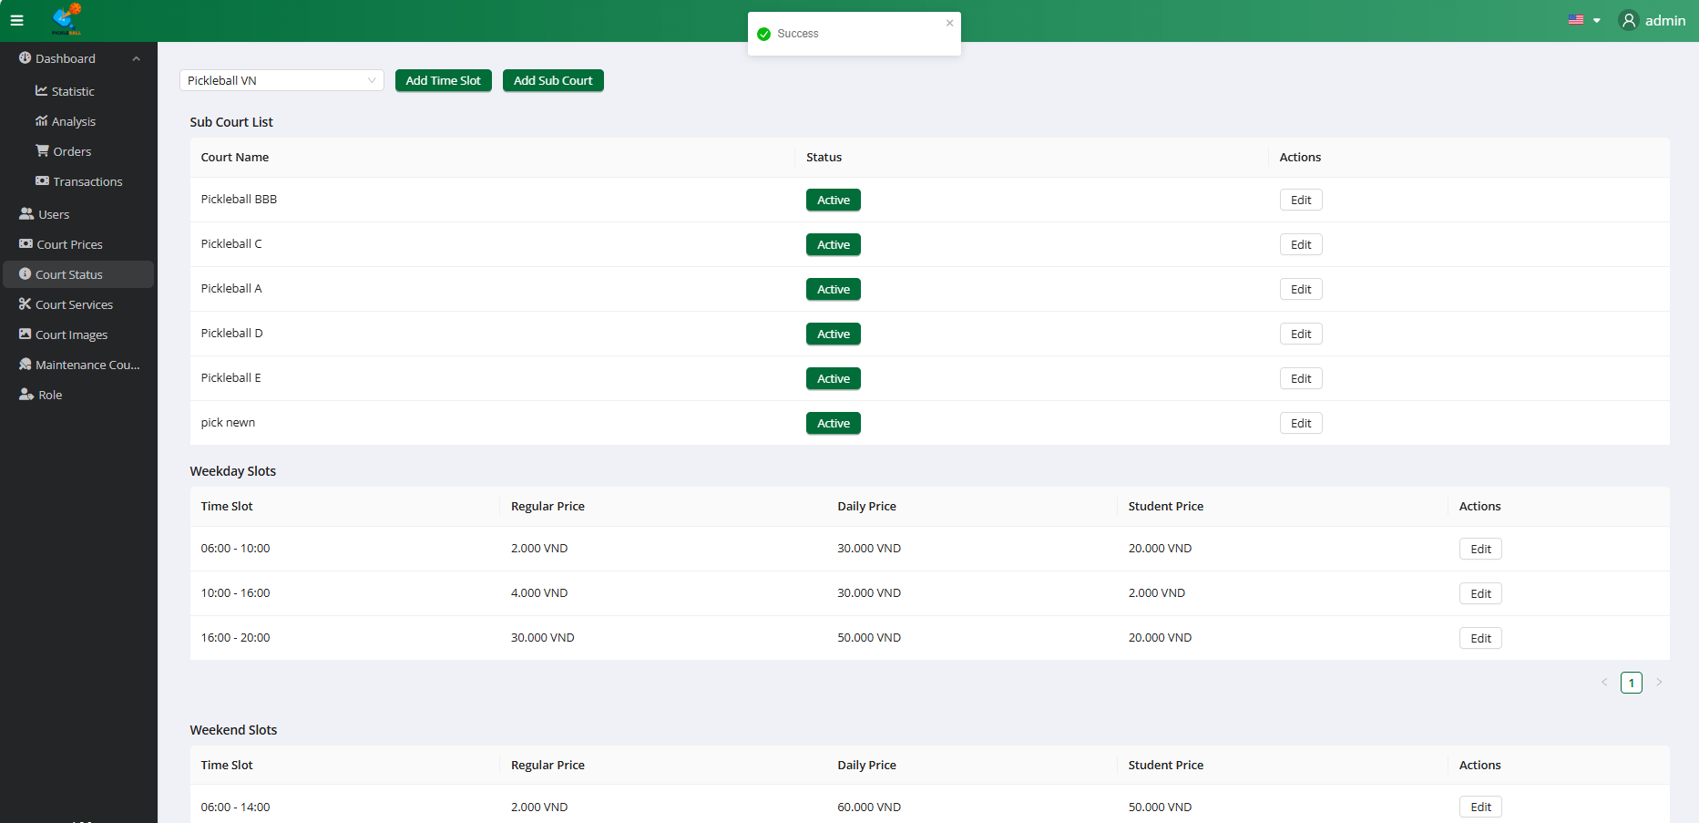

**Step 5:** Click on the “Update” button

### 3.7.11 Edit Timeslot



**Step 1:** Click on the button “Sub-Court”



**Step 2:** Filter by Sub-Count

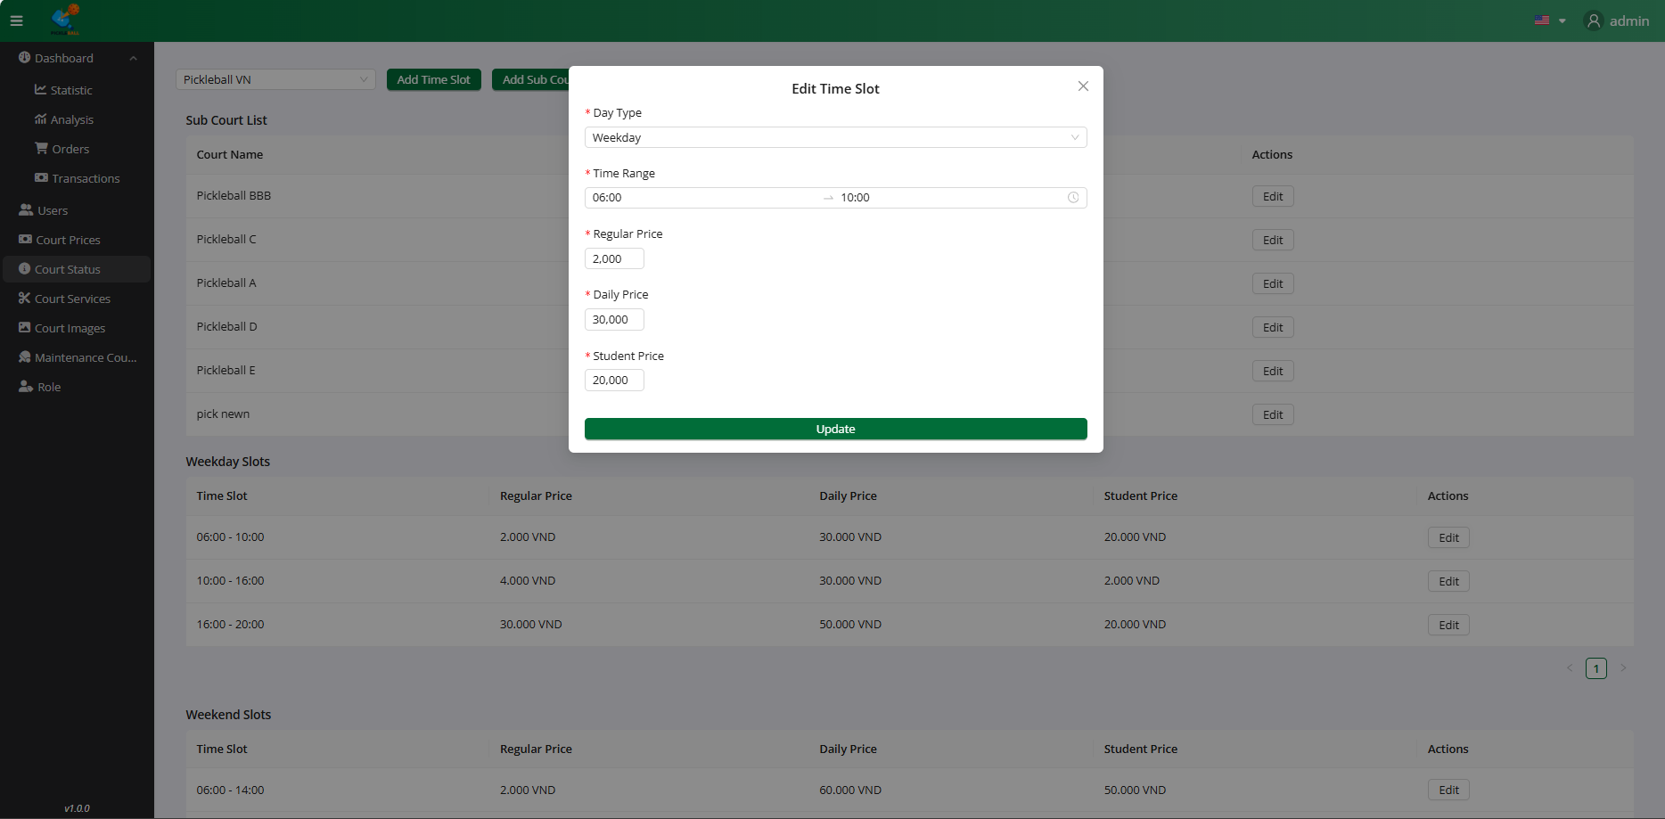

**Step 3:** Click on the button “Edit”

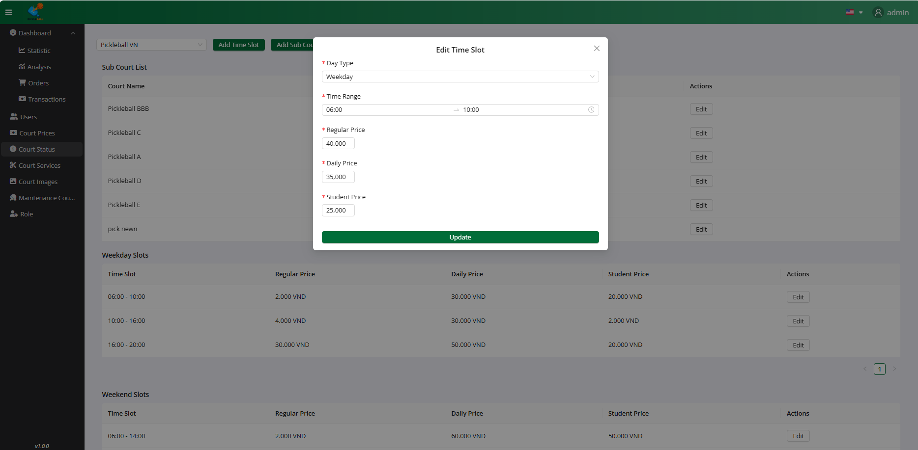

**Step 4:**Input all field valid to update Court

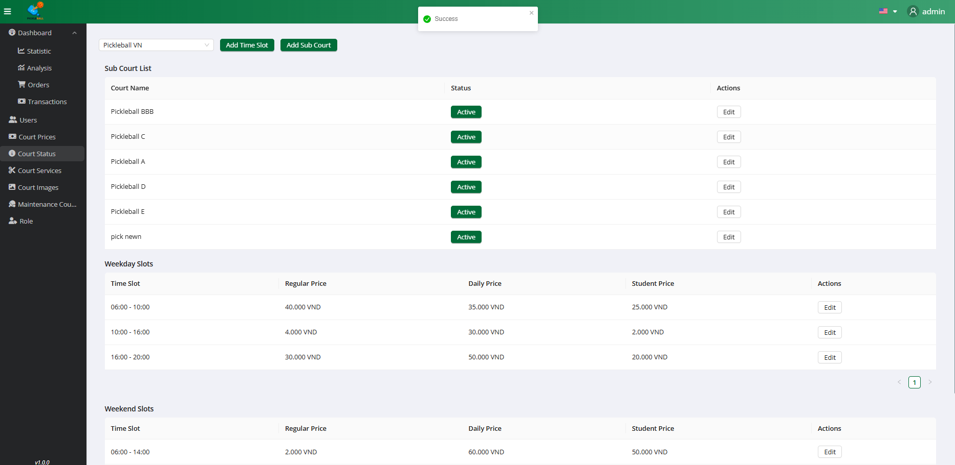

**Step 5:** Click on the “Update” button

### 

### 3.8 Workflow Manage Service

### 3.8.1 View Service

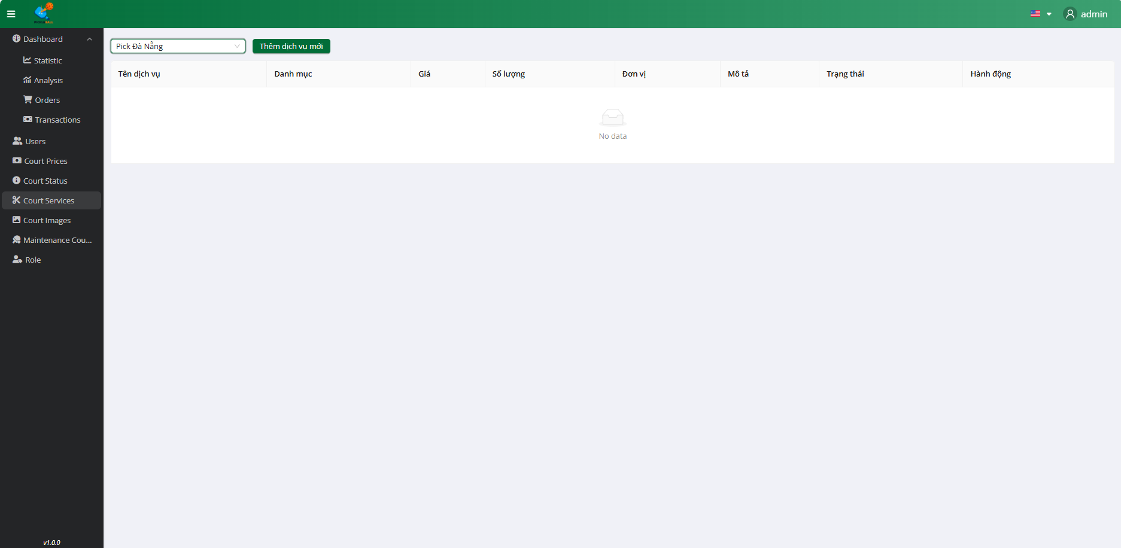

**Step 1:** Click on the button “Service”

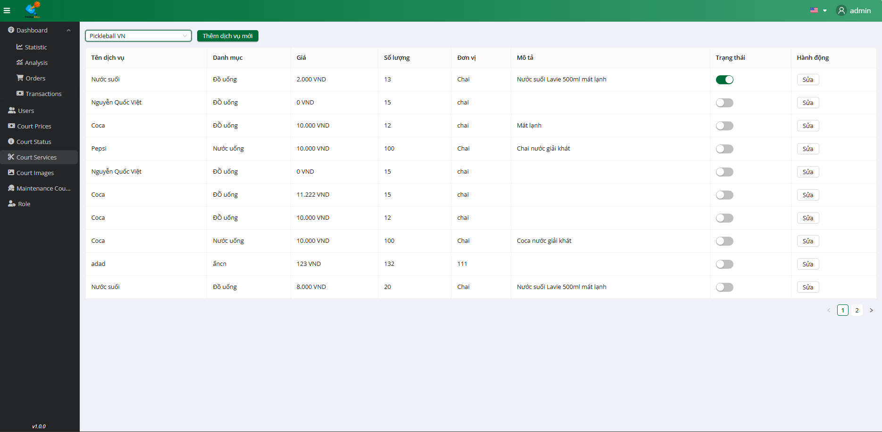

**Step 2:** Filter service by Sub-Count

### 3.8.2 Add Service



**Step 1:** Click on the button “Service”



**Step 2:** Filter service by Sub-Count

### 

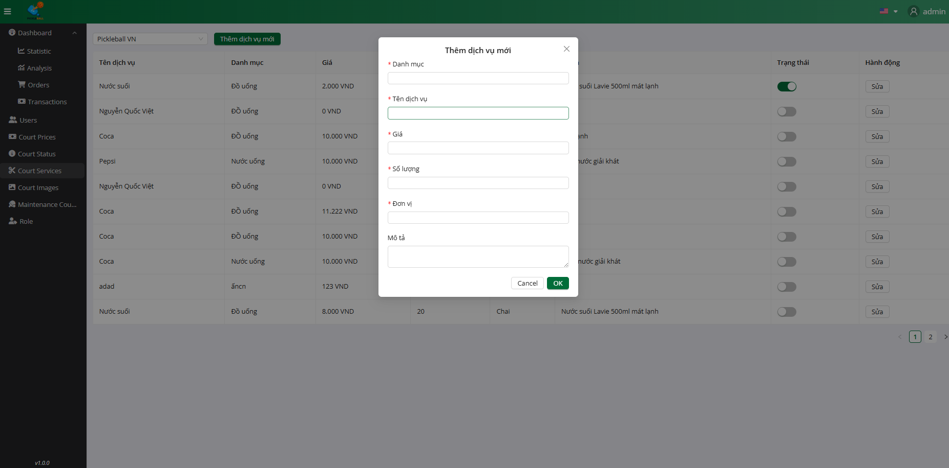

**Step 3:** Click on the “Thêm dịch vụ” button

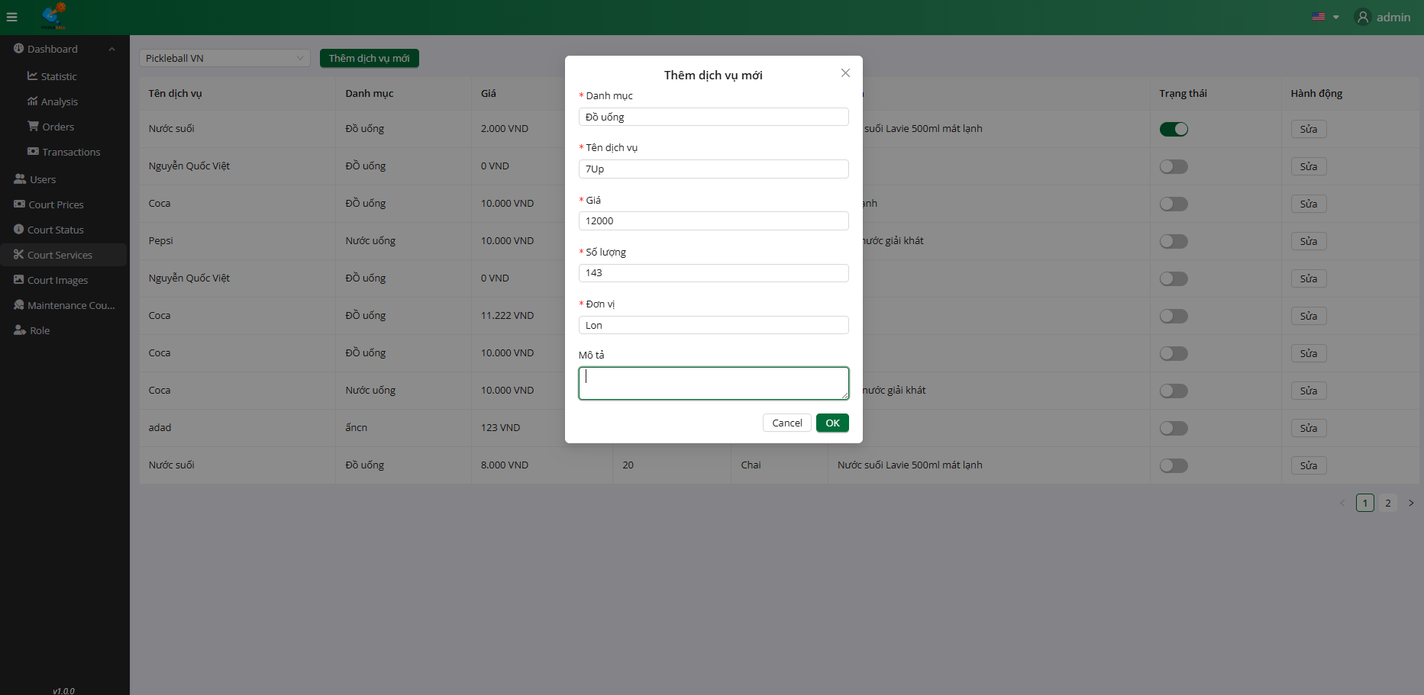

**Step 4:**Input all field valid to create service

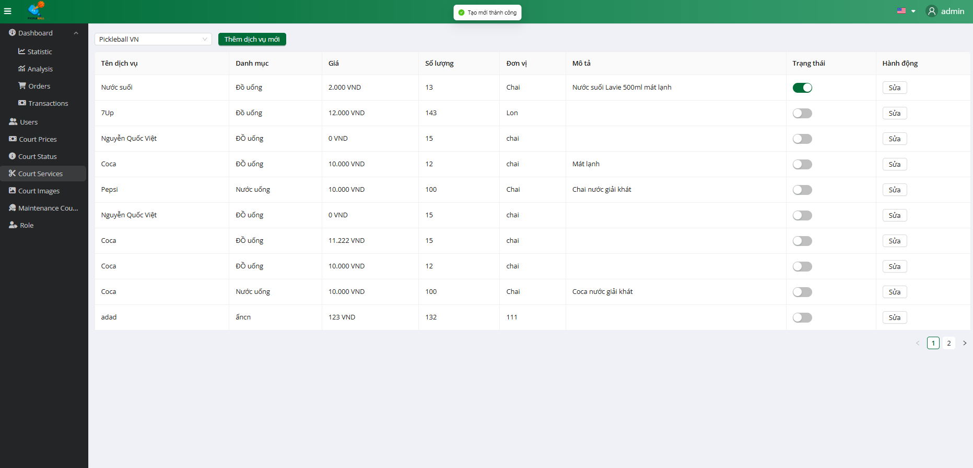

**Step 4:** Click on the “Ok” button

### 3.8.3 Edit Service



**Step 1:** Click on the button “Service”



**Step 2:** Filter service by Sub-Count

### 

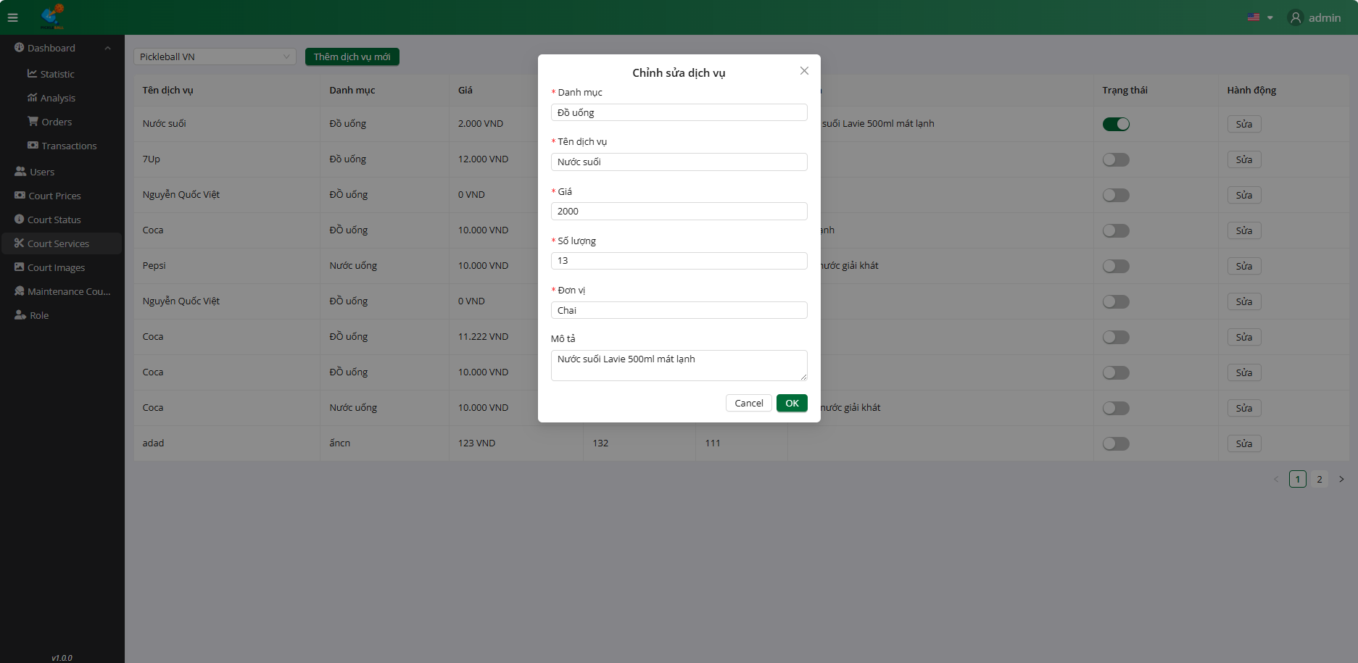

**Step 3:** Click on the “Sửa” button

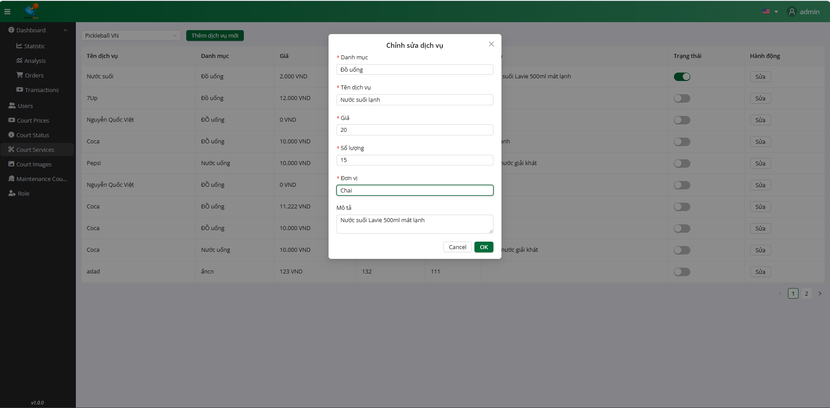

**Step 4:**Input all field valid to update service

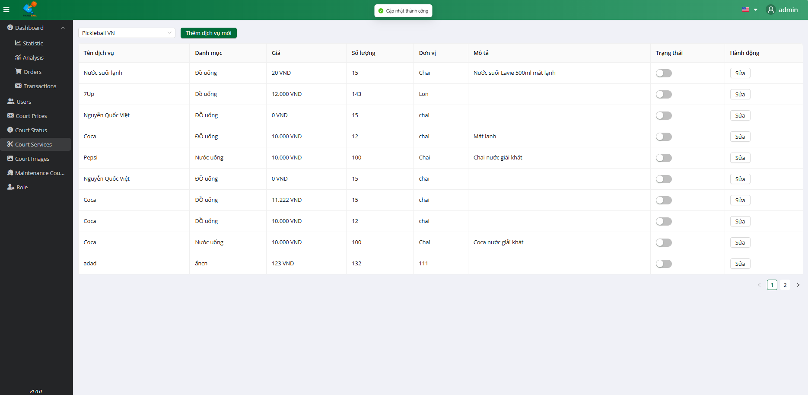

**Step 4:** Click on the “Ok” button

### 

### 3.8.4 Change Status User



**Step 1:** Click on the button “Service”



**Step 2:** Filter service by Sub-Count

### 

### 

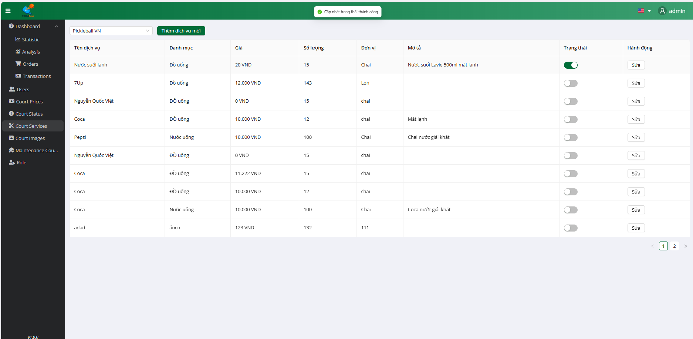

**Step 2:** Click on the button “Status”

### 

### 

### 3.9 Workflow Manage Maintenance Court

### 3.9.1 View Maintenance

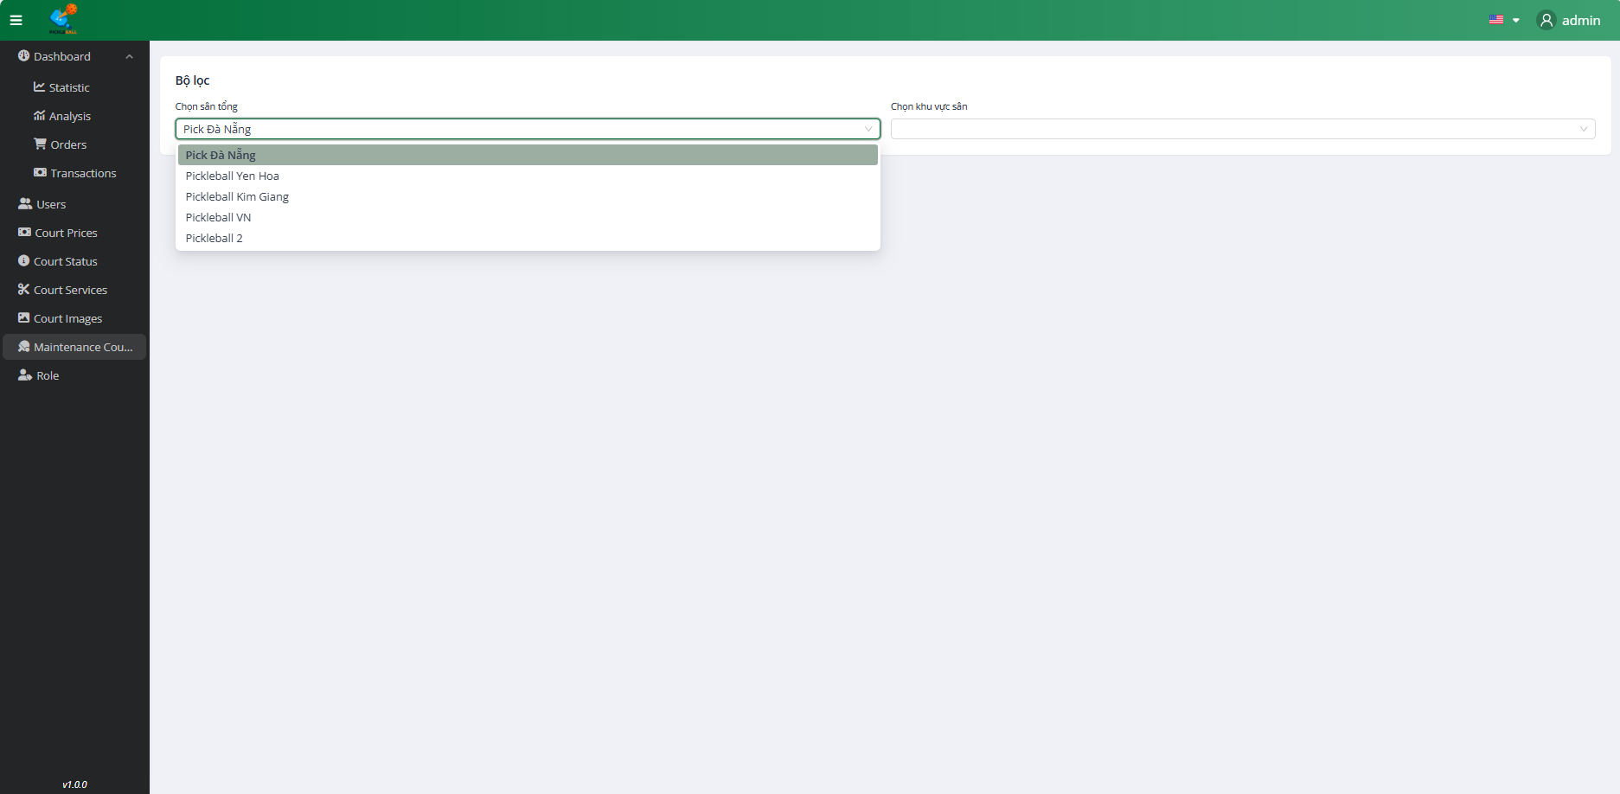

**Step 1:** Click on the button “Maintenance Court”

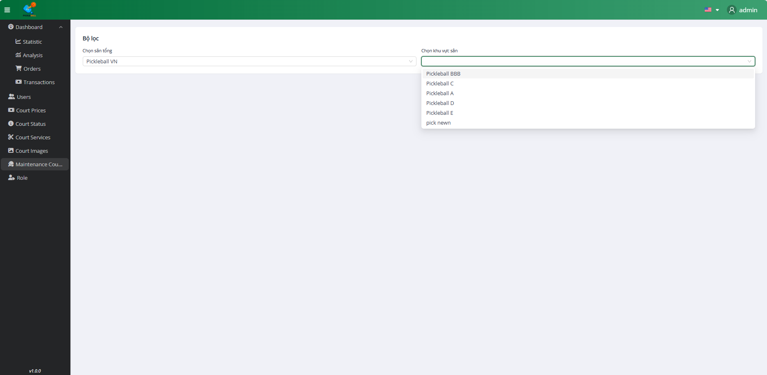

**Step 2:** Filter maintenance by Count

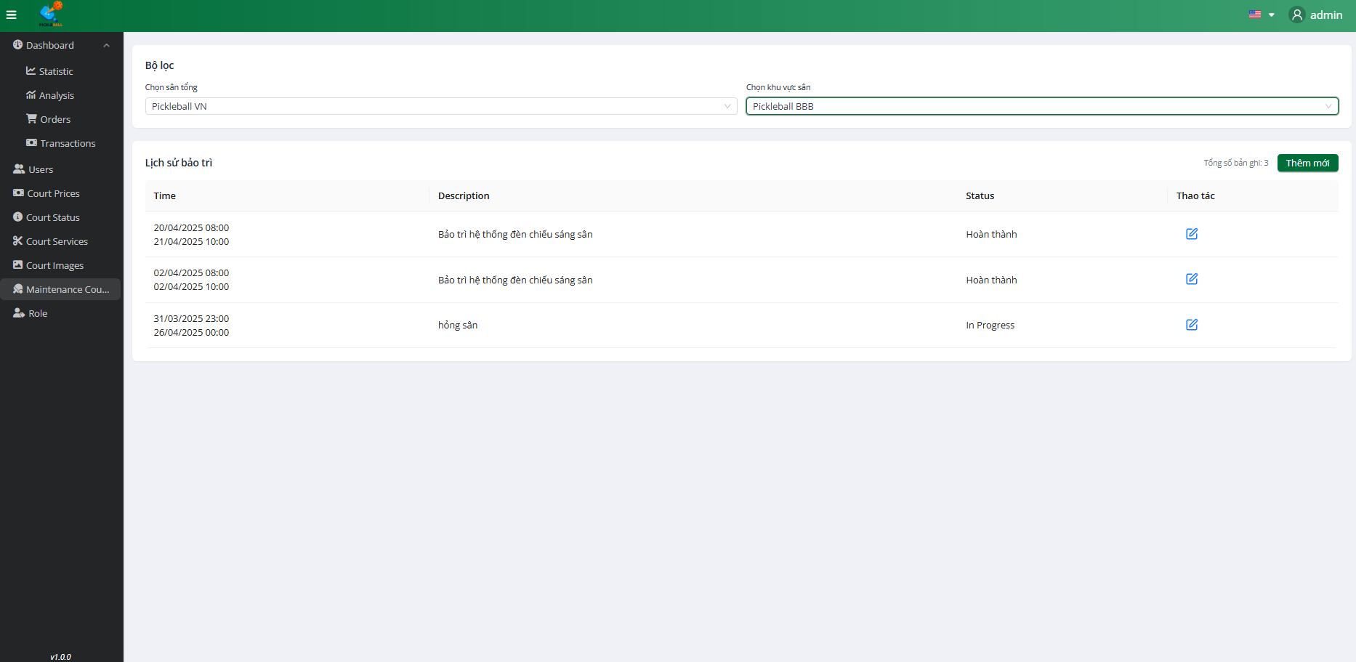

**Step 3:** Filter maintenance by Sub-Count

### 3.9.2 Create Maintenance



**Step 1:** Click on the button “Maintenance Court”



**Step 2:** Filter maintenance by Count



**Step 3:** Filter maintenance by Sub-Count

### 

### 

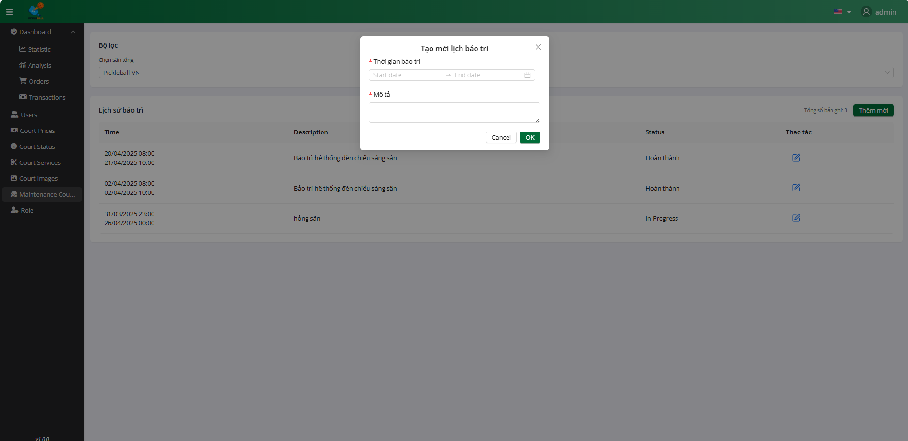

**Step 4:** Click on the “Thêm mới” button

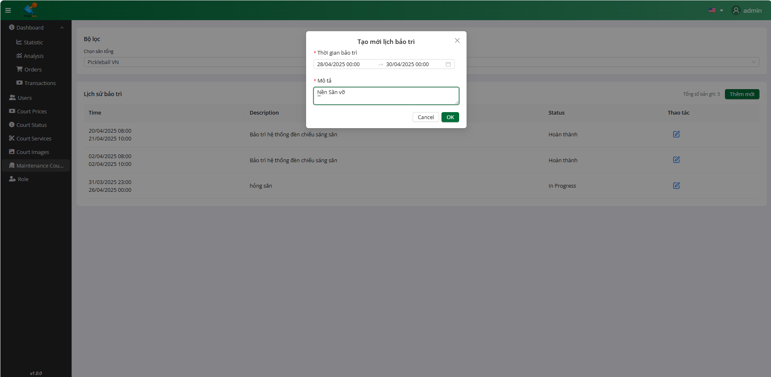

**Step 5:**Input all field valid to create maintenance

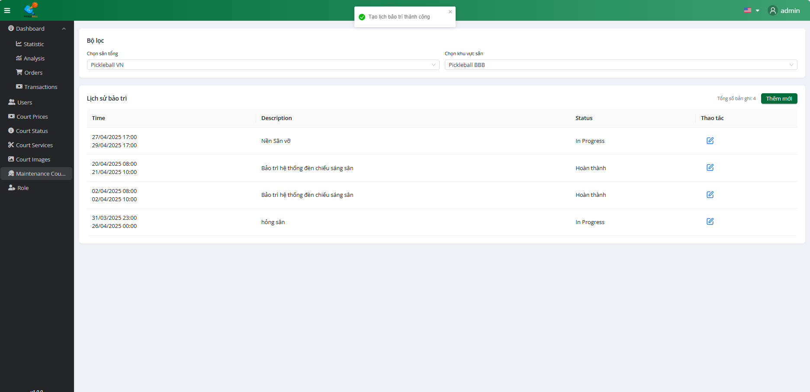

**Step 4:** Click on the “Ok” button

### 3.9.3 Edit Maintenance



**Step 1:** Click on the button “Maintenance Court”



**Step 2:** Filter maintenance by Count



**Step 3:** Filter maintenance by Sub-Count

### 

### 

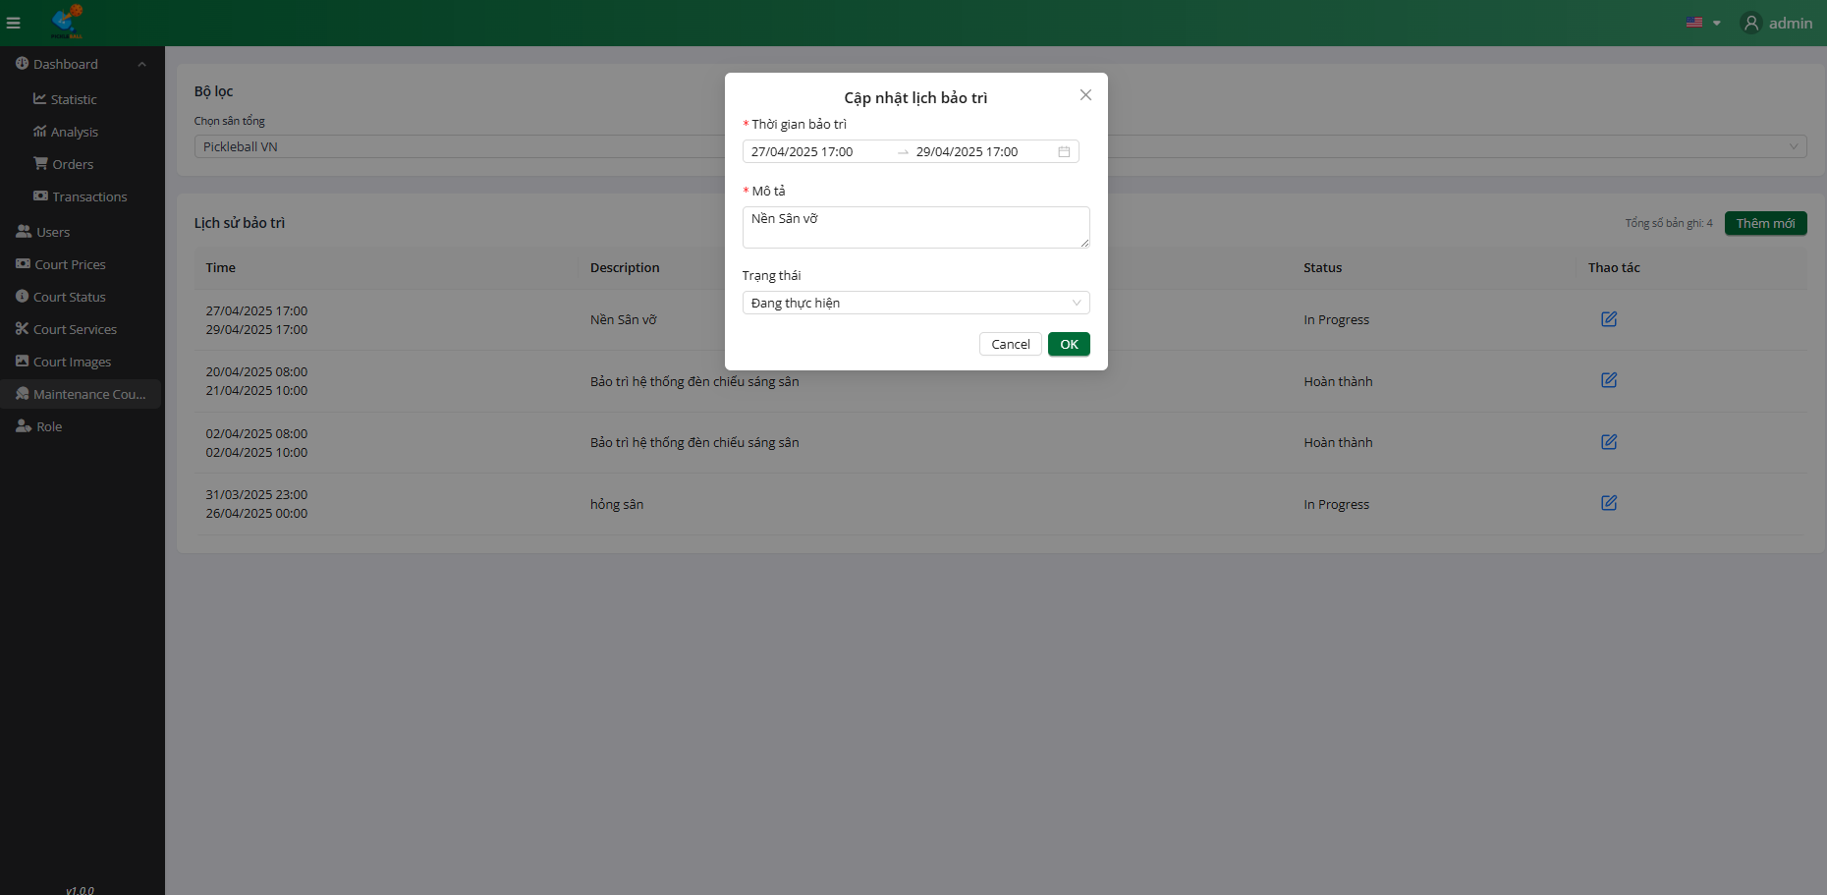

**Step 4:** Click on the “Edit” button

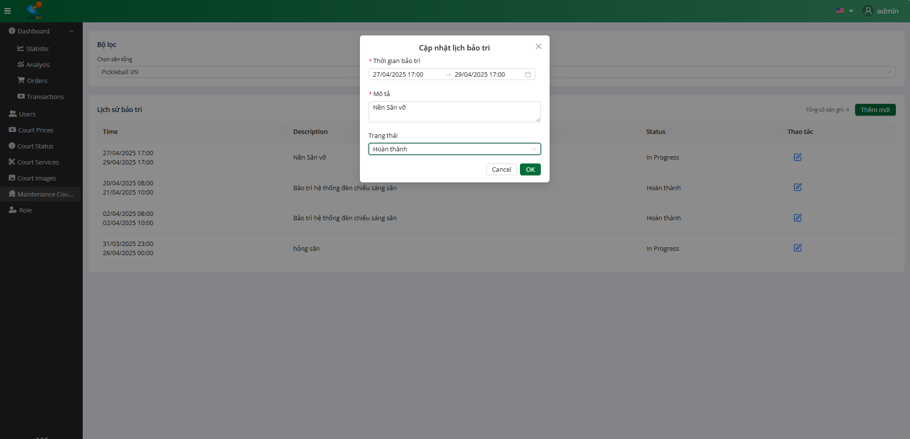

**Step 5:**Input all field valid to update maintenance

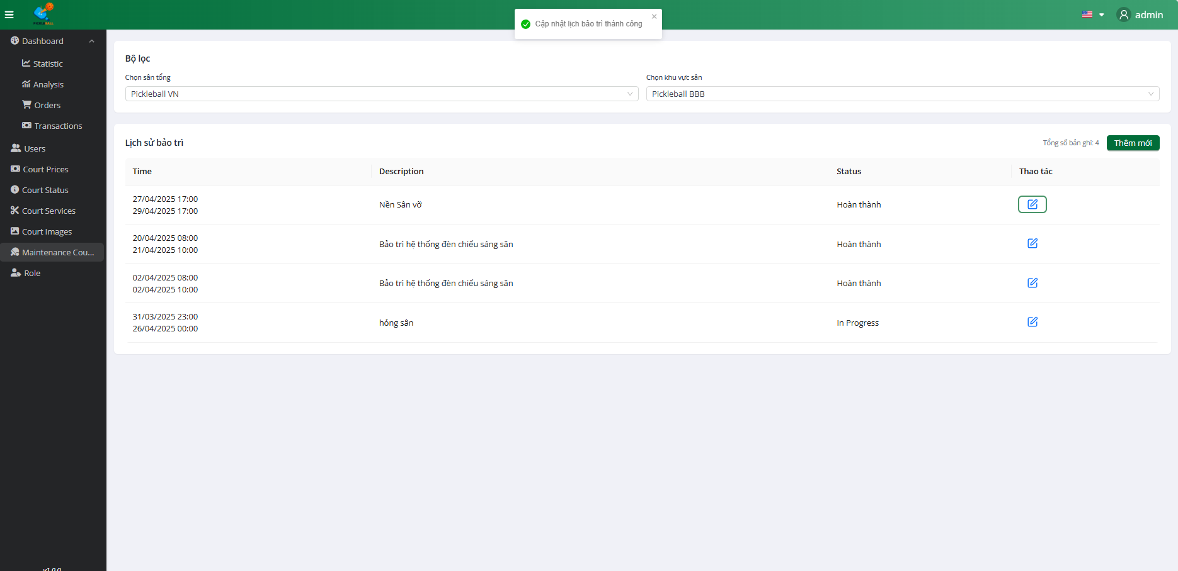

**Step 6:** Click on the “Ok” button

### 

### 3.10. Workflow Manage Role

### 3.10.1 View Role

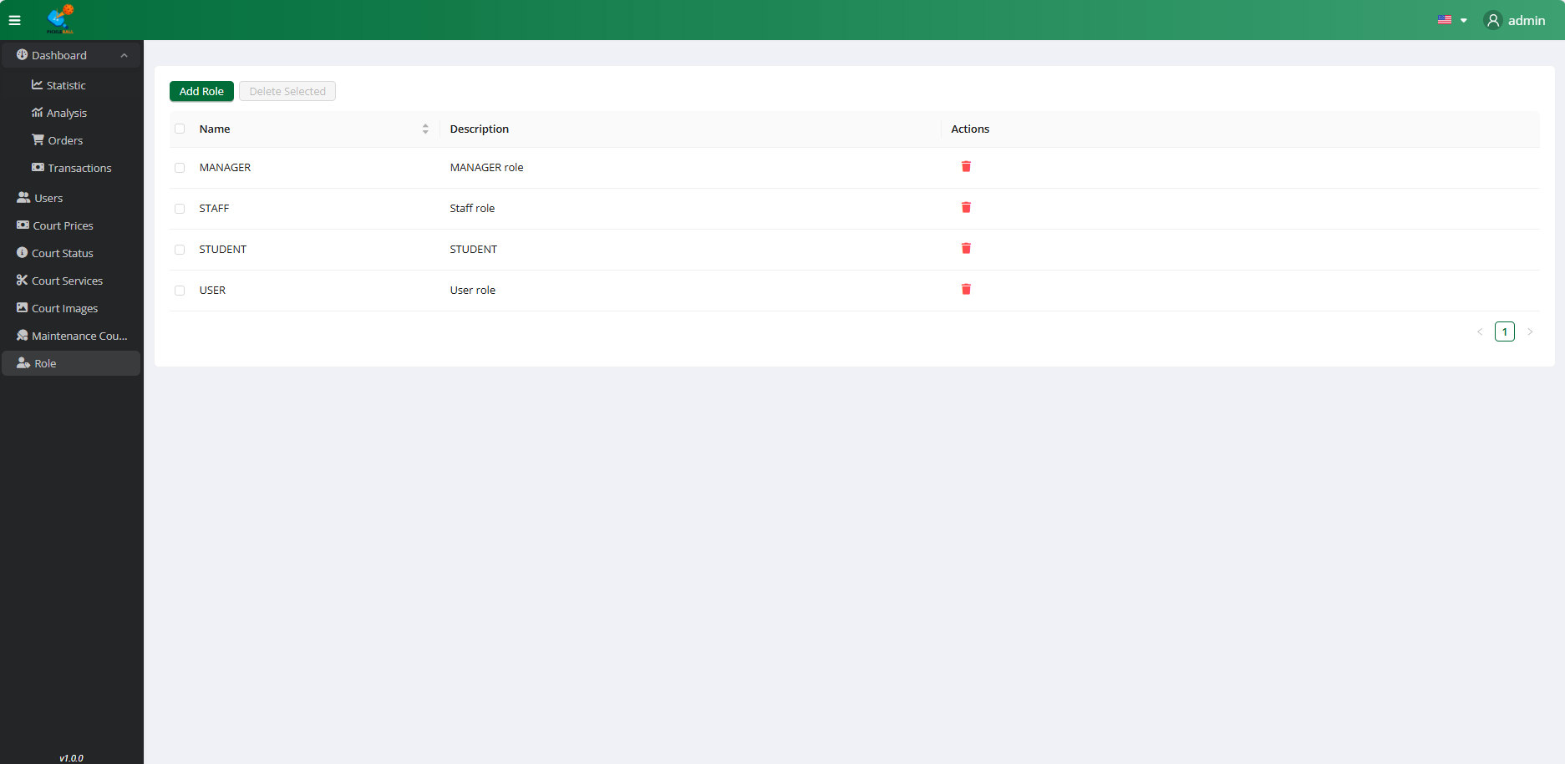

**Step 1:** Click on the button “Role”

### 3.10.2 Create Role



**Step 1:** Click on the button “Role”

### 

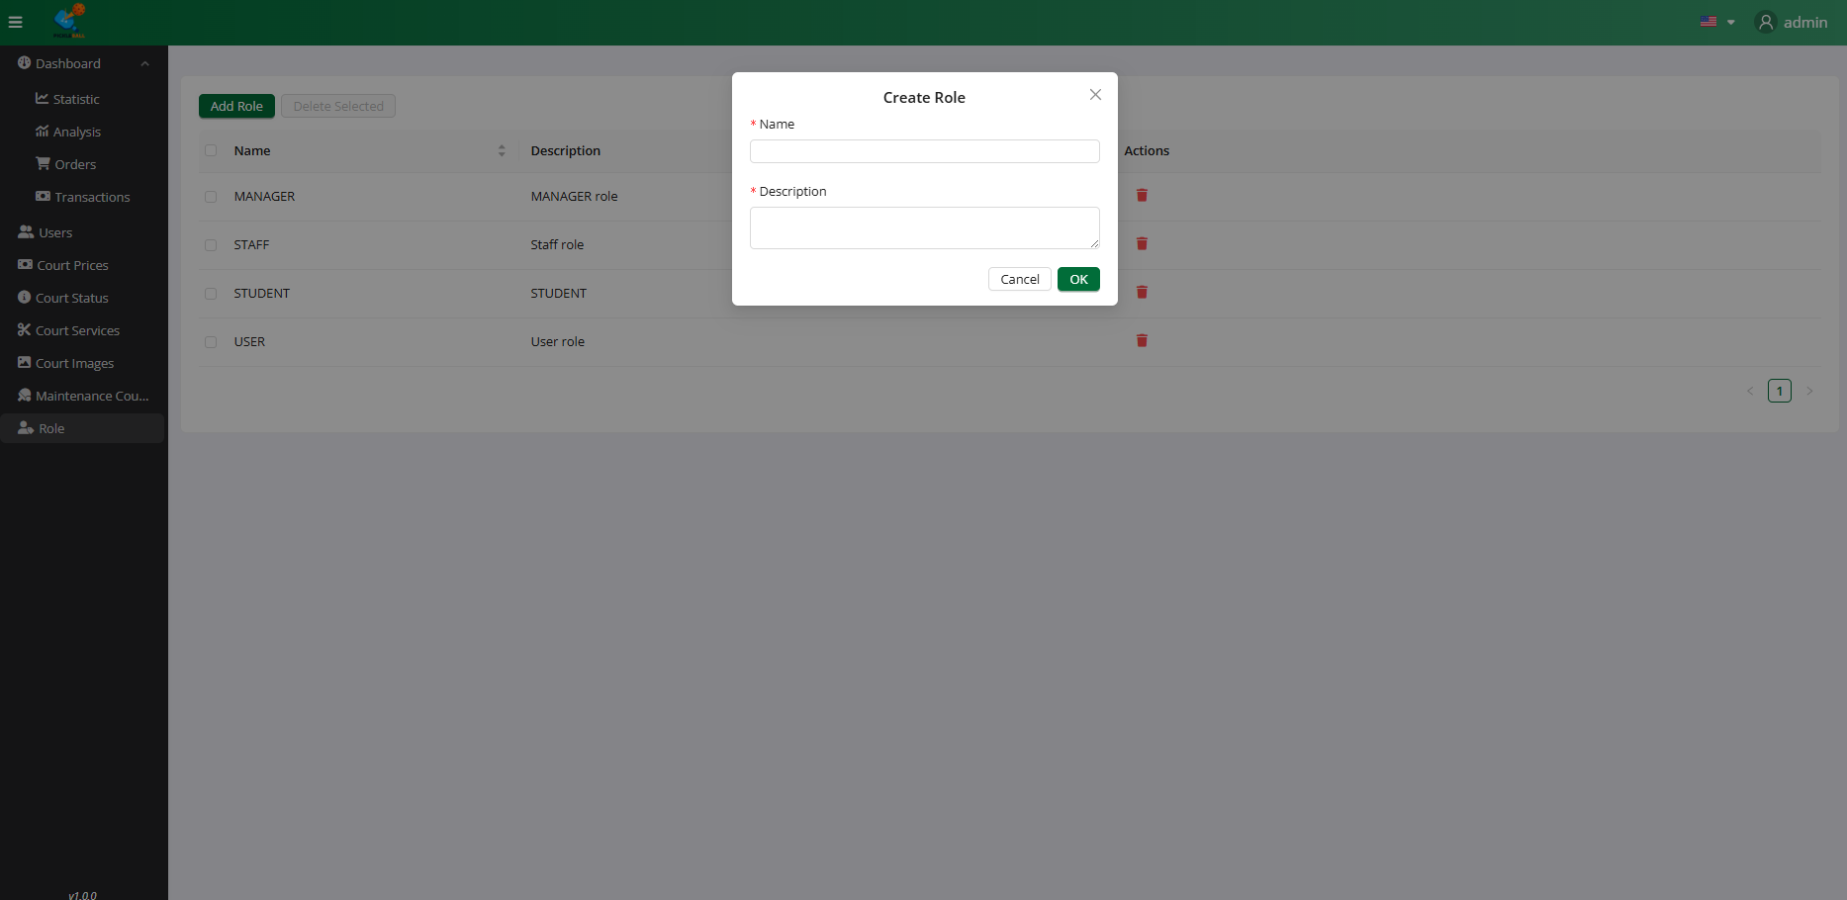

**Step 2:** Click on the “Add Role” button

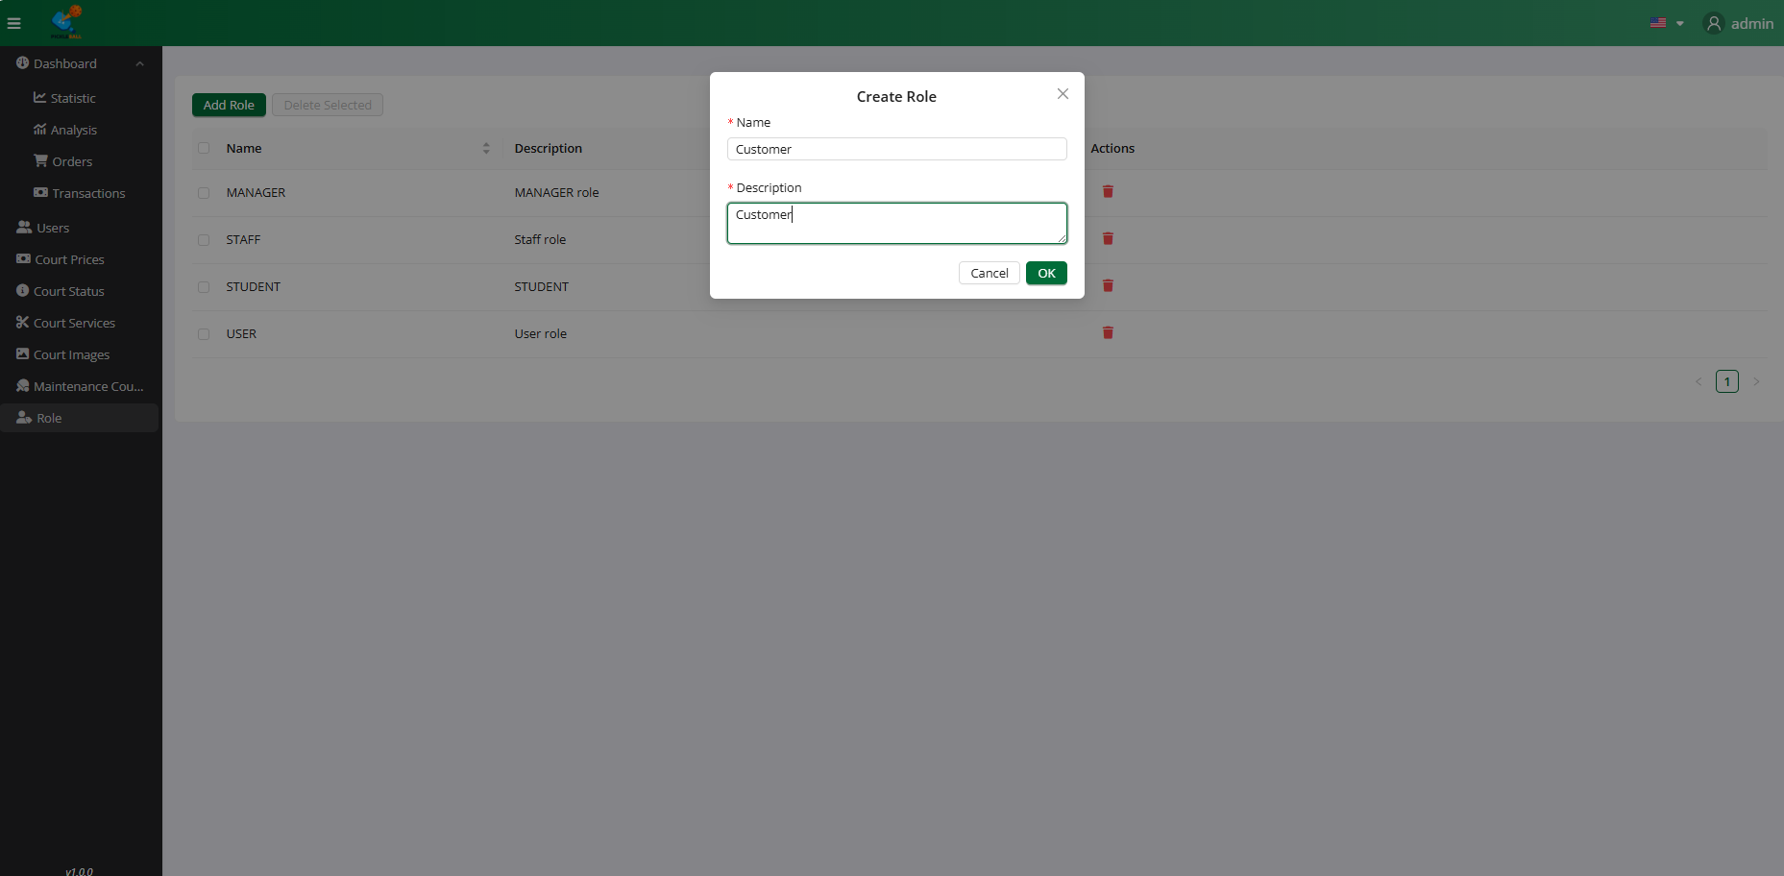

**Step 3:**Input all field valid to create role

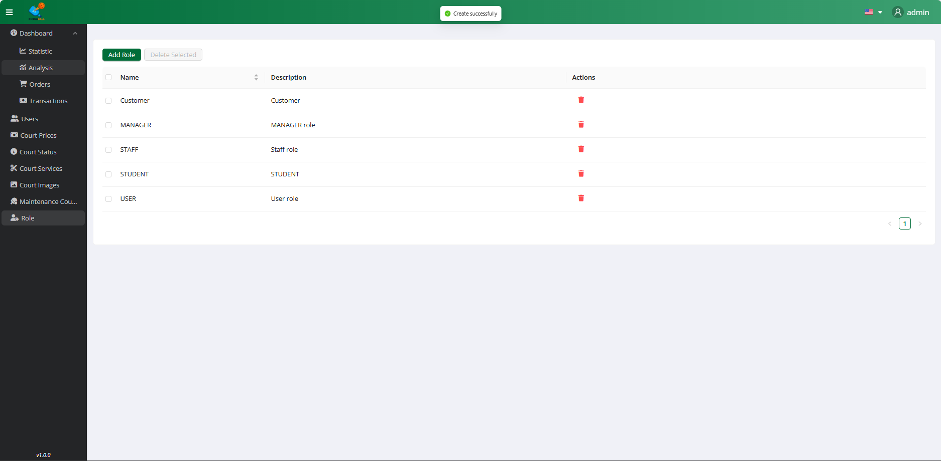

**Step 4:** Click on the “Ok” button

### 3.10.3 Delete Role



**Step 1:** Click on the button “Role”

### 

**Step 2:** Click on the “Delete” button

### 

### 

### 3.3 Workflow on Mobile

### 

#### 

#### 

#### 3.3.4 Login

### 

**Step 1:** Click on the “Login” button

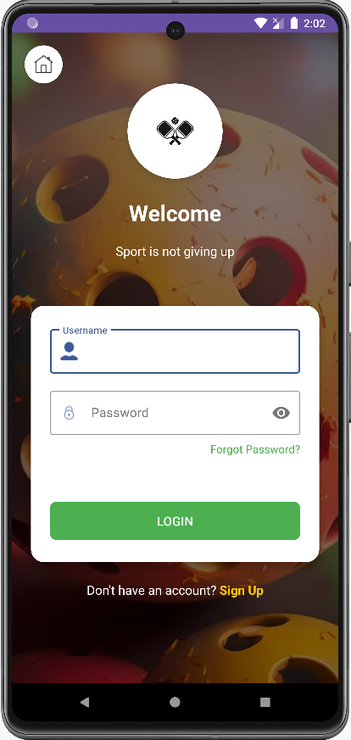

**Step 2:** Enter username & password valid

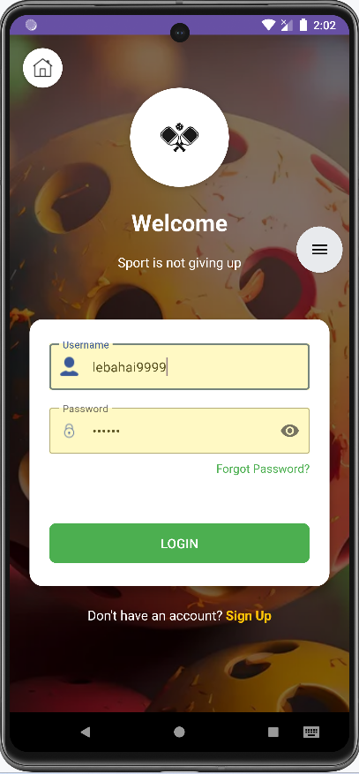

**Step 3:** Click on the “Login” button

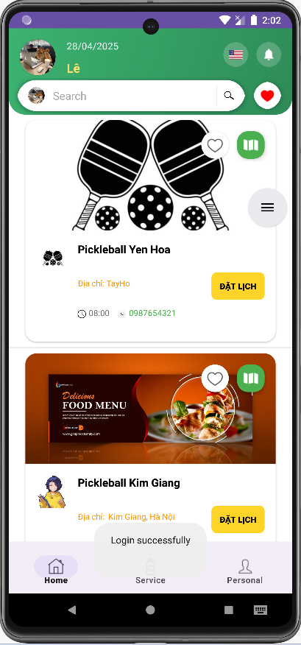

#### 3.3.5 Logout

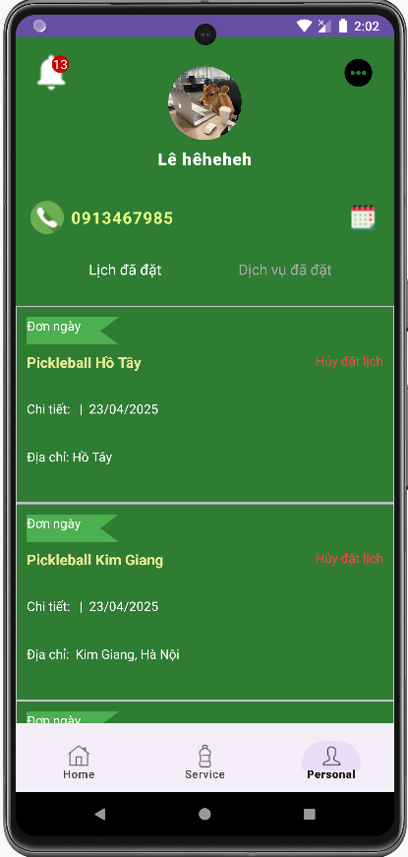

**Step 1:** Click on the “Profile” button

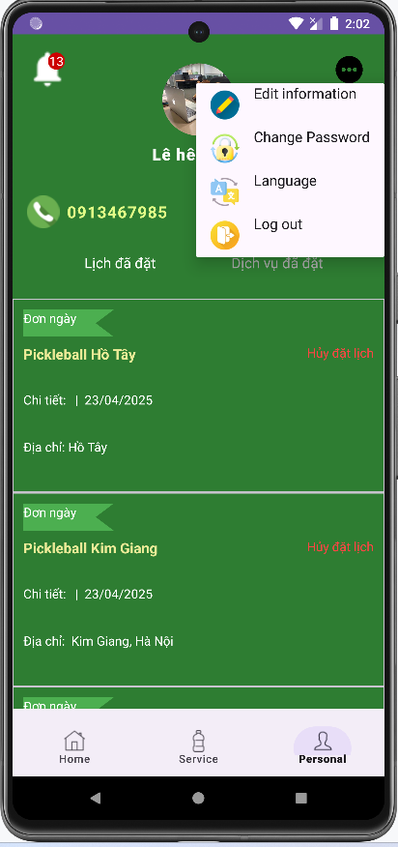

**Step 2:** Click on the “More” button



**Step 3:** Click on the “Logout” button

#### 3.3.6 Register

### 

### 

**Step 1:** Click on the “Register” button

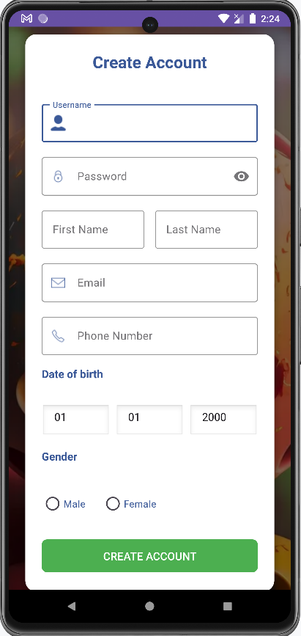

**Step 2:** Input all field valid to create account

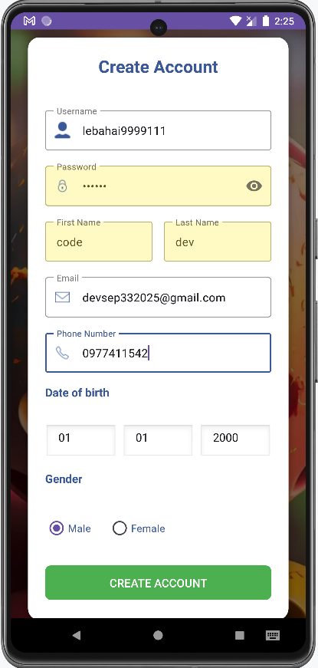

**Step 3:** Click on the “Create Account” button

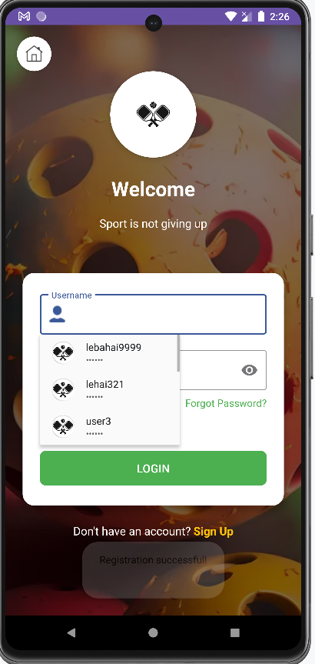

#### 3.3.7 Forget password



**Step 1:** Click on the “Forget password” button

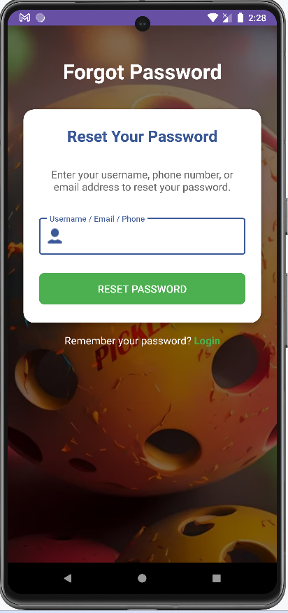

**Step 2:** Input username/phone number/email valid

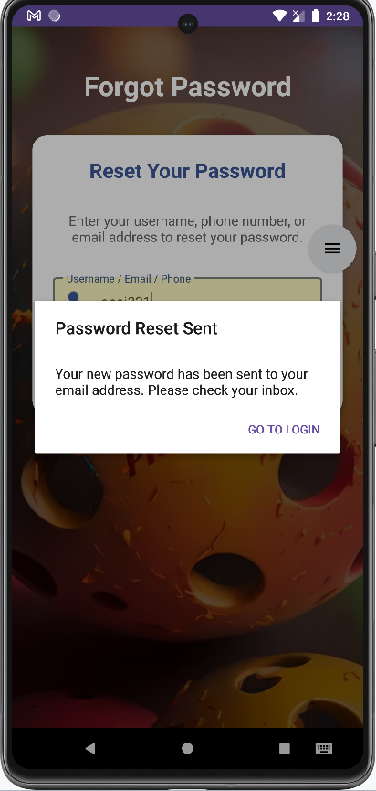

**Step 3:** Click on the “Reset Password” button

#### 3.3.8 Change password



**Step 1:** Click on the “More” button



**Step 2:** Click on the “Change Password” button

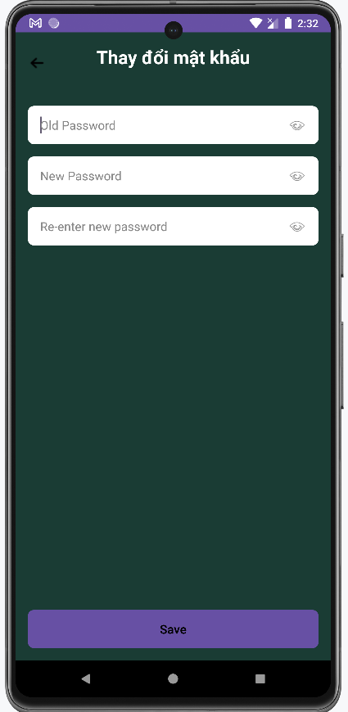

**Step 3:** Enter old password & new password & re-enter new password

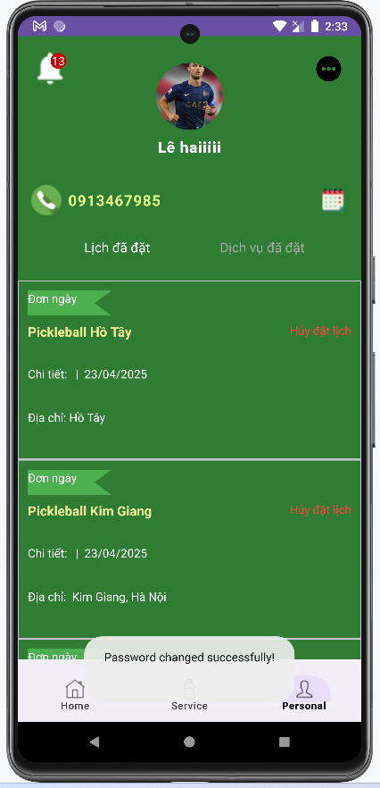

**Step 4:** Click on the “Save” button

#### 3.3.9 Manage Profile



**Step 1:** Click on the “More” button



**Step 2:** Click on the “More” button

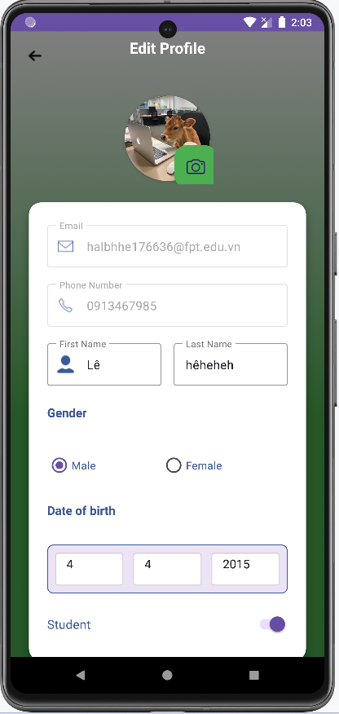

**Step 3:** Click on the “Edit Profile” button

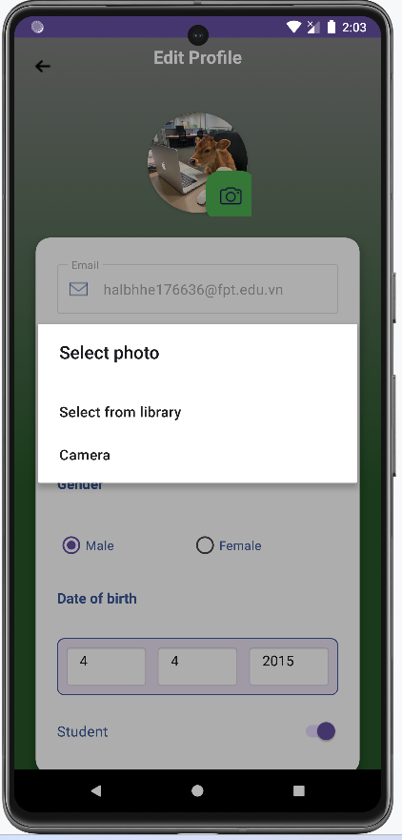

**Step 4:** Click on the “Camera” button to change avatar

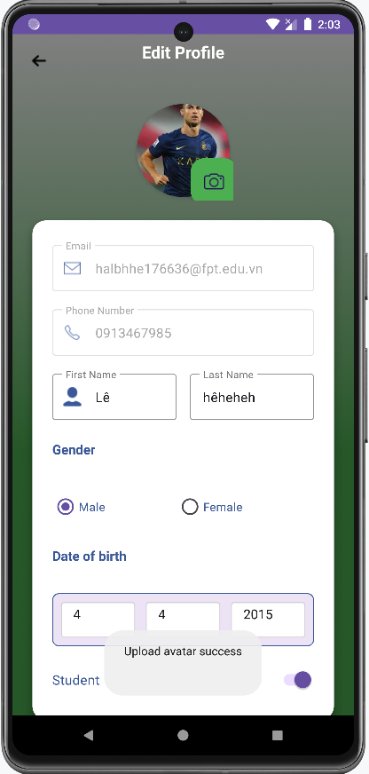

**Step 5:** Enter field valid to change information

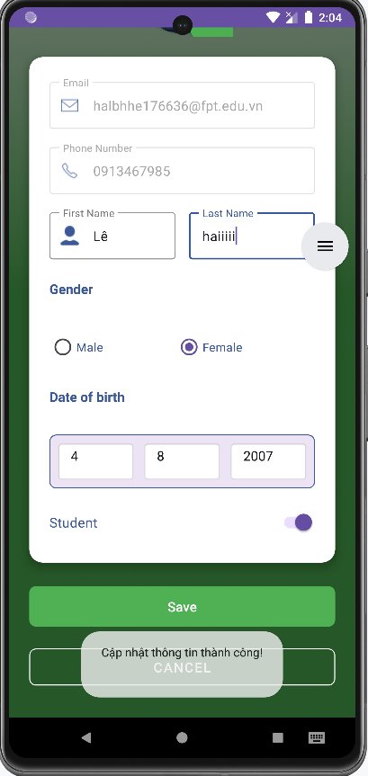

**Step 6:** Click on the “Save” button to change information

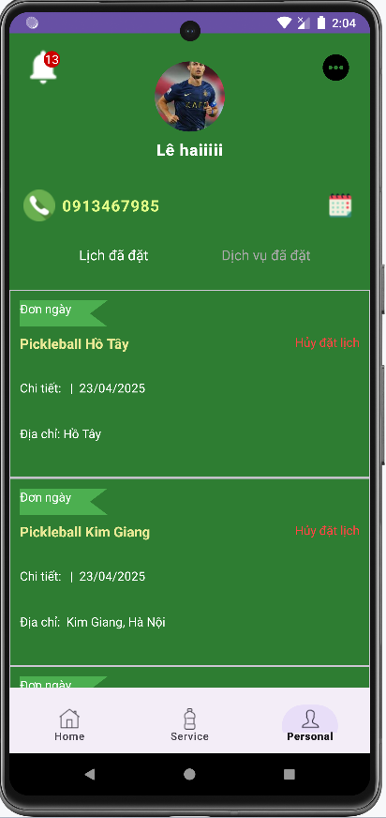

### 

#### 3.4.0 Notify

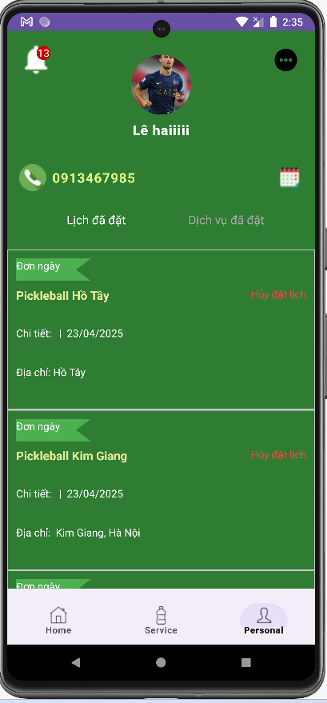

**Step 1:** Click on the “Notify” button

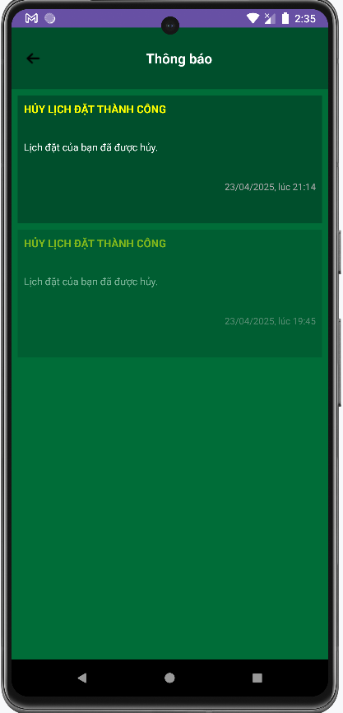

**Step 2:** Click on the item to view detail notification

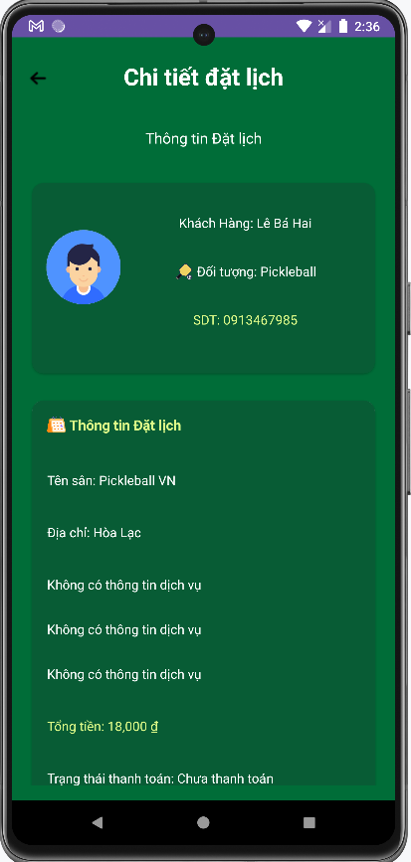

### 

#### 3.4.1 Booking Daily

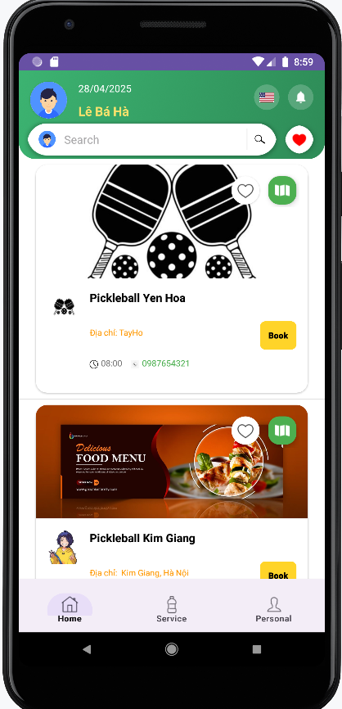

**Step 1:** Click on the “Book” button

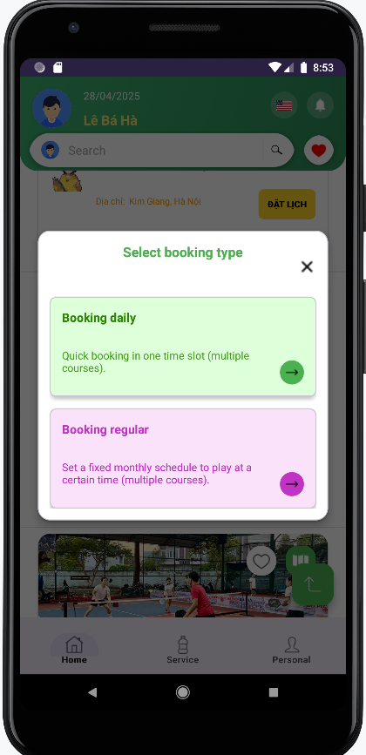

**Step 2:** Click on the “Booking daily” button. The system redirects to the “Booking Daily” screen.

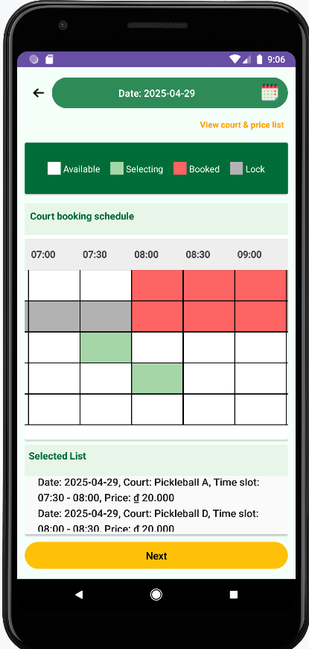

**Step 3:** Click on the time slot cell that has status “Available”. Then click on “Next” button

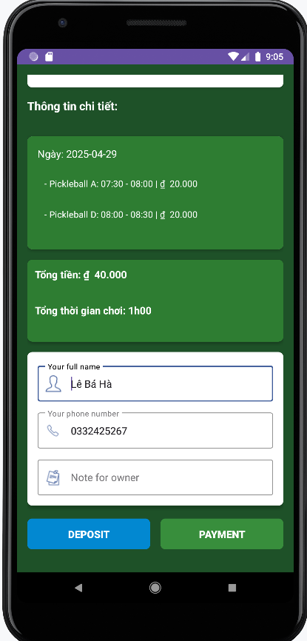

**Step 4:** Fill in the form for all required fields

**Full name(*):** This is for a user to input a valid user name. Not be empty.

**Phone number(*):** This is for the user to input a valid phone number. Not be empty.

**Note:** Note for staff.

**Step 5:** Click on the “PAYMENT” button or “DEPOSIT”

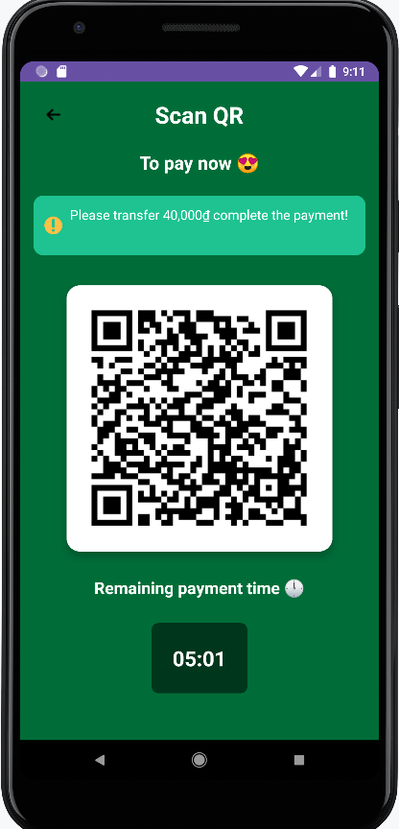

**Step 6:** Scan QR code and complete payment or deposit

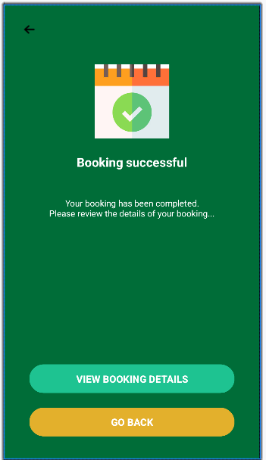

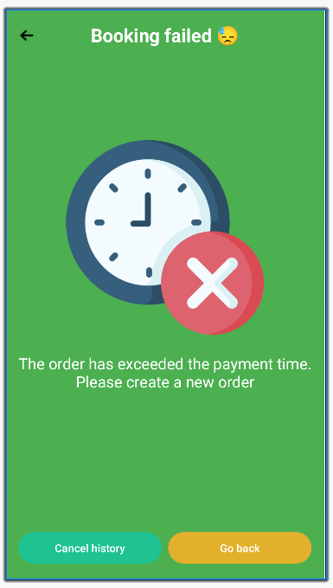

**Step 7:** The system redirects to the “Booking Success” screen or if you don't complete booking so the system redirects to the “Booking Failed”

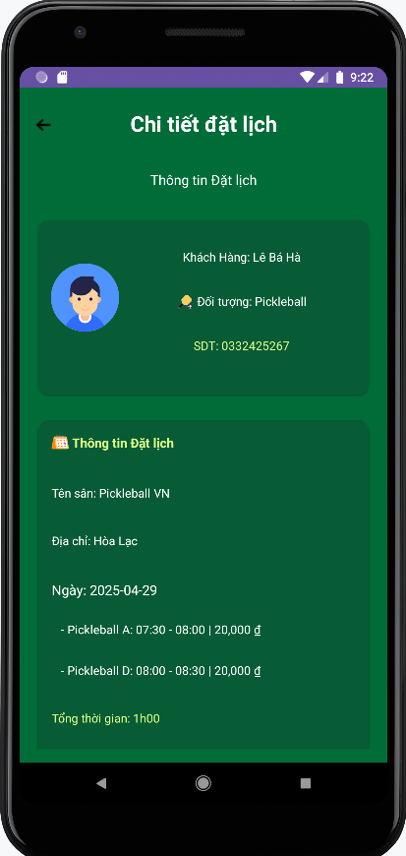

**Step 8:** Click on “VIEW BOOKING DETAIL” or “Cancel History” to view booking details

#### 3.4.2 Booking Regular

#### 



**Step 1:** Click on the “Book” button



**Step 2:** Click on the “Booking regular” button. The system redirects to the “Booking Regular” screen.

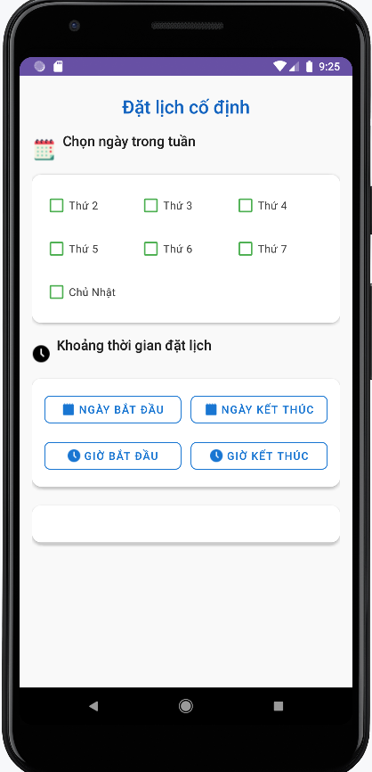

**Step 3:** Fill in the button for all required fields

**Select day a weekend(*):** This is for a user to click on the day of the weekend. Not be empty.

**The range time of date(*):** This is for the user to click on the range of time of day. Not be empty.

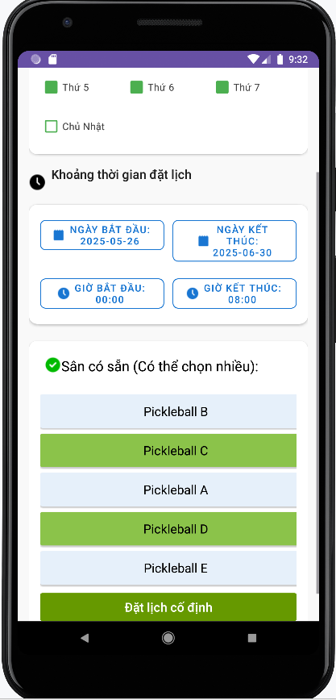

**Step 4:** Select a court available. Not empty. Then click “Đặt lịch cố định”

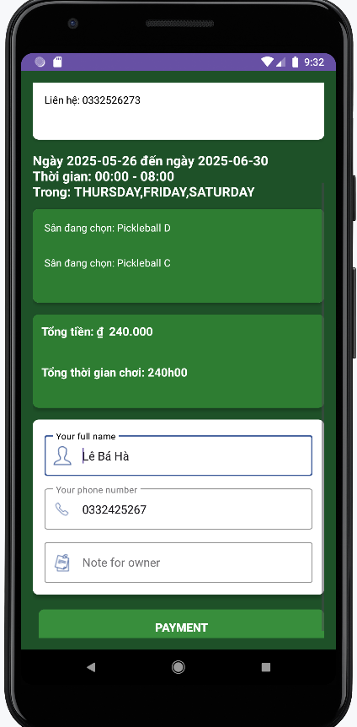

**Step 5:** Fill in the form for all required fields

**Full name(*):** This is for a user to input a valid user name. Not be empty.

**Phone number(*):** This is for the user to input a valid phone number. Not be empty.

**Note:** Note for staff.

**Step 6:** Click on the “PAYMENT”

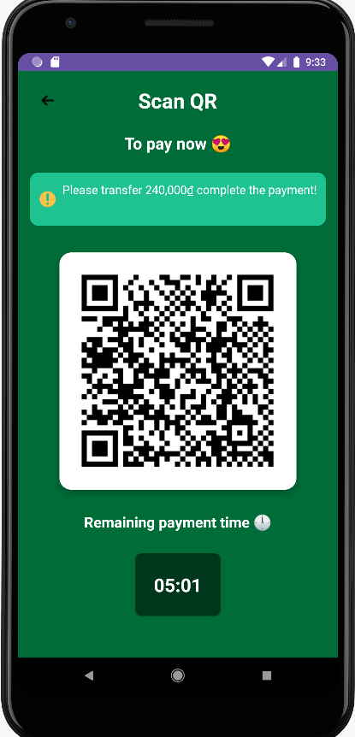

**Step 7:** Scan QR code and complete payment





**Step 8:** The system redirects to the “Booking Success” screen or if you don't complete booking so the system redirects to the “Booking Failed”



**Step 9:** Click on “VIEW BOOKING DETAIL” or “Cancel History” to view booking details

#### 3.4.1 Booking Optimal



**Step 1:** Click on the “Book” button



**Step 2:** Click on the “Booking regular” button. The system redirects to the “Booking Regular” screen.



**Step 3:** Fill in the button for all required fields

**Select day a weekend(*):** This is for a user to click on the day of the weekend. Not be empty.

**The range time of date(*):** This is for the user to click on the range of time of day. Not be empty.

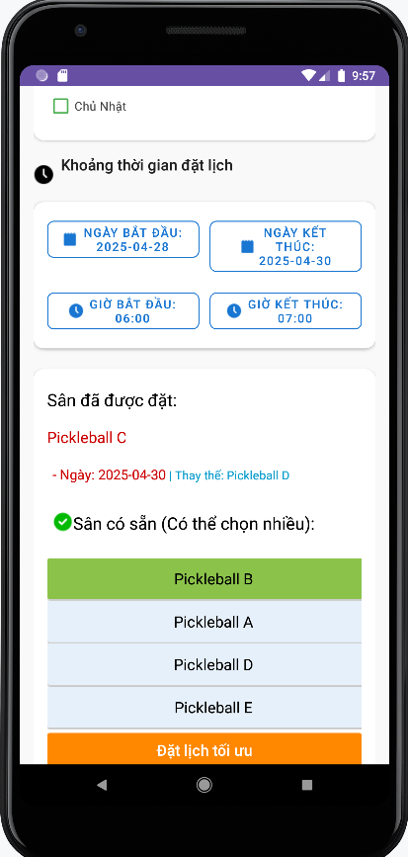

**Step 4:** Select a court available or select a replacement court . Not empty. Then click “Đặt lịch tối ưu”



**Step 5:** Fill in the form for all required fields

**Full name(*):** This is for a user to input a valid user name. Not be empty.

**Phone number(*):** This is for the user to input a valid phone number. Not be empty.

**Note:** Note for staff.

**Step 6:** Click on the “PAYMENT”



**Step 7:** Scan QR code and complete payment





**Step 8:** The system redirects to the “Booking Success” screen or if you don't complete booking so the system redirects to the “Booking Failed”



**Step 9:** Click on “VIEW BOOKING DETAIL” or “Cancel History” to view booking details

#### 3.4.1 Booking Service

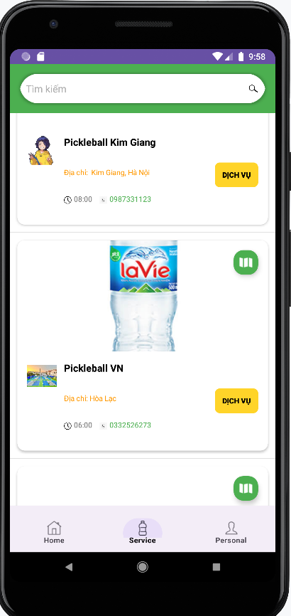

**Step 1:** Click on the “Service” button

**Step 2:** Click on “Dịch vụ” button

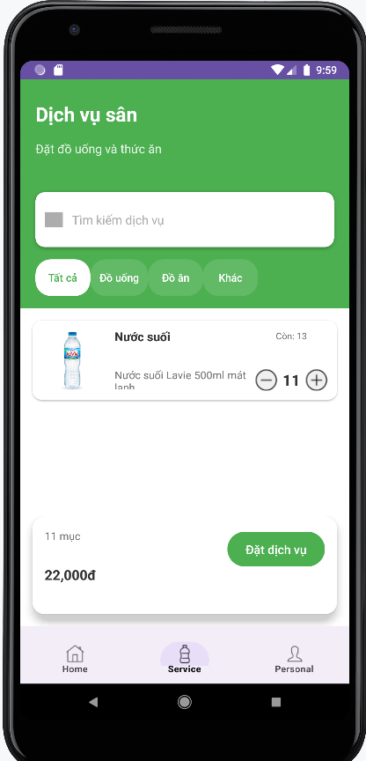

**Step 3:** Click on the “+” button. Then click on “Đặt dịch vụ” button

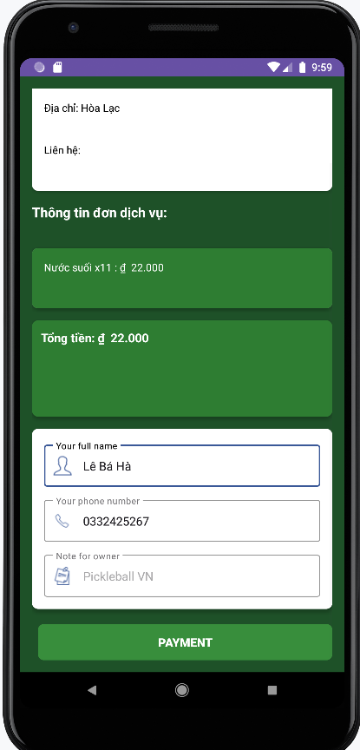

**Step 4:** Fill in the form for all required fields

**Full name(*):** This is for a user to input a valid user name. Not be empty.

**Phone number(*):** This is for the user to input a valid phone number. Not be empty.

**Note:** Note for staff.

**Step 5:** Click on the “PAYMENT”



**Step 6:** Scan QR code and complete payment





**Step 7:** The system redirects to the “Booking Success” screen or if you don't complete booking so the system redirects to the “Booking Failed”



**Step 8:** Click on “VIEW BOOKING DETAIL” or “Cancel History” to view booking details

#### 3.4.1 Change Booking

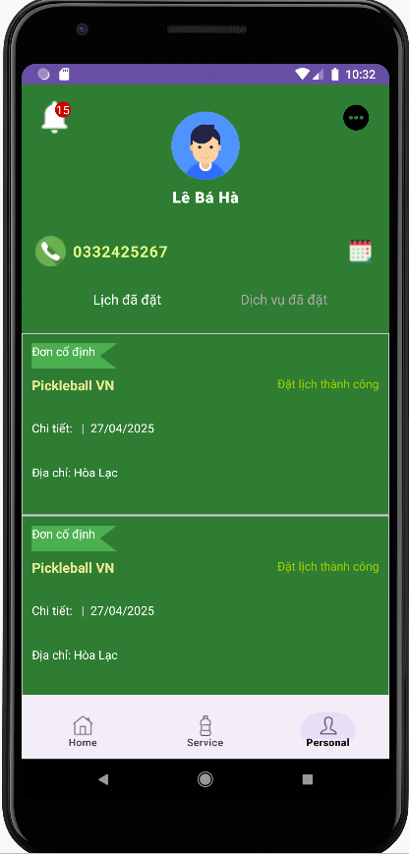

**Step 1:** Click on the “Personal” button

**Step 2:** Click on booking has status is “Đặt Lịch Thành Công”

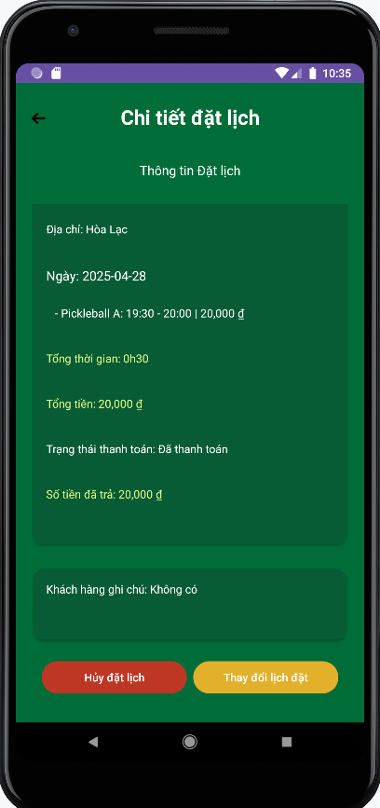

**Step 3:** Click on the “Thay đổi lịch đặt” button.

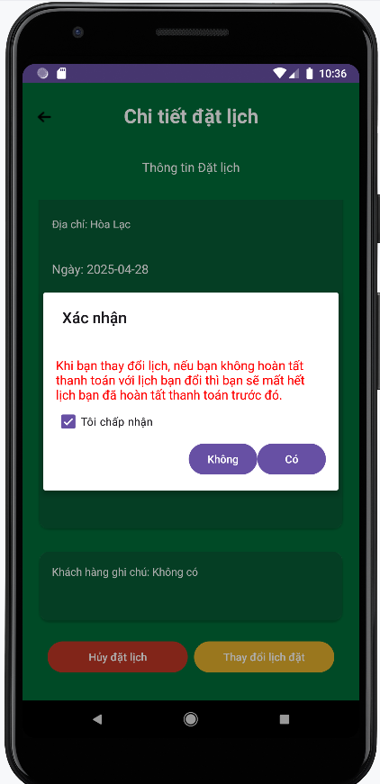

**Step 5:** Click on the “Tôi chấp nhận”. Then click on “Có”

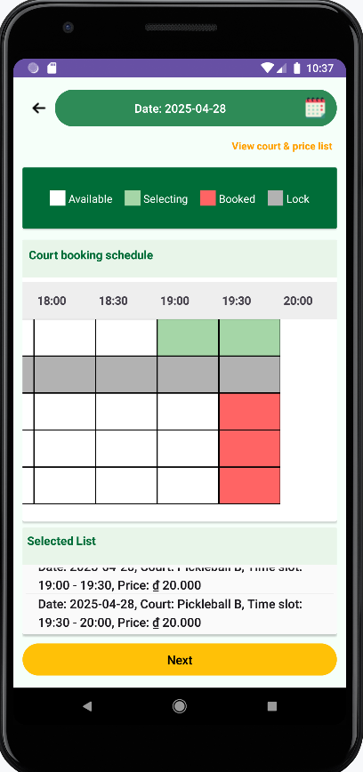

**Step 4:** If the amount of old booking less than new change order the system will generate new QR to payment (if user not payment new order then the system will display “Booking failed”), if equal new change order the system will redirect to “Booking successful”, if less new change order the system will redirect to “Booking successful” and refund money







**Step 5:** Click on “VIEW BOOKING DETAIL” or “Cancel History” to view booking details



#### 3.4.1 Cancel Booking



**Step 1:** Click on the “Personal” button

**Step 2:** Click on booking has status is “Đặt Lịch Thành Công” or “Đang xử lý”

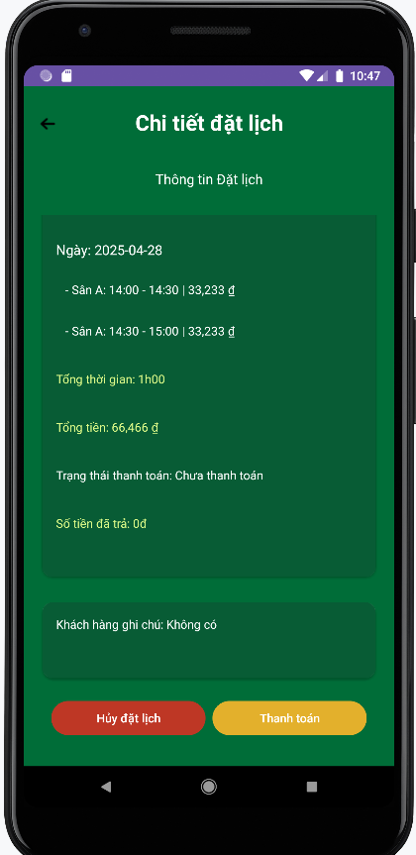

**Step 3:** Click on “Hủy đặt lịch” button